Volatile and Climate Cycles on Short and Long Timescales
Leslie Ann Young
Southwest Research Institute
Tanguy Bertrand
NASA Ames Research Center
Laurence Trafton
University of Texas, Austin
Francois Forget
Laboratoire de Météorologie Dynamique (LMD/IPSL), Sorbonne Universités
Alissa Earle
Massachusetts Institute of Technology
Bruno Sicardy
LESIA-Observatoire de Paris, CNRS

1. Introduction
Much of Pluto’s surface and atmosphere can be understood by considering its volatile and climate cycles. Pluto has three volatile ices on its surface and in its atmosphere: N₂, CH₄, and CO. N₂ is the main constituent in Pluto’s atmosphere, and is present on large areas of its surface. Unlike Earth, Venus, or Titan, the Pluto’s main constituent is able to condense on its surface. This leads to interactions between the atmosphere and surface, via relaxation to solid-gas equilibrium. There are similarities with other atmospheres whose main constituent is also solid on the surface: Mars; Triton; Io, to some extent; and probably other volatile-bearing dwarf planets in the Kuiper Belt, at some point in their orbits. Despite their differences in temperature, surface pressure, composition, and miscibility of the main and secondary constituents, these vapor-pressure-equilibrium atmospheres share three important characteristics. First, because pressure is very sensitive to temperature, and temperature is sensitive to insolation, albedo, and volatile distribution, we find that vapor-pressure-equilibrium atmospheres vary widely with time. For example, the Martian surface pressure varies by ~30% over its year, while Pluto’s and Triton’s pressure varies by orders of magnitude. Second, because of latent heat exchanges, sublimation and condensation can make up for energy imbalances between insolation and thermal emission, so there is transport of volatiles keeping a global surface pressure if the atmosphere is thick enough (Leighton & Murray 1966; Trafton & Stern 1983). Third, because the ices are subliming and condensing, they are inherently out of thermal equilibrium. The atmospheres supported by vapor pressure are sensitive to departures from thermal equilibrium, which is otherwise prescribed by the equilibrium phase diagram.
Insolation is the major driver for the sublimation and condensation of volatiles (See Section 3.1), their transport across Pluto, and the net exchange of volatiles between the surface and atmosphere. The volatile cycle evolves over different timescales: diurnal sublimation and condensation occur over Pluto’s 6.4-day rotation; seasonal transport and large pressure changes occur over its 248-year orbit, made more pronounced by Pluto’s large eccentricity of 0.25 and obliquity of 119.6°; the character of its seasonal behavior changes over its ~3 Million year (Myr) Milankovitch-like cycles in the orbit and pole orientation; and Pluto experiences changes over the 4.5 Billion years (Gyr) of solar system evolution.
The continual cycles of sublimation and condensation of volatile ices induce geological processes such as resurfacing, glacial flow, and pit formation, and contribute indirectly to dunes of ice and perhaps to the erosion of the water ice bedrock. Because of the volatile cycles, parts of Pluto's surface are among the youngest in the solar system. (See Chapter by Moore et al.). The volatile cycles also are key drivers of Pluto’s atmosphere dynamics, as the condensation and sublimation of N₂ induces winds that strongly impact the general circulation (See Chapter by Forget et al.).
Several properties of the surface and subsurface impact and complicate the volatile cycles (Section 3). Unlike H₂O and CO₂ ice on Mars, Pluto's volatile ices (N₂, CH₄, CO) are intimately mixed together to form separate solid solution phases. There is no pure phase for these species on Pluto, owing to their attraction at the molecular level. In thermodynamic equilibrium, the state of Pluto’s volatiles thus depends on a ternary phase diagram. Changes in the composition of these mixtures impact the volatile cycles (see Section 3.1). In addition, the ices can be contaminated by accumulation of dark materials (from sedimentation of haze particles or from processing of the surface by UV irradiation or energetic particles). New Horizons also revealed that the topography is playing a significant role in the distribution of volatile ice (see Section 3), as N₂-rich ice is mostly found in the depressions, whereas CH₄-rich ice has been detected at higher altitude, particularly in in the equatorial regions. Finally, climate modeling studies have highlighted how sensitive the sublimation-condensation rates of volatile ices are to the surface albedo, emissivity, thermal inertia, and the solid phase of the ice. These properties of the volatile ices lead to complex interactions between the N₂ and CH₄ cycles involving positive or negative feedbacks between changes of surface properties and sublimation-condensation rates.
A clearer insight into the processes ruling Pluto’s volatile cycles can help us understand the complex present-day Pluto, the Pluto of the past, and make testable predictions for Pluto’s near future. Models have been used to simulate Pluto's volatile cycles at different timescales, with different levels of simplification.
We review the observations relevant to volatile and climate cycles in Section 2, and cover the basic physics of volatile cycles in Section 3. In Section 4, we review various models, and then present the volatile cycles over diurnal, seasonal, and longer scales in Section 5. We cover open questions and future work in Section 6.

2. Observations

2.1. Earth-based observations
Observations made by ground-based telescopes, or space-based observatories such as the Hubble Space Telescope (HST), are important for volatile cycles even in the post-flyby era. They provide the setting for the history of work on Pluto’s volatile cycles; some observations are only possible from earth-based telescopes; and telescopic observations are the only means of assessing long-term changes on Pluto.

2.1.1 Albedo and color maps
While New Horizons images resolved geological features, they could not measure the southern latitudes that were in darkness during the New Horizons flyby, and observed a snapshot of Pluto. For changes over decades and southern coverage, both important for volatile cycles, we turn to maps from Earth-based telescopes or HST, even though their resolutions are at best 250 to 500 km, or a few resolution elements across Pluto’s 2380-km diameter. Buie et al. (1997) reviewed mapping efforts prior to 1996. The first maps were constructed from the changes in the mean brightness and the amplitude of rotational lightcurves since 1954, or from the series of Pluto and Charon transits and eclipses—collectively termed mutual events—that occurred within a few years of Pluto’s 1987 equinox. (Mutual events also gave the first good constraints on Pluto’s radius, e.g., 1178±23 km when limb darkening is included; Young & Binzel 1994, See Tholen & Buie 1997). Subsequently, Pluto maps were constructed from direct imaging with HST in 1994 and 2002-2003. The most complete analyses from rotational lightcurves was by Drish et al. (1995); from mutual events was by Young et al. (1999, 2001b); and from HST maps was by Buie et al. (2010b). Pluto’s disk is also marginally resolved by modern speckle imaging (Howell et al. 2012), but no maps have been constructed as yet from speckle data.
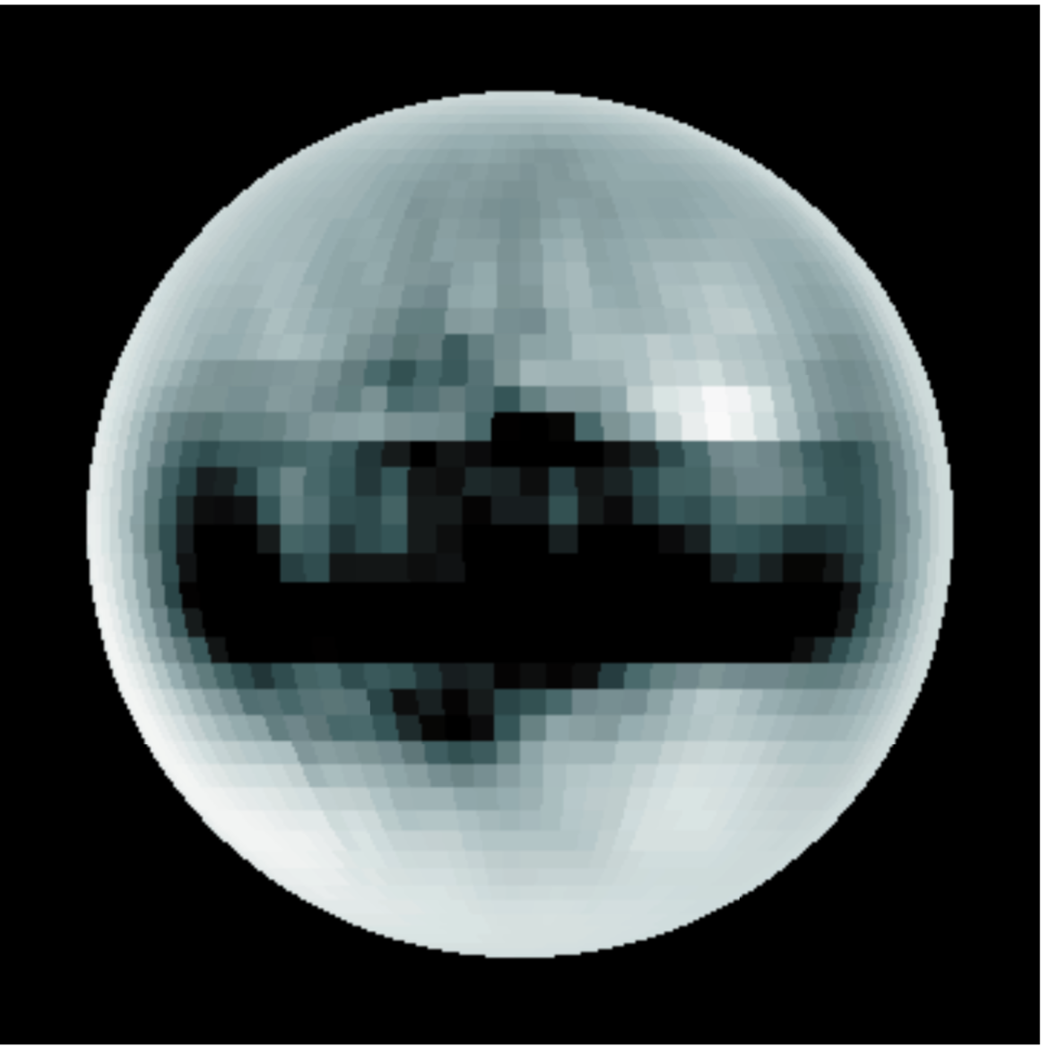 | 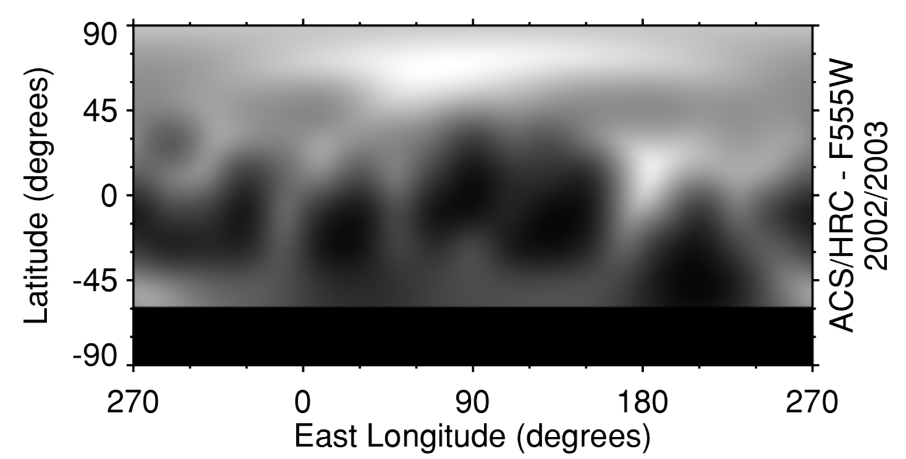
Fig. 1. Pre-encounter maps of Pluto. Left: Map of the sub-Charon hemisphere centered on 0° longitude, 0° latitude ca. 1987 (Young et al. 1999). Right: Maps of all longitudes, and latitudes north of 60° S, ca. 2002-2003 (Buie et al. 2010).

Pluto’s changing rotational lightcurve gives clear evidence for a bright southern pole prior to the most recent equinox (Andersson & Fix 1973; Buie & Tholin 1989; Drish et al 1995; Buie et al. 1992). Between 1954 and 1986, when the sub-Earth latitude changed from 55°S to 3°S, Pluto’s rotational lightcurve decreased in brightness and generally increased in amplitude, as would occur if a bright and uniform southern pole was seen more directly in 1954 than in 1986, and a variegated darker equator was seen more directly in 1986 than 1954. (The IAU, New Horizons, and many Pluto researchers all now use the rotational north pole, see Zangari 2015) This conclusion depends very little on underlying model assumptions, particularly Pluto’s radius. As discussed in Drish et al. (1995), all maps that use the 1954 rotational lightcurve include a bright southern pole. For example, the anti-Charon hemisphere (latitude 180°) of Buie et al. (1992) is based on rotational lightcurves, and presents a bright southern pole for that hemisphere. Mutual events also showed bright southern terrains on the sub-Charon hemisphere centered at 0° longitude (Young et al. 1999; 2001b; Buie et al. 1992). Some of the bright southern terrains presented in the mutual event maps may be affected by the then-uncertain radii and limb-darkening parameters of Pluto and Charon. For example, the mutual event map of Young et al. (1999) shows a bright rind for ~1/5 of the projected radius, raising concerns about the southern-most latitudes. By HST observations of 1992 (sub-Earth latitude 12.7°), the southern pole was more foreshortened and therefore difficult to image; HST-derived maps for 1992 indicated that the terrains at southern terminator, 45°S to 78°S, were bright at the sub-Charon hemisphere (0° longitude), but dark at the anti-Charon hemisphere. The HST observations of 2002-2003 (sub-Earth latitude near 30°N) showed even less of the southern terrains, and similar longitudinal variation at the southern terminator.
The HST maps and rotational lightcurves suggest changes in Pluto’s surface albedo pattern, as discussed in Buie et al. (2010b). Pluto darkened by 5% between 1933 and 1954 in the B filter; since the sub-Earth latitude was near 53° S for both epochs, this implies real darkening of the southern terrains, not a mere geometric effect (Schaefer et al. 2008). Drish et al. (1995) were unable to make a single static map consistent with rotational lightcurves from 1954 to 1986; in particular, snapshot maps using data 1980-1986 did not show a bright and extended southern cap, but this snapshot included only a 10° change in sub-observer latitude. Buratti et al. (2003) compared rotational lightcurves from 1954 to 1999 with FOC HST maps (Stern et al. 1997), and concluded that lightcurve amplitudes were consistent with a static model; they also noted that the observed 1999 lightcurve was darker than models predict, but they took this as only weak evidence for volatile transport. Buie et al. (2010b) saw evidence for a reddening trend from 2000 through 2002/2003, and darkening in B between 2002 and 2003, although a static model was consistent with the data in V over the year of data collection. Buratti et al. (2015) show a decrease in the lightcurve amplitude from primarily 2013 observations that much smaller than predicted from the FOC HST maps. New or newly remeasured photometry now exist from 1930-1951 (Buie & Folkner 2015); 1961-1966 (Eglitis et al. 2018); 1990-1993, 1999, and 2013 (Buratti et al. 2003, 2015). All these datasets can be usefully reassessed, now that radii, orbits, photometric properties (e.g., limb-darkening), and a snapshot of a high-resolution map are better known from the New Horizons encounter.

2.1.2 Surface composition and temperature
Cruikshank et al. (2015) and the Chapter by Cruickshank et al. review the spectroscopy and composition of Pluto’s surface. As with albedo maps, ground-based observations are useful for historical context, for spectral resolution and spectral ranges not reached by New Horizons, and for time variability. Spectra with λ/Δλ ~ 350, similar to that of LEISA on New Horizons, gave the first evidence for N₂ as a major species, with CO and CH₄ as minor species (Owen et al. 1993). Many of the observations of Pluto’s ices have been taken in the near-IR (e.g., Grundy et al. 2013, see Figure 2; Cruikshank et al. 2015; Cruikshank et al, this volume; and references therein), but CH₄ is also detectable at visible wavelengths, which gives a longer timebase of observations (Grundy & Fink 1996). Observations in the mid-IR give constraints on the fraction of uncontaminated N₂ ice, the nature of the tholin ice, and the mixing state of CH₄. Pre-encounter observations were often of merged spectra of Pluto and Charon. There are no published spectra that resolve the disk of Pluto, although many get longitudinal information by observing the lightcurve vs. rotation (Grundy et al. 2013), and OSIRIS on Keck has resolution comparable to the visible HST maps (Holler et al. 2017). In Pluto’s the near-IR spectrum, CH₄ dominates, N₂ is detectable at 2.15 µm, and CO bands are seen at 1.58 and 2.35 µm. H₂O was not detected pre-encounter. Ethane (C₂H₆) and tholins were also detected spectroscopically (DeMeo et al. 2010; Olkin et al. 2007). These affect the volatile cycles indirectly, by controlling the areas available for volatile condensation of sublimation. A near-IR spectrum of Pluto is presented in the Chapter by Cruikshank et al.
CH₄-ice on Pluto is seen to be in two states: diluted in N₂-rich ice or as CH₄-rich ice. These can be distinguished in three ways. First, the bands of CH₄ diluted in N₂ are shifted to shorter wavelengths by about 4 to 6 nm in H and K bands compared to pure CH₄ or CH₄-rich ice (Douté et al. 1999; Protopapa et al. 2015). Second, there is a feature at 1.69 µm that is present in pure CH₄ ice or CH₄-rich ice (Douté et al. 1999, Protopapa et al. 2015). Third, the slope of dilute CH₄ has a shallower slope from 2.9 to 3.2 µm than pure CH₄, and presumably shallower than CH₄-rich ice as well (Olkin et al. 2007). CO-rich ice has not been detected on Pluto, or elsewhere in the Kuiper Belt.
Modeling has typically found roughly equal areas of fine-grained CH₄-rich ice and larger-grained N₂-rich ice. The amount of CH₄ diluted in the large-grained N₂-rich ice has been modeled at 0.36% to 0.5% (Douté et al. 1999, Olkin et al. 2007, Protopapa et al. 2008, Merlin et al. 2010). Laboratory work shows N₂ becomes saturated in CH₄:N₂ ice at ~3% at Pluto temperatures (Prokhvatilov and Yantsevich 1983; see phase diagram in the Chapter by Cruikshank et al.). At these small amounts, the effect of the diluted N₂ is not detectable in the spectrum of the fine-grained CH₄-rich ice. Although many early papers (e.g., Douté et al. 1999) refer to areas of “pure CH₄ ice,” spectroscopically, these ices can be either pure CH₄ or CH₄-rich. Thermodynamic arguments suggest that all the areas described as “pure CH4” is actually CH₄-rich (see Section 3.1.1).
Pluto’s Earth-based disk-integrated spectrum shows a clear variation with sub-solar longitude (e.g., Grundy et al. 2013). Compared to rotational variation, decade-long changes are subtle. To measure how Pluto’s surface changes with time requires monitoring with a consistent instrument and observing procedure to minimize systematic errors, and the careful removal of the rotational signature. Two such programs are Grundy and Fink (1996) and Grundy et al. (2013, 2014). Together, these show a long-term rise in the CH₄ absorption features, and a recent decline in the strength of the N₂ and CO absorption features. Grundy et al. (2014) argue that these changes are not explained by changes in viewing geometry, using pre-encounter albedo and composition maps. Future work is needed to see if the observed decrease is due to the loss of N₂ and CO ices from the visible hemisphere, or a change in the surface texture that decreases the absorption band, or if the changes are consistent with the New Horizons composition map and changing viewing geometry.
The temperature of the N₂-rich ice is critical for the study of volatile cycles, because the atmospheric surface pressure can be inferred from vapor-pressure equilibrium and the temperature of the N₂ ice. Tryka et al. (1994) report 40±2 K from the temperature-dependent N₂ band, implying pressures of 1.9 to 15.9 Pa (19 to 159 µbar). Certainly, N₂ is in its β crystalline phase. For pure N₂, this implies a temperature above the 35.62 K phase transition (0.42 Pa). The temperature of the N₂ phase transition is lowered slightly when diluted with trace CH₄ (Prokhvatilov and Yantsevich, 1983) and raised slightly when diluted with trace CO (Tegler et al. 2019). A sideband of N₂ at 2.162 µm appears at temperatures colder than 41 K, and is apparent in Pluto’s spectrum. Thus, even though a correlation between grain size and temperature makes complicated temperature retrieval (Grundy 1995), near-IR spectra imply that the temperature of the surface N₂ ice is between 35.62 and 41 K. As we see in the next section, this is consistent with the surface pressure observed by the New Horizons radio occultation.
In thermal emission, Pluto’s brightness temperature is seen to be colder at longer wavelength (Stern et al. 1993; Jewitt 1994; Sykes et al. 1987; Aumann and Walker 1987; Lellouch et al. 2000, 2011, 2016; Butler et al. 2019), which is explained by a combination of Pluto’s variegated terrain and a wavelength-dependent spectral emissivity (Lellouch et al. 2011, 2016). Data from ISO, Spitzer, and Herschel show rotational variation, with colder brightness temperatures at the longitudes associated with bright albedos and N₂ absorption (Lellouch et al. 2000, 2011, 2016). These measurements imply N₂ temperatures near 37 K, and low thermal inertia values for the CH4-rich and volatile-free terrains of ~20-30 J m⁻² s^{-0.5} K⁻¹ (hereafter tiu, for thermal inertial units, Putzig 2006). The low thermal inertia implies a porous structure for the top few cm, which are affected by the diurnal temperature cycle. As with albedo and IR spectra, decade-long changes in thermal emission are much more subtle than rotational changes. Observations were taken prior to equinox and perihelion at ~100 µm (Sykes et al. 1987; Aumann and Walker 1987) and at mm/sub-mm (Stern et al. 1993, Jewitt 1994), but these were not rotationally resolved. Models based on pre-encounter composition maps were able to match ISO and Spitzer data with static composition maps and thermophysical parameters of bolometric Bond albedo, emissivity, and thermal inertia that were static from 1997 to 2004 (Lellouch et al. 2011). Hints of change between 2004 and 2007 (Lellouch et al. 2011) were not supported by later data from 2012 (Lellouch et al. 2016).

2.1.3 Atmospheric structure, composition, and variation
Stellar occultations observed from Earth have proven to be a powerful technique to probe the changes in Pluto’s atmosphere over the span of decades, occasionally at high spatial resolution. Stellar occultations are more sensitive than near-IR spectra for detecting changing N₂-ice temperature (under the assumption of vapor-pressure equilibrium). More information can be found in the Chapter by Summers at al. The differential refraction of stellar rays causes a drop of flux which can be used to retrieve the vertical refractivity profile of the atmosphere via an inversion technique for observations with high enough cadence and signal-to-noise ratio. Assuming a composition (a pure N₂ atmosphere in the case of Pluto), plus the ideal gas law and hydrostatic equilibrium, local profiles of density, pressure and temperature can be derived (see e.g. Vapillon et al. 1973; Elliot & Olkin 1996; Elliot, Person & Qu 2003), often at a vertical resolution of a few km or better. For lower quality light curves, typically a temperature and reference pressure can be derived through forward modeling.
Due to refraction effects, the deepest atmospheric layers accessible to ground-based occultations of Pluto do not reach the surface, but probe the atmosphere at a few km altitude (pressure ∼1 Pa). For high quality light curves, levels up to 380 km altitude (∼1 mPa) can be probed.
Pluto’s atmosphere was first glimpsed during a stellar occultation in 1985 (Brosch 1995) and fully recognized as such after a high-quality occultation was observed by multiple sites in 1988 (Hubbard et al. 1988; Elliot et al. 1989). Beginning in 2002, Pluto started to move in front of the Galactic center, increasing the rate of successful events to a few per year.
As of 2016, more than 20 stellar occultations by Pluto have been documented (Young 2013; Bosh et al. 2015; Meza et al. 2019; Desmars et al. 2019). Some occultations had sufficient quality to provide a good assessment of the global pressure changes over time. For instance, an occultation observed in 2002 showed that Pluto’s atmosphere underwent an expansion by a factor of about two between 2002 and 1988 (Elliot et al 2003, Sicardy et al. 2003). This increase was confirmed as more occultations were observed (Elliot et al. 2007, Olkin et al. 2015, Sicardy et al. 2016). This seemed paradoxical to some, as Pluto continuously receded from the Sun since its perihelion in 1989. Clearly, more complex seasonal cycles are at work (see Section 4.2).
Studies of the changes in Pluto’s climate were confounded by a fundamental uncertainty in the nature of the Pluto’s lower atmosphere, and by differences in analysis technique (see Bosh et al. 2015 for a review of these complications). The first complication is that Pluto’s radius was not directly measured until the New Horizons flyby of 2015 (as noted, occultations do not probe to Pluto’s surface). Occultation work prior to the flyby perforce presented results as a function of radius (distance to Pluto center) rather than altitude (distance to Pluto surface). A second complication is the unknown cause of the low fluxes reached by the occultation lightcurves, corresponding to the lower 10’s of km in Pluto’s atmosphere, affecting fluxes below half-light in 1988 or roughly quarter-light in 2002 and beyond (that is, the portions of the lightcurve where the stellar flux is less than half or a quarter of its unocculted value). While the upper portions of the lightcurves were well described by a clear atmosphere with at most a small thermal gradient, the lower fluxes were modeled as caused by haze absorption (“haze/no-steep-gradient”; Elliot et al. 1989) or steep thermal gradient below ~1215 km radius (“clear/steep-gradient”; Hubbard et al. 1990; Elliot et al. 2003; Dias-Oliveira et al. 2015).
One solution to the haze/thermal-gradient puzzle is to focus on only the upper portions of the lightcurve, sidestepping the haze/gradient question. Even this is problematic, as described by Bosh et al. (2015). By one measurement—the radius in Pluto’s shadow at which the stellar flux drops to half its unocculted value—the large increase between 1988 and 2002 had effectively leveled off after 2002 (Bosh et al. 2015). By another measurement— a 2- or 3-parameter model of pressure and temperature and optional (small) thermal gradient at a reference radius (typically 1275 km), fit to only the upper portions of the lightcurve—the pressure has increased steadily at 3.5% to 7.5% per year since 1988 (Bosh et al. 2015; Olkin et al. 2015).
Other approaches look for changes using the entire lightcurve. For very high-quality data, the lightcurve can be inverted to derive temperature, pressure, and density vs. radius, under the assumptions of a clear N₂-atmosphere and hydrostatic equilibrium (e.g., Elliot, Person & Qu 2003; Sicardy et al. 2003; Young et al. 2008). For data of high or moderate quality, Elliot and Young (1992) developed a 6-parameter model that included the 3 upper-atmosphere parameters describing (i) temperature, (ii) a small temperature gradient, (iii) a reference pressure, plus 3 parameters describing a haze with (iv) an onset radius, (v) onset absorption coefficient, and (vi) haze scale height. This “EY92” model was applied to many observations from 1988 and beyond (Elliot & Young 1992; Young et al. 2008; Gulbis et al. 2015). While the EY92 model matched the shape of many lightcurves, it failed to reproduce the central flash seen near the center of Pluto’s shadow, and does not allow for the ~60 K drop in temperature from the upper atmosphere to a surface near 40 K (see below). Other researchers (Hubbard et al 1990; Zelucha et al. 2011) constructed thermal profiles from physically motivated radiative-conductive models, dependent on the surface radius (again, this was unknown before the New Horizons flyby) and CH₄ or CO mixing ratios. As discussed in the Chapter by Summers et al., the energetics of Pluto’s atmosphere is not well understood.
Fitting with a temperature template uses the entire lightcurve, can describe even the central portions of the occultation lightcurve (unlike the EY92 model), and does not rely on an accurate understanding of Pluto’s atmospheric energy balance. Dias-Oliveira et al. (2015) constructed a temperature template from a high-quality occultation light curve, which was able to be fit to various occultation events assuming no significant haze absorption (Fig 2-XX). The template includes a steep thermal gradient below ~1215 km; a maximum near 1215 km; and a mild negative gradient of dT/dr = –0.2 K km⁻¹ between 1215 and 1390 km. Above 1400 km, the temperature is poorly constrained, and the template adopts an isothermal upper atmosphere at 81±6 K. This 10-parameter temperature-template model (9 temperature parameters plus a reference pressure) gives a good agreement between the pressures derived from Earth in 2015 (Sicardy et al. 2016, Meza et al. 2019) and from the REX experiment on-board New Horizons (Hinson et al. 2017), which validates the applicability of the temperature template. In the most comprehensive occultation survey made to date, Meza et al. (2019) used the temperature template to trace back Pluto’s atmospheric changes between 1988 and 2016, revealing an increase by a factor of about three during that period.
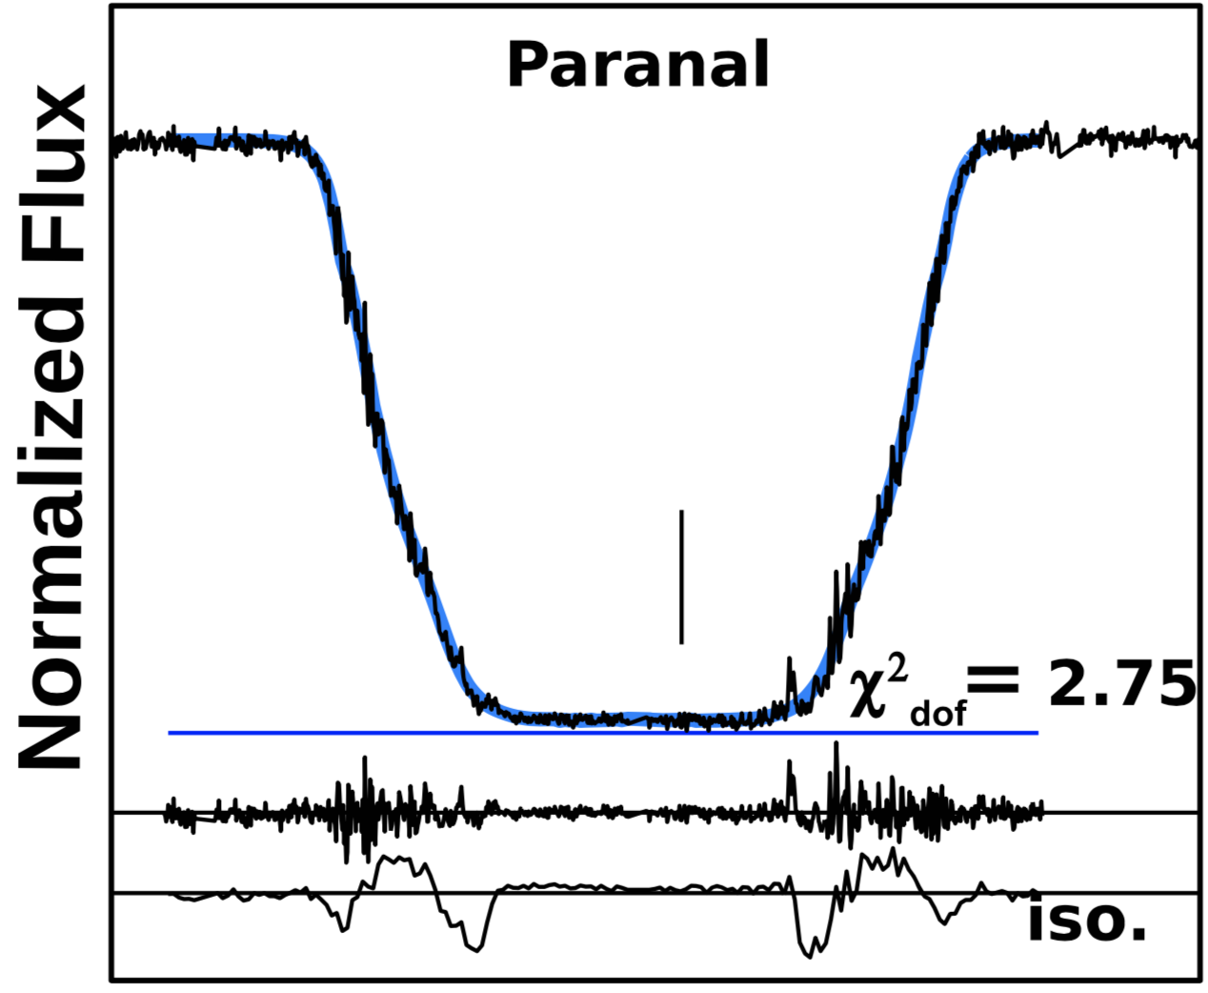
Fig. 2XX. Pluto occultation from Paranal on 2012 July 18, adapted from Dias-Oliveira et al. 2015 (converted to gray-scale). The gray curve is from the template thermal profile. The data plotted spans 3 minutes, with the vertical tick mark located at 04:13 UT, and includes flux from Pluto, Charon and the star. From top to bottom, the horizontal lines indicate (i) the measured zero stellar flux, (ii) the zero flux, together with the residuals (data minus model), (iii) the residuals obtained by forcing an isothermal mesosphere at 95.K above a radius of 1400 km.
Stellar occultations have proven the most sensitive way of measuring seasonal change in Pluto’s atmosphere. This in turn allowed modelers to constrain certain physical parameters that enter into models of seasonal volatile transport (Bertrand & Forget 2016; Johnson et al. 2020; Bertrand et al. 2018; See Section 4.3). These models predict that Pluto’s atmosphere is near its maximum expansion, and will start to decline in the upcoming decades. Thus, it is important to continue observing stellar occultations from Earth to confirm that trend. Unfortunately, as Pluto moves in front of more depleted stellar fields, such occultations have already become rarer.
While ground-based stellar occultations measure Pluto’s atmospheric refractivity, and possibly its opacity, they are insensitive to the atmospheric composition. Ground-based observations confirmed CH₄ as a minor species from IR spectroscopy at high spectral resolution (Young et al. 1997; Lellouch et al. 2009, 2011a, 2015), and CO as a minor species from the IR and radio spectroscopy (Young et al. 2001a; Bockelée-Morvan et al. 2001; Lellouch et al. 2010; Greaves et al. 2011; Lellouch et al. 2017), as well as the detection of HCN (Lellouch et al. 2016). Because the total surface pressure was not known pre-encounter, the mixing ratio of the minor species was also uncertain. For N₂ pressures of 6.5-24 µbar, the best-fit mixing ratios are 0.06% to 0.53% for CH₄, and 0.04% to 0.07% for CO (Lellouch et al. 2011a). The precision has not yet been good enough to detect changes with time. This may change, now that we can use New Horizons measurements of the temperature structure to improve models of CH₄ line absorption.

2.2. New Horizons Observations
The New Horizons spacecraft revealed many observations relevant to volatile transport. Other chapters cover this in detail: geology (White et al.), the geologic evidence for sublimation processes (Moore et al.), photometric properties and color (Olkin et al.), volatile distributions (Cruikshank et al.), and atmospheric structure (Summers et al.). New Horizons revealed latitudinal variation in albedo and composition, and albedo variations larger than any in the solar system apart from Iapetus, as well as dramatic topography, glaciers, color contrasts, and a range of surface ages. The presence of the deep N₂ plains of Sputnik Planitia was completely unexpected, and dominates much of the post-encounter thinking about volatile transport and volatile cycles.
New Horizons measurements yielded surface radii and pressures, ending years of ambiguous ground-based extrapolations. The mean radius from imaging is 1188.3±1.6 km (Nimmo et al. 2017). The topography on Pluto varies about this mean by roughly ±5 km (Schenk 2018). Specifically, the radii probed with precision by the REX radio occultation were 1187.4 ± 3.6 km at ingress and 1192.4 ± 3.6 km at egress (Hinson et al. 2017). The mean pressure at 1189.9 km was 1.15±0.07 Pa (Hinson et al. 2017), and the variation between ingress and egress is as expected given their different altitudes. The pressure of 1.15±0.07 Pa is consistent with N₂-ice in equilibrium at 36.9±0.1 K (Fray and Schmitt 2008). The CH₄ number density was measured by solar occultation (Young et al. 2018). Models were needed to extrapolate to the surface from 80 km, the lowest altitude at which CH₄ was last well measured, resulting on a CH₄ surface ratio of 0.28-0.35%.

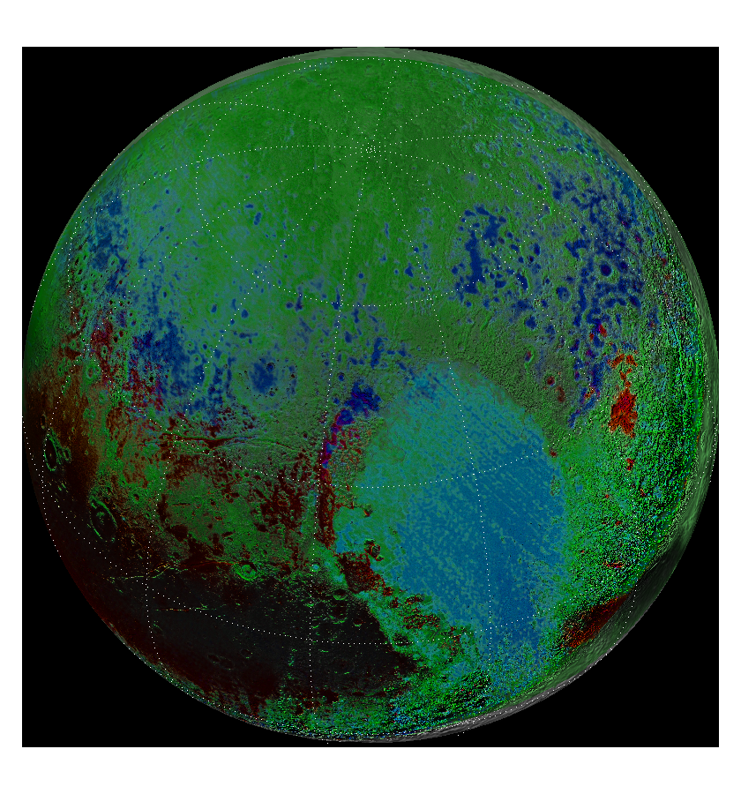

Fig. 3-XX. Orthographic views of the encounter hemisphere of Pluto, centered on 160° E, 45° N, with 30° lines of latitude and longitude. Hue and saturation indicate composition, and brightness is set by the basemap. The red channel is the H₂O spectral index of Schmitt et al. (2017) scaled from -0.00 to 0.25. The blue channel is from the N₂ spectral index of Schmitt et al. (2017) scaled from -0.005 to 0.105. The green channel is scaled from the average of the 1.7-µm CH₄ spectral index of Schmitt et al. (2017) scaled from -0.05 to 0.41 and the 0.89-µm CH4 spectral index of Earle et al. (2017) scaled from -3 to 4.
Sputnik Planitia is a feature roughly 1200-km wide by 2000-km tall centered at roughly 15° N and 180° E (Fig 3-XX), depressed several km below the surrounding terrain. It covers 5% of Pluto’s surface (White et al. 2017) and is likely to be several km deep (McKinnon et al. 2016), which makes it major reservoir of N₂ on Pluto (Glein & Waite 2018), with a mass equivalent to a global layer ~60 to 500 m deep (6 x 10⁴ to 5 x 10⁵ kg m⁻³). Both N₂-rich and CH₄-rich phases are present in Sputnik Planitia (Protopapa et al. 2017), with traces of CO (Schmitt et al. 2017). Consistent with ground-based spectra, the CH₄ is seen at only 0.3 to 0.5% in the N₂-rich ice, which is much lower than its saturation limit (See Section 3.1). There is a gradient of properties within Sputnik Planitia, with the northwest area having a smaller grain size or path-length, and less N₂ (Protopapa et al 2017).
Outside of Sputnik Planitia, Pluto’s surface shows strong latitudinal patterns in albedo (Schenk et al. 2018), color (Olkin et al. 2017; Earle et al. 2018) and composition (Protopapa et al 2017; Schmitt et al. 2017; Earle et al. 2018; Gabasova et al. 2019). Near the equator, Pluto’s surface shows high albedo contrast, with Cthulthu and other dark, reddish areas girdling the equator to roughly 10°N. These dark areas are mostly volatile free, most likely covered by tholins (See Cruikshank chapter), but New Horizons detected CH₄₋rich ice at some high-altitude ridgetops. At low-to-mid northern latitudes (10°N to 35°N), LEISA detected abundant CH₄-rich ice in the same pixels as H₂O ice. The CH₄-rich Bladed Terrain Deposits (BTD) are at these latitudes. In the mid latitudes (35°N to 55° N), N₂-rich ice is common. In both the mid-latitudes and the bladed terrain, N₂ favors low altitudes (Lewis et al. 2020). In the N₂-rich ice, trace amounts of CO are present, and the CH₄ is diluted at well below its saturation value, typically 0.1% to 0.5% (Protopapa et al. 2017). At high latitudes (55°N to 90°N), there is increasingly more CH₄-rich ice with increasing northern latitude. The presence or amount of N₂ in the CH₄-rich ice is not measurable. The composition of terrains south of the equatorial macula is difficult to measure.
For all volatile ices, inside or outside of Sputnik Planitia, the derived grain sizes for the CH₄-ich ice is relatively small, 0.2 to 1 mm, while the grain sizes for the N₂-ich ice is quite large, 0.1 to 1 m. Ground-based observations also found small CH₄ grains and large N₂ grains (Merlin et al 2010; Grundy & Buie 2001; Douté et al. 1999). The large N₂ grains are more usefully thought of as distances between scattering centers than the size of an individual grain (Grundy & Buie 2001).
Ethane could not be detected by LEISA because the spatial resolution is too low to observe its weak signature at 2.405 µm. Although CO₂ is present on Triton, this non-volatile ice is not detected on Pluto.

3. Characteristics of the volatile cycles on Pluto

3.1. Generalities

3.1.1 Pure ices and ice mixtures
Several bodies in the solar system have atmospheres supported hydrostatically by the vapor pressure of ices on the surface—Mars, Triton, and Pluto. On Pluto, global hydrostatic equilibrium at a nearly uniform temperature of the N₂-rich ice is enforced primarily by the high volatility of N₂. The ice temperature drives the vapor pressure that determines the bulk of the atmosphere.
The equilibrium vapor pressure of the ice phase of a pure species is determined uniquely by its temperature according to the Clausius-Clapeyron equation. This pressure is often reliable in scenarios that depart slightly from equilibrium as well, such as the situation on Pluto of slowly subliming or condensing ice, as long as the temperature is stable. At the low temperatures of Triton and Pluto, the volatile species are N₂, CO, and CH₄, in descending order of volatility. The contrast between the volatile pressures becomes more extreme with decreasing temperature. At 40 K, The N₂ equilibrium pressure is 6.55 Pa and the CO and CH₄ pressures are smaller by factors of 0.16 and 1.2 x 10⁻⁴, respectively (using the compilation of Fray & Schmitt, 2009). At 36.9 K, in equilibrium with the 1.15 Pa from the New Horizons radio occultation, the CO and CH₄ pressures are smaller than that of N₂ by factors of 0.12 and 6.0 x 10⁻⁵, respectively. So, for temperatures at Pluto, CH₄ is much less volatile than N₂ or CO (Fig 4-XX).
Fig 4-XX. Equilibrium vapor pressure vs. ice temperature over pure ices, from Fray & Schmitt (2009).
The vapor pressure is an extremely sensitive function of temperature. For example, at 37 K, an increase of only 0.16 K (0.4%) increases the N₂ pressures by 10%. This is because of the large latent heat of sublimation, L, which in this temperature range is ~2.5 x 10⁵ J kg⁻¹, 2.8 x 10⁵ J kg⁻¹, and 6.1 x 10⁵ J kg⁻¹ for N₂, CO, and CH₄ respectively. The equilibrium pressure increases with temperature according to the Clausius-Clapeyron equation:$dp_{eq}/dT_{eq}=\left(p_{eq}/T_{eq}\right)\left(L/RT_{eq}\right)$, where R is the specific gas constant. For N₂, the unitless ratio $L/RT_{eq}$ ranges from 31 to 18 for T_{eq} between 30 and 45 K; for CO and CH₄, the ratios are similarly large (32 to 21 for CO, and 39 to 26 for CH₄).
Hydrostatically supported atmospheres demonstrate the different behavior of immiscible volatile ices (such as H₂O and CO₂ on Mars) and miscible ones (such as N₂ and CH₄ on Pluto or Triton). When ice includes immiscible species, the total vapor pressure is the sum of the vapor pressures of the pure constituents. This is because their self-attraction at the molecular level is stronger than their mutual attraction. They therefore do not mix at the molecular level and so the species do not mutually perturb each other’s energy levels. Their spectral lines thus remain unshifted. Their vapor pressure depends on a single thermodynamic variable, temperature, and it does not depend on the relative proportions of the species present. For an atmosphere supported in hydrostatic equilibrium by the vapor pressure of immiscible ices, the partial pressure of each pure species would sum to give the total surface pressure of the atmosphere.
Miscible species (e.g., N₂ and CH₄), for which their mutual attraction at the molecular level is greater than their self-attraction, exhibit the opposite, and a more complicated, behavior. In the solid phase, these species are found to be intimately mixed at the molecular level, forming a solid solution. This results in the perturbation of each other’s molecular energy levels, with spectral lines of the participating species being shifted relative to the spectra of the pure solid species. In general, the total pressure will not be the sum of the partial pressures of the pure species, but will depend on the composition of the system. The thermodynamic state of the system determines the phases and the total vapor pressure, and in thermodynamic equilibrium, the state depends on the equilibrium phase diagram for the solid solution. In general, an equation of state (EOS) will be needed to calculate the equilibrium pressure and phase compositions. With three volatiles, a ternary phase diagram is needed to describe the phases of Pluto’s solid solution (Tan & Kargel 2018). However, isobaric calculations of the ternary N₂/CO/CH₄ diagram in Table 2 of Tan & Kargel 2018 show that the equilibrium composition of CO is insensitive to temperature changes. Moreover, CO and N₂ are similar in properties (e.g. molecular weight and sublimation pressure) and phase behavior. This is the rationale for neglecting CO in Pluto’s phase equilibrium and adopting the N₂-CH₄ binary phase diagram for EOS calculations (Trafton, Tan, & Stansberry 2019).
The binary phase diagram (Prokhvatilov & Yantsevich 1983, also see Chapter by Cruikshank et al.) shows that the solubility of the solid solution (CH₄ in N₂-rich ice, or N₂ in CH₄-rich ice) is only a few percent at Pluto’s low ice temperatures. If the solution is saturated, in equilibrium two separate solid phases would form: a N₂-rich phase and a CH₄-rich phase, each at the saturation concentration. No pure ice of either species would exist in thermodynamic equilibrium. The partial pressures at fixed temperature do not depend on the relative proportions of these phases, which is determined by the overall composition of the system. In this saturated case there are 2 species (N₂ and CH₄) and 3 phases (N₂-rich ice saturated with CH₄, CH₄-rich ice saturated with N₂, and vapor), and Gibb’s phase rule says there should be only one degree of thermodynamic freedom. Temperature thus suffices to determine the equilibrium state of the system including the vapor pressure.
As described by Trafton (2015, his Section 5.2), in thermodynamic equilibrium, the 3-phase saturated solution might be expected to have some similarities to an immiscible solution, namely the dependence on a single thermodynamic variable. But, the component partial pressures fall short of those for the pure components as calculated by Tan and Kargel (2018, as tabulated in Young et al. 2019): in the saturated 3-phase system at 35.6 to 40.0 K, the ratio of an ice’s partial pressure to its pure vapor pressure is 98% to 95% for N₂ and 74% to 79% for CH₄. If the solid solution is unsaturated in thermodynamic equilibrium, then only a single solid phase will be present —a “homogeneous” phase that is either N₂-rich or CH₄-rich, analogous to the homogeneous gas phase. In this case (2 species, 2 phases), Gibb’s phase rule says there should be two degrees of thermodynamic freedom, and the vapor pressure would depend on two thermodynamic variables; e.g., temperature and ice mole fraction, x_{CH4} in N₂-rich ice or x_{N2} in CH₄-rich ice.
A common approximation in lieu of the EOS has been to use Raoult’s law (Owen et al. 1993; Trafton et al. 1990; Forget et al. 2017; Bertrand et al. 2019), which states that the partial pressure of a component of the solid solution is the vapor pressure of the pure component times its mole fraction in the solid. This does not work well when the phase changes with concentration, as for Pluto’s volatiles. Take, for example, N₂-rich ice at 38 K with CH₄ undersaturated at x_{CH4}=0.3% (e.g., at the sublimation point, or at V-VS₁ boundary in the terminology of Tan & Kargel 2018), for which Raoult’s law would predict a partial pressure of 0.5 µPa, while the EOS of Tan & Kargel (2018) predicts a partial pressure of 13 µPa; at the CH₄ saturation value of x_{CH4}=3.9%, the partial pressure for Raoult’s law is 6.6 µPa, vs. 130 µPa for the EOS. Similarly, for CH₄-rich ice at 38 K with N₂ undersaturated (similarly, at the sublimation point, or at V-VS₂ boundary in the terminology of Tan & Kargel 2018), a partial pressure for N₂ of 0.045 Pa would be reached at x_{N2} ≈ 2.5% applying Raoult’s law but only x_{N2} ≈ 0.08% using the EOS. As shown in Section 3.4.1, the misapplication of Raoult’s law has little practical impact on calculations.

3.1.2 Insolation at various timescales
The intensity and distribution of the incident solar flux depends on the instantaneous heliocentric distance and subsolar latitude (Levine et al, 1977). Since these parameters are well known, insolation on Pluto can be easily calculated before making any assumptions about thermal properties, surface composition and reflectivity, etc., thus making incident insolation one of the basic inputs for the various models described below. At the time of the New Horizons encounter, Pluto was at 32.9 AU from the sun, for a normal incident solar flux of 1263 mW m⁻². Pluto was experiencing Northern summer, with its subsolar latitude at 52° N. During this time all latitudes South of 38° S were in constant shadow, while all areas north of 38° N received constant sunlight, with the maximum diurnal average insolation (995 mW m⁻²) occurring at the North Pole (Fig 5-XX, top panel).
In Pluto’s current orbit, the obliquity is 119.51° and the solar longitude of perihelion is ~3˚ N, which means that equinox occurs near perihelion and aphelion. Therefore, both hemispheres receive similar distribution of insolation over Pluto’s year (Fig5-XX, middle panel, Earle et al., 2017): each pole receives the same maximum insolation, and comparable latitudes spend the same amount of time in continuous darkness. Pluto has a high orbital eccentricity (approximately 0.25) which causes its heliocentric distance to vary from less than 30 AU out to almost 50 AU, which leads to the normal incident solar flux varying by a factor of ~3 over the course of its orbit (Spencer et al., 1997).
When averaged over a full orbit, insolation is symmetric across the equator (Fig5-XX, lower panel; Nadeau and McGehee, 2017; Hamilton et al. 2016). (The asymmetric insolation in Spencer et al. (1997), and adapted in Earle & Binzel (2015) is a miscalculation.) Due to Pluto’s high obliquity, the average insolation over one Pluto year in its current orbit is highest at the poles and lowest at 25° N and 25° S.
Also shown (Fig 5-XX, Middle) are the climactic zones on Pluto as defined by Binzel et al. (2017). In Pluto’s current orbit, the subsolar latitude reaches ±61° at the solstices. Between these extremes are the tropics, where the sun is overhead at some time in the year, equivalent to Earth’s tropics of Cancer and Capricorn. The complement, poleward of ±61°, is termed the polar climate zone. Latitudes poleward of ±29° experience days where the Sun never sets in the summer or never rises in the winter, otherwise known as the arctic (and the complement, between ±29°, is termed diurnal climate zone). Unlike on Earth, the tropics and artic latitudes overlap, for a tropical arctic climate zone. The climate zones appear associated with the gross geology of Pluto (Fig 7-XX). In particular, the diurnal zone is a zone where albedo feedback is favored, leading to strong albedo contrasts (Earle et al. 2018).
The obliquity, solar longitude of perihelion, and eccentricity vary over timescales of Myr (Eq 3-XX). This is known as the Milankovitch mechanism, which also occurs on other planetary bodies such as the Earth, Mars and Titan. These parameters combine to modulate the solar insolation and surface temperatures, forcing the volatile ices that form glaciers, frost or lakes to migrate in different regions over time. Recent years have emphasized the importance of these cycles, but have also introduced some elements of confusion. We present here the equations controlling the insolation at Pluto, using the equations Dobrovolskis et al. (1997). Earle (2013) showed that the important dynamical parameters (the principle moments of inertia, the semi-major axis of the Pluto-Charon system, or the radii and masses of Pluto and Charon), have changed by less than 6% since the work of Dobrovolskis et al. (1997). Until such time as the numerical integrations are repeated, we also use the numerical results from Dobrovolskis et al. (1997). In terms of the time (t) in Myr A.D., we define an intermediate angle (ψ), which varies with a period of 360°/91° = 3.96 Myr; and a phase angle (φ), defined as the angle, projected onto Pluto’s orbital plane, between the ascending node on the invariable plane and Pluto’s spin vector, which varies with a period of 360°/130.2° = 2.76 Myr. From these we can calculate the eccentricity (e), obliquity (θ), and the solar longitude of perihelion (L_{s,peri}, related to the parameters in Dobrovolskis et al. 1997 via $L_{s,peri}=-χ$, where χ is the angle, measured in Pluto’s orbital plane, from Pluto’s longitude of perihelion to its vernal equinox).
(Eq 3a-XX) $ψ=72.8°+91.0°t$
(Eq 3b-XX) $ϕ=19.5°+130.2°t$
(Eq 3c-XX) $e=0.244°+0.022°\cos{ψ} +0.005°\cos{3ψ}$
(Eq 3d-XX) $θ=115.5°+11.8°sinϕ$
(Eq 3e-XX) $L_{s,peri}=-ϕ+24.0°\sin{ψ}$
Pluto’s obliquity varies by about 23° between 104° and 127° over a period of 2.8 My, thus affecting the latitudes of the climate zones and the annually averaged insolation. Over 2.8-My timescales, the latitude of minimum insolation moves from ±30° to the equator, and the difference between average insolation at the equator vs. the poles becomes more or less dramatic. The eccentricity oscillates between 0.222 and 0.266 with a 3.95 My period.
The longitude of the ascending node (Ω) regresses over 360° with a period of 3.7 Myr, given by $Ω=111.428°-97.209°t-1.5°\sin{ψ}$, while the argument of perihelion (ω) librates with a period of 3.96 Myr. The longitude of perihelion, being the sum of Ω and ω, also regresses with a period of 3.7 Myr. However, these angles are of minor importance for the insolation at Pluto. Numerical integration shows Pluto’s spin pole advancing with a precession period near 11.5 Myr. This combines with the change in the longitude of the ascending node to result in a period for φ of 2.76 Myr, which leads to a variation of the solar longitude of perihelion (L_{s,peri}). In Pluto’s current orbit, the northern spring equinox was nearly coincident with perihelion (L_{s,peri} ≈ 0°). When a solstice is at perihelion (L_{s,peri} = 90° for northern summer solstice at perihelion, or L_{s,peri} = 270° for southern), one hemisphere experiences a short, intense summer and long winter, while the other hemisphere experiences a short winter and long, less intense summer. (Fig 6-XX; also see Bertrand et al. 2019; their Fig 5). Because of the prominence of the N₂ deposits in Sputnik Planitia near 15° N, the solar forcing of the N₂-rich ices is most extreme when northern solstice is at perihelion (Fig 6-XX, upper) and nearly uniform when northern solstice is at aphelion (Fig 6-XX, lower). Perihelion northern summer solstice (L_{s,peri} = ~90°) happens at times of high obliquity, and perihelion southern summer solstice (L_{s,peri} = ~270°) happens at times of low obliquity, with some small variation due to the 24.0° libration of ω.

Fig. 5-XX. Incident solar flux (insolation) on Pluto at various timescales. Contour labels are in mW m⁻². (Top) Insolation over one Pluto rotation at the time of New Horizons flyby, with longitudes relative to midnight. (Middle) Diurnally averaged insolation over one Pluto year, with the subsolar latitude (SSL) shown as a white dashed line. Also plotted in gray are critical latitudes: the tropics at ±61°, between which the sun is overhead at some time in the year; and the artic/diurnal division at ±29°, between which sun rises and sets every day of the year, and beyond which the latitude experiences arctic night sometime during the year. (Lower) Annually averaged insolation.
Fig. 6-XX. Diurnally averaged insolation over one Pluto year for two different epochs, with the subsolar latitude (SSL), tropics, and the diurnal/arctic division plotted as in Fig 5-XX, Middle. Top: Northern summer solstice at perihelion (L_{s,peri} = 90°) at a time of high obliquity. Bottom: Southern summer solstice at perihelion (L_{s,peri} = 270°) at a time of low obliquity.

Fig. 7-XX. Climate zones on Pluto and their geographic expression. The division between the arctic and diurnal climate zones oscillates between ±13° and ±37°, and the division between the tropic and polar climate zones oscillates between ±53° and ±77°. The base of each triangle on the left indicates the current location of each zone boundary while pointing in the direction of the boundary’s current migration. The area between ±13° is a permanent diurnal zone, which experiences sunrise and sunset every Pluto day. The area between ±53° is the zone of permanent tropics, where the Sun always reaches the zenith at least once per orbit. Poleward of ±37° is the permanent arctic zone, which always experiences arctic seasons, up to century-long summers and winters during each orbit. Poleward of ±77° is the permanent polar zone, where the Sun never reaches zenith over any orbital period. Adapted from Binzel et al. (2017).

3.1.3 Thermal inertia
The average insolation only tells some of the story. The substrate is able store the heat accumulated during the day or summer and release it during night or winter, an ability quantified by its thermal inertia. Thermal inertia dampens and retards the response of the surface temperature to insolation, and raises the mean temperatures (Spencer 1989). The effects are very different on diurnal and seasonal timescales. Using the definition of Spencer (1989), the sub-surface thermal wave has a characteristic skin depth $Z=Γ/(ρc\sqrt{ω})$, where $Γ$ is the thermal inertia, $ρ$ is density, c is the specific heat, and $ω$ is frequency (2$π$/period). The importance of the thermal inertia is parameterized by $Θ=Γ\sqrt{ω}/(εσT_{SS}^{3})$, where $ε$ is emissivity, $σ$ is the Stephan-Boltzmann constant, and T_{SS} is the temperature in instantaneous equilibrium with the normal insolation (Spencer 1989). For small values of $Θ$, the temperature responds quickly to changes in insolation, and little heat is conducted into or out of the subsurface. For large values of $Θ$, subsurface conduction is comparable to the peak-to-peak variation in the solar heating, and the temperature variation is more uniform with time. For the CH₄-rich and non-volatile terrain types, Lellouch et al. (2011, 2016) report low diurnal thermal inertia of 16-26 J s^{−1/2} m⁻² K⁻¹ (tiu). This is much smaller than the thermal inertia for solid ices near 40 K (Spencer & Moore 1992), whether H₂O (2200 tiu), N₂ (530 tiu), or CH₄ (630 tiu) XX it would be great to have modern numbers. The diurnal skin depths are ~1 cm, and so the reported thermal inertia relates to the thermophysical properties of the top-most layers. The small thermal inertia implies a substrate with high porosity at the top-most layers of Pluto’s surface (Carson et al. 2005). The much larger seasonal thermal waves can penetrate deep in the high thermal inertia substrate. Several models predict much larger seasonal thermal inertias, for example 800 tiu (Bertrand and Forget 2016), for which the seasonal skin depth is 40 m.
For the diurnal thermal wave, the thermal parameter $Θ$ is about 4.5-6 for the CH₄-rich and non-volatile terrain types (Lellouch et al. 2016). For seasonal thermal wave, the thermal parameter is likely to be similar. Pluto’s year is 1.4 x 10⁴ times longer than its day, so $\sqrt{ω}$ is 118 times smaller. Countering this is the fact that the seasonal thermal inertia is larger than the diurnal one, and that the relevant temperature is not the subsolar temperature, T_{SS} (as in Spencer 1989), but rather the smaller global N₂ temperature (as in Young 2012). Near the times of maximum insolation, the thermal conduction is comparable to the energy lost by thermal emission for thermal parameters greater than about unity. When there is no insolation (e.g., during polar winter), the heat stored in the substrate can be significant.

3.1.4 Atmospheric effects on surface energy balance
Pluto’s atmosphere is so transparent and rarefied that any atmospheric processes (clouds, hazes, convection, radiative transfer) have no significant impact on the radiative thermal and conductive balance at the surface. Thermal conduction to the surface given a near-surface gradient of ~5 K km⁻¹ (Hinson et al. 2017) is only ~0.02 mW m⁻², and the heat transfer through turbulent diffusion is only a few mW m⁻² (Stansberry et al. 1992), so the ambient atmospheric temperature hardly affects the local surface temperature. In addition, most of Pluto’s thermal emission is longward of 52 µm, which is not absorbed by the atmosphere. Nevertheless, the atmosphere affects the surface energy balance through changes to the albedo (as newly deposited ice is likely to be bright), or to the thermal inertia (as the sublimation and condensation can affect porosity). Most significantly, the atmosphere affects surface temperatures through latent heat of sublimation, particularly of N₂-rich ice (see Chapter by Forget).

3.2 N₂ cycle
It is useful to begin with the simple picture of Pluto’s N₂ atmosphere in global balance with its surface N₂ ice (Spencer et al. 1997). For a high-enough surface pressure, the pressure at a reference altitude will be nearly the same everywhere, and the surface pressures and temperatures of the N₂ ice will be close to vapor-pressure equilibrium. For a surface without topography, the N₂ ice temperatures will be close to isothermal across the surface, at a value which is determined by the radiative balance between the absorbed insolation and thermal radiation from the N₂ ice. Sublimation occurs from areas of high insolation, with condensation onto areas of low insolation, and the sublimation winds transport mass and latent heat of sublimation from areas of net sublimation to areas of net condensation. Because N₂ is so much more volatile than CO or CH₄, the small amount of CH₄ or CO diluted in the N₂-rich ice does not change this basic picture.
Putting these considerations into equation form, the local energy balance can be written:
(1-XX) $c_{s}\frac{dT}{dt}=μ\left(1-A\right)\frac{S_{1AU}}{∆^{2}}-εσT^{4}-k\frac{dT}{dz}+L\dot{m}$
where c_{s} is the surface heat capacity (in J m⁻² K⁻¹; see Forget et al. 2017; Hansen & Paige 1996), t is time, $μ$ is the cosine of the incidence angle, A is the bolometric Bond albedo, $S_{1AU}$ is the solar constant (that is, the normal solar flux at 1 AU), $∆$ is the heliocentric distance in AU, $ε$ is the emmissivity, $σ$ is the Stefan-Boltzmann constant, k is the conductivity, z is the substrate depth (0 at the surface, negative below), L is the latent heat of sublimation, and $\dot{m}$ is the net mass flux, positive for condensation. Locally, the mass fluxes for N₂ are energy limited, and the left-hand side is small compared with the other terms, so that $L\dot{m}$ balances insolation, thermal emission, and conduction to the subsurface. Globally, what goes up mainly comes down; on seasonal timescales, and sometimes on diurnal timescales, the global average of $L\dot{m}$ can be neglected (Young 2012).
If Pluto’s atmosphere were always dense enough to ensure efficient global transport of N₂, if the surface were entirely covered by N₂, if the thermal inertia were negligible, if the global average of $L\dot{m}$ can be neglected, and if there was no topography, then the global average of Eq (1) would simplify to: $εσT_{eq}^{4}≈\overline{μ}\left(1-A\right)S_{1AU}/∆^{2}$, where $\overline{μ}=1/4$ for spatially uniform ice. The surface pressure is set by vapor-pressure equilibrium. To first order, the N₂ frost temperature depends on $(1-A)/ε$. However, the real Pluto deviates from this ideal because the atmosphere may or may not occasionally be non-global, Pluto’s surface is heterogeneous, thermal inertia is likely to be significant on diurnal and seasonal timescales, and New Horizons detected significant topography on Pluto. We deal with each of these items in turn.

3.2.1 Departure from global equilibrium (or “Will Pluto’s atmosphere collapse?”)
For the New Horizons flyby conditions (subsolar latitude = 51.6°, p = 1.15 Pa, T_{eq} = 36.9 K), Pluto’s N₂ ice temperatures should be nearly isothermal across the globe, and the N₂ ice should be nearly in equilibrium with the atmosphere, despite local sublimation or condensation and the variation of insolation with time. Near-equilibrium is a consequence of the high volatility and latent heat of sublimation of N₂ at Pluto’s temperatures, as can be demonstrated several ways. First, the number of molecules leaving the N₂-rich ice nearly equals the number of molecules impinging on and sticking to it. That is, the net sublimation rate is much smaller than the one-way upward or downward flux. Roughly estimating the mass flux by $L\dot{\dot{m}≈εσT^{4}}$ gives $\dot{m}≈$ 4.2x10⁻⁷ kg m⁻² s⁻¹. By kinetic theory (the Knudsen-Langmuir equation), and assuming unit sticking coefficient, the one-way upward mass flux is ${\dot{m}}_{up}=p_{eq}/\sqrt{2πRT}$. At flyby conditions, this gives ${\dot{m}}_{up}=$ 4.4 x 10⁻³ kg m⁻² s⁻¹, about 10,000 times larger than the net flux. Second, the timescale for N₂ to relax toward an equilibrium pressure is very short. By hydrostatic equilibrium and kinetic theory, $dp/dt=-g\dot{m}=-\left(p-p_{eq}\right)g/\sqrt{2 πRT}$. This equation is one of relaxation to an equilibrium, $p=p_{eq}+\left({p\left(t_{0}\right)-p}_{eq}\right)\exp\left(-\left(t-t_{0}\right)/τ)\right)$, with a timescale $τ=\sqrt{2 πRT}/g$. For Pluto’s flyby conditions, this timescale is 7 minutes, about 1300 times shorter than Pluto’s 6.4-day rotation. Third, the isothermality of the surface requires that the sublimation wind, v_{sw}, be much smaller than the sound speed, $v_{s}=\sqrt{γRT}$, where $γ$ is the adiabatic constant (Trafton & Stern 1983; Spencer et al. 1997). The sublimation wind is the wind needed to transport atmosphere from areas of greater to lesser insolation. For the ideal ice-covered “iceball,” if the sub-solar latitude is at the pole, then the sublimation wind can be calculated by imagining a girdle at the equator with area equal to the circumference time the scale height (Spencer et al. 1997). Multiplying this area by the number density and sublimation wind speed gives a mass flux, which must equal the net condensation in the winter hemisphere. Different subsolar latitudes and different choices of where to place the girdle affects the calculated sublimation wind. The maximum sublimation wind is smaller for equator-to-pole flow than for pole-to-pole flow. This effect can be expressed by $v_{sw}=4ξεσT^{4}r_{0}g/(Lp_{eq})$, where r₀ is Pluto’s surface radius, and $ξ$ is a unitless constant that varies between 0.044 and 0.30 depending on illumination (Young et al. 2019; Stern & Trafton 2008), giving v_{sw} ≈ 0.20 m s⁻¹ at the flyby, in rough agreement with the meridional speeds in Forget et al. (2017). At T = 36.9 K, the sound speed, $v_{s}$, is 123 m s⁻¹, or ~550 times larger than the sublimation speed.
This picture of an isothermal, isobaric surface breaks down with lower temperatures and pressures. Spencer et al. (1997) describes the breakdown of the global atmosphere at temperatures below ~30.5 K, for p_{eq} = 6.4 mPa for pole-to-pole flow (e.g., from the sub-solar to the anti-solar point). At that temperature, the atmosphere is still in local equilibrium with the ice: the timescale for equilibrating is still only 7 minutes, and the imbalance between the upward and downward mass flux is only 1 part in 150. However, N₂ still must flow from latitudes of greater insolation to latitudes of lesser insolation. A thinner atmosphere requires faster sublimation winds to transport the same mass. For a surface covered completely with volatiles, at 30.5 K, the sound speed is only ~5 times larger than the sublimation wind, which is too small to maintain an isothermal surface (Trafton 1984). At these low pressures, the conditions are more like Io’s atmosphere, where the atmosphere is collisional, super-sonic winds flow, and the principle volatile is transported across the globe, but the rate of transport is not enough to regulate the surface temperature. For such cases, simplified hydrodynamics equations can be applied, as has been done for Io (Ingersoll et al. 1985), Eris (Hofgartner et al. 2019), and previously for Pluto and Triton under the assumption of a thick CH₄ atmosphere (Trafton & Stern 1983; Trafton 1984). As we discuss in Section 4, for many assumptions of albedo, emissivity, and thermal inertia, Pluto’s atmosphere stays global throughout its entire orbit.

3.2.2 Surface heterogeneity and the N₂ cycle
That Pluto’s surface was varied in albedo and composition was well established before the New Horizons flyby, and confirmed spectacularly by the LORRI and Ralph instruments of New Horizons. A inhomogeneous N₂ ice distribution lowers the pressure at which an atmosphere transitions from global to local, because a smaller net sublimation or condensation flux needs to move across the planet.
Because Pluto’s N₂ ice is not spatially uniform, the mean insolation onto the N₂ ice varies with subsolar latitude and longitude, as well as with heliocentric distance, as discussed in 3.1.2. On diurnal timescales, the energy balance is controlled by the diurnally averaged insolation onto the N₂ ice, not the instantaneous insolation, because the latent heat required to increase the column mass of the atmosphere in response to the changing surface temperature dampens how quickly temperatures can change over a rotation. Young (2014, 2017) defined a unitless parameter analogous to the Spencer thermal parameter that dampens the change in surface temperature because of the “atmospheric breathing,” which can be written as $Θ_{A}=(ω/fg)(d lnp_{eq}/d lnT)Lp_{eq}/(εσT^{4})$, where f is the fraction of the surface covered by volatiles. For the conditions at flyby, and using f ≈ 1/2, $Θ_{A}≈2300.$ Even near the limit of a global atmosphere, at 6.4 mPa, $Θ_{A}$~40. For large $Θ_{A}$, the peak-to-peak temperature is smaller by a factor of ${4/Θ}_{A}$ compared with what it would be if the thermal emission were in instantaneous equilibrium with the average insolation. In Pluto’s current configuration, the N₂ ice temperatures warm up and cool off by only mK as Sputnik Planitia— the bulk of Pluto’s N₂—approaches local noon or midnight.
On seasonal timescales, the mean insolation on the N₂ ice is greatly influenced by large reservoir of N₂ in Sputnik Planitia, which is primarily in the northern hemisphere, centered on 15°N. In Pluto’s current orbit, this implies the greatest insolation happens partway between perihelion and summer solstice, near the time of maximum insolation onto 15°N (Fig 5-XX, Middle; Johnson et al. 2019).
When perihelion coincided with northern summer solstice, 0.9 My ago, each Pluto orbit experienced a period of short and intense insolation onto Sputnik Planaria. In contrast, when perihelion coincided with southern summer solstice, 2.3 My ago, the competing effects of heliocentric distance and subsolar latitude nearly balance, leading to mild changes in temperatures over a Pluto orbit.
And how is it that Pluto’s surface is heterogeneous? The areas not covered by N₂ are seen by New Horizons to be CH₄-rich (Section 3.4), or covered by the non-volatiles: H₂O and a dark material, presumably tholin (Section 3.5). Areas covered with N₂-ice can lose N₂ through sublimation, revealing a substrate of H₂O or other material, and sublimation and processing by UV or energetic particles could, perhaps, form a surface lag deposit of CH₄ or non-volatile organics. Conversely, areas will become new N₂ condensation sites if they become colder than the equilibrium N₂ temperature for the local surface pressure (See Section 3.5).

3.2.3 Impact of topography on the N₂ cycle
If Pluto’s surface were entirely flat (i.e., had no topographic relief), then the N₂ ice temperature would be nearly isothermal across the globe, due to the transport of latent heat of sublimation from areas with more insolation to areas with less insolation. Pluto is not flat, as revealed by New Horizons stereo imaging (Schenk et al. 2018), with altitudes as much as 5 km above and below the mean level (see Section 2.2). Hydrostatic equilibrium requires that the surface pressure is higher at lower altitudes, and so therefore is the equilibrium ice temperature. The N₂ ice and gas reach equilibrium quickly, and so the actual N₂ ice temperature will also be warmer at depth and cooler at altitude. The warmer N₂ ice deposits at low altitudes radiate more heat to space than do the high-altitude cooler deposits. To maintain local conservation of energy, vapor-pressure equilibrium, and hydrostatic equilibrium, the difference in thermal radiation needs to be balanced by latent heat of sublimation through the increased deposition of volatile ice at depth and the increased sublimation at altitude. Consequently, N₂ ice tends to accumulate and be more stable at depth.
This atmospheric-topographic process explains why N₂ ice preferentially accumulates in the depressions on Pluto. The atmospheric-topographic process was described by Trafton et al. (1998) and used by Trafton & Stansberry (2015), Bertrand & Forget (2016), Bertand et al. (2018, 2019), and Young et al (2017). Trafton and Stansberry (2015) quantified the effect of topography by considering idealized mountains and valleys, based on preliminary topographic relief results from the New Horizons flyby.
Table 1-XX updates their results using current parameters from that mission, illustrating the above processes and the extension of volatile transport to the vertical dimension for day-night, seasonal, or astronomical cycles. The Table shows the ice temperature and mass transport flux for topographic relief of ±4 km at the subsolar point and dark side (night or winter) at perihelion, during the New Horizons flyby, and at 42 AU. In the model, Pluto’s atmosphere is supported by the vapor pressure of N₂ ice in global radiative equilibrium at a reference level taken to be near the mean of the topographic radial variations with parameters determined from the New Horizons flyby and adjusted for other solar distances, as needed. The topographic variations are measured with respect to a N₂ atmospheric reference level at p_{ref} =1.15 Pa (Hinson et al. 2017), which, in the absence of topographic relief, would correspond to an isothermal ice surface in global radiative balance and vapor phase equilibrium near 36.9 K. The atmospheric pressure at the topographic ice surface is evaluated by $p_{s}=p_{ref}exp⁡(-h/H_{ref})$ H_{ref} =18 km is the effective pressure scale height spanning the approximately isothermal topographic relief during the New Horizons flyby (Hinson et al. 2017), and h is the displacement of the surface from the reference layer, positive upwards. The temperature at the reference level T_{ref} is determined from p_{ref}=p_{eq}(T_{ref}); but for other solar distances, T_{ref} and the scale height are varied according to the insolation flux (weighted by Tryka et al. 1993; 1994 near perihelion). The temperature just above the surface T_{S} is determined by p_{s}=p_{eq}(T_{s}) since the atmospheric column is supported hydrostatically by the ice equilibrium vapor pressure. Unit emissivity is assumed, and an ice albedo A=0.85 (Burrati et al. 2017). The equation that balances the difference between the one-way thermal fluxes from ice evaporation and sticking atmospheric gas against the difference between the local absorbed insolation and ice radiation fluxes is given, for a unit sticking coefficient, by
(2-XX) $L\dot{m}=L\left(\frac{p_{eq}(T_{i})}{\sqrt{2πRT_{i}}}-\frac{p_{eq}(T_{s})}{\sqrt{2πRT_{s}}}\right)=μ\left(1-A\right)\frac{S_{1AU}}{∆^{2}}-εσT_{i}^{4}$

The cosine of the incidence angle, $μ$, is 1 for the subsolar point and 0 for the dark side (night or arctic winter). We assumed emissivity ε = 1 and albedo A=0.7 The atmospheric temperature at the surface, $T_{s}$, satisfies $p_{eq}\left(T_{s}\right)=p_{ref}exp⁡(-h/H)$, where H is the isothermal scale height, and h is the displacement of the surface from the reference layer, positive upwards. H = 19 km at the time of the flyby (Hinson et al. 2017) and scaled at other distance from the Sun). T_{i} is the ice temperature.

Table 1-XX. Topographic temperature differences and transport of N₂ ice on Pluto
 | Perihelion: T_{ref} = 38 K |  | 31.9 AU: T_{ref} = 36.9 K |  | 42 AU: T_{ref} = 32.2 K
Dark side | T_{i} (K) | $\dot{m}$ (kg m⁻² s⁻¹) | T_{i} (K) | Dark side | T_{i} (K) | $\dot{m}$ (kg m⁻² s⁻¹)
Mountain | 37.62031 | -0.45x10⁻⁶ | 36.53609 | Mountain | 37.62031 | -0.45x10⁻⁶
Valley | 38.38742 | -0.48x10⁻⁶ | 37.27906 | Valley | 38.38742 | -0.48x10⁻⁶
Sub-solar | T_{i} (K) | $\dot{m}$ (kg m⁻² s⁻¹) | T_{i} (K) | Sub-solar | T_{i} (K) | $\dot{m}$ (kg m⁻² s⁻¹)
Mountain | 37.62054 | 0.44x10⁻⁶ | 36.53645 | Mountain | 37.62054 | 0.44x10⁻⁶
Valley | 38.38753 | 0.40x10⁻⁶ | 37.27930 | Valley | 38.38753 | 0.40x10⁻⁶

Table column headings are the ice temperature (T_{i}), and the local vertical mass flux ($\dot{m}$), positive for sublimation. This work predicted that N₂ ice preferentially accumulates in the depressions on Pluto, a result that has since been observed. Note that the dark side deposition flux is greater in the valleys than in the mountains, while the subsolar sublimation flux is greater in the mountains. This reflects the net volatile transport to the dark hemisphere, as well as to local depressions. The sublimation winds arise to maintain global hydrostatic equilibrium. Finally, note that the volatile transport between hemispheres is balanced mountain to mountain, but favors deposition into the valleys. At perihelion conditions, the equilibrium temperature in the valley is 0.77 K warmer than on the mountain, and that the night-time condensation rate is higher in the valley by 3.7 x 10⁻⁸ kg m⁻² s⁻¹, equivalent to a rate of 0.117 cm year⁻¹ or 30 cm per Pluto year, or about 3.6 cm (Pluto year)⁻¹ km⁻¹.
Young et al. (2017) found a similar result, that 1.5-km deep depressions at 57° N are 0.13 K warmer than the surrounding uplands, with a net condensation rate of 5 cm per Pluto year, also giving 3 cm (Pluto year)⁻¹ km⁻¹. Over one Pluto year, N₂ accumulation at depth can affect albedo, and thus energy balance. It may also be detectable in near-IR spectra through wavelength shifts in the CH₄ absorption. It is likely too small to affect the detectability of N₂ by its weak 2.15-µm feature.
The enhanced condensation rate fills up depressions at a rate proportional to the depth of the depression, or $\dot{h}=h/t_{infill}$. The scale factor can be found from simple scale analysis (Trafton et al. 1998). In a depression of depth $h$, the pressure will be higher because of hydrostatic equilibrium, by $dp/dz=-p/H$, where $H=RT/g$ is the pressure scale height, and g is the gravitational acceleration, 0.614 m s⁻¹. Since the depressions are small, typically a few km, the increase in the pressure will depend only weakly on the details of the atmospheric temperature structure. The equilibrium temperature will also be higher, according to the Clausius-Clapeyron equation, $dp_{eq}/dT_{eq}=\left(p/T\right)\left(L/RT\right)$. Together, the equilibrium temperature follows the wet adiabat, with lapse rate ${-dT_{eq}/dz= Γ}_{w}=T_{eq}g/L$. For Pluto at 37 K, $Γ_{w}≈0.09$ K km⁻¹. The surface at the bottom of the depression, being warmer by $ΔT=Γ_{w}h$, emits more thermal radiation than the surface at the top of the depression by $ΔF=4εσT^{3}Γ_{w}h$, or, for T = 37 K and $ε=1$, an additional energy flux of $ΔF$ = 1.05 mW m⁻² per 1 km of depth. If the insolation is the same at the top and bottom of a depression, and ignoring thermal conduction, then the additional emission drives a larger condensation rate (Trafton et al. 1998; Trafton & Stansberry 2015). Divide by the latent heat to get mass flux (mass per area per time), and again by density (~ 1 g cm⁻³) to get the rate at which a depression fills up: $\dot{h}=ΔF/(ρL)$. Altogether, the infilling time constant is
(eq 4-XX) $t_{infill}=\frac{ρL^{2}}{g4ϵσT^{4}}$
The infilling can be expressed as a decaying exponential, h(t) = h(0) exp(-t/t_{infill}), demonstrating that t_{infill} is a characteristic timescale for infilling that is independent of the depression depth. For temperatures of 30 to 45 K, $t_{infill}$ is 19 to 3 Million years. That is, scale analysis predicts that it took ~7 Myr to fill up Sputnik Planitia from a depth of 5.5 km to the current depth of 2 km. The infilling of the deep Sputnik Planitia basin could also be explained by this process, with N₂ filling the basin in simulations in typically in 10 My (Bertrand and Forget 2016; Bertand et al. 2018).
Comparing the infilling timescale to the rate of glacial flow (Fig 8-XX), we see that infilling of depressions by atmospheric transport is more important than glacial flow on regional to global scales (100’s to 1000’s of km), both because of timescale arguments, and because the atmospheric transport can fill in depressions even when high topography separated the depression sinks from N₂-ice sources.

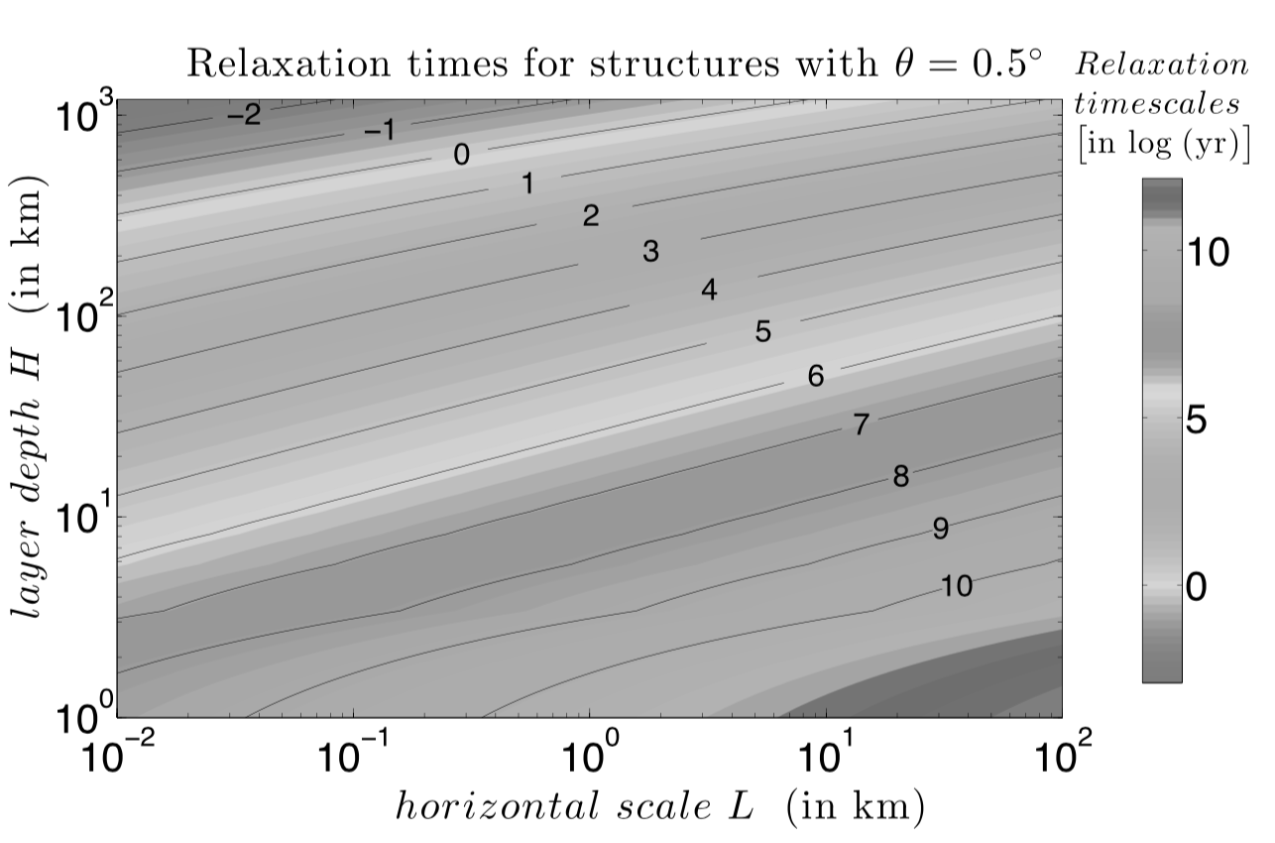
Fig 8-XX From Umurhan et al. 2017 (see Umurhan et al. 2017 for color version). Relaxation timescale for glacial flow over shallow slopes. The timescale for filling in depressions by atmospheric transport at current Pluto temperatures is about 10⁷ years. Thus, atmospheric transport is shorter (more efficient) than glacial flows for shallow deposits or deposits separated by large distances. Moreover, atmospheric transport operates even when the source and sink areas are discontinuous, as is more likely for shallow deposits and large separations.

3.3 CO cycle
CO is almost as volatile as N₂, but it is found in trace amounts in the atmosphere as a consequence of its low mixing ratio in the N₂-rich ices and the ternary phase diagram (Tan & Kargel 2018). No CO-rich ices have been detected on Pluto from either New Horizons or ground-based observations, and the strong CO bands are seen co-located with the N₂-rich ice (Schmitt et al. 2017). This is also seen in how CO and N₂ vary with sub-observer longitude in ground-based spectra, for both Pluto (Grundy et al. 2013) and Triton (Holler et al. 2016).

3.4 CH₄ cycle
Great progress has been made on the equilibrium behavior of N₂:CO:CH₄ mixtures. However, CH₄ is observed to be in disequilibrium on Pluto, and the CH₄ cycle is still not well understood. The cycles of N₂ and CH₄ are entwined, and the drivers of disequilibrium of CH₄ occurs on multiple timescales (Young et al. 2019; Trafton et al. 2019). Methane can condense at warmer temperatures than N₂. Since fresh ice of either species is probably bright, areas of high-albedo CH₄ may then be able to cool down enough to allow N₂ condensation. This process could explain the presence of N₂-rich deposits observed by New Horizons outside the deepest depressions, such as Eastern Tombaugh Regio (Bertrand et al. 2019). Also, the CH₄ cycle affects the atmospheric chemistry. In Pluto’s current atmosphere, the first step in haze production is the absorption of Lyman-alpha by CH₄. If the atmosphere becomes optically thin to Lyman-alpha, because of lower CH₄ mixing ratio or smaller surface pressure, this will fundamentally change haze formation. Since haze can alter surface properties (albedo, emissivity), this can have a positive or negative feedback on volatile cycles. Processing of the surface by energetic particles or UV photons can also affect surface properties. Thus, the CH₄ cycle is important for understanding how Pluto works.
Models of the CH₄ volatile cycle should strive to explain the following observed phenomena. (1) The atmospheric mixing ratio of CH₄ is ~0.3% (Young et al. 1997; Young et al. 2018), 10 to 100 times higher than expected by 3-phase equilibrium (where the three phases are N₂-rich ice saturated with CH₄, CH₄-rich ice saturated with N₂, and vapor). (2) The dilution of CH₄ in the N₂-rich terrains is only ~0.3 to 0.5% (Protopapa et al. 2017; Douté et al. 1999), rather than the ~4% expected for 3-phase equilibrium. (The dilution of N₂ within CH₄ is not measurable from near-IR spectra). (3) CH₄-rich terrains dominate the surface northward of 55°N, with significant CH₄-rich terrain at low northern latitudes (20°N to 35°N) (Protopapa et al. 2017; Schmitt et al. 2019). (4) The fraction of CH₄-rich ice is slightly larger in northern Sputnik Planitia, where the dilution of CH₄ in N₂-rich ice is also larger (Protopapa et al. 2017; Schmitt et al. 2019). (5) CH₄ is seen near the equator in eastern Tombaugh Regio, and in the Bladed Terrain. (6) CH₄ is seen at high altitude, particularly striking on Pigafetta Montes (previously termed Enrique Montes).

3.4.1 Enhanced CH₄ atmospheric mixing ratio
The enigma of Pluto’s high atmospheric mixing ratio has been recognized since gaseous CH₄ was first discovered on Pluto (Young et al. 1997; Spencer et al. 1997; Trafton et al. 1998). In the context of observations by New Horizons and new N₂-CO-CH₄ thermodynamics, the observed atmospheric CH₄ mixing ratio (0.28% to 0.35%; Young et al. 2018) is much higher than the CH₄ mixing ratio for 3-phase equilibrium (0.003% to 0.013%; Tan and Kargel 2018; Young et al. 2019). As reviewed in Trafton et al. (1998), two models were proposed that alternatively explain the observations, termed “detailed balance” (Trafton 1990) and “methane patch” (Stansberry et al. 1996).
The term “detailed balance” refers to a near-balance between the competing processes of sublimation and condensation on the molecular scale, all occurring in a state near thermal equilibrium, where every kinetic ice-gas transition at the surface is balanced by its inverse transition. Owing to the coupling of hydrostatic and phase equilibrium in this model, a thin layer of CH₄-rich ice is maintained dynamically on the surface of the volatile ice. In this model, CH₄- and N₂-rich ice in the layer are separately in phase equilibrium, where their equilibrium vapor pressures balance the atmospheric partial pressures at the surface. During net sublimation or deposition, this solid layer “rides” on the ice surface, with its molecular membership continuously changing. The thickness of the layer is limited by the depth to which it interacts with the atmosphere. A surface discontinuity in the ice composition thus results from satisfying hydrostatic and phase equilibrium simultaneously. N₂ may diffuse through this layer during net sublimation. However, its vapor pressure will be reduced by the ratio of the mole fraction of N₂ at the surface vs. below the layer. With fewer N₂ molecules on the surface, the N₂ vapor pressure must be lower. This detailed balance layer may be too thin to be detected spectroscopically.
One significant effect of a CH₄-rich boundary layer would be to suppress the N₂ pressure at the surface, so that the N₂ partial pressure—and therefore the total atmospheric pressure—could be smaller than that over pure N₂ ice by one or two orders of magnitude. Take for example CH₄-rich ice at 38 K, for which the CH₄ equilibrium pressure is 0.17 mPa (Fray & Schmitt 2009). For a 0.3% gaseous CH4 mixing ratio and CH₄-ice at 38 K, the N₂ pressure would be suppressed by a factor of 49, reduced from a pure vapor pressure of 2.2 Pa to a partial pressure of only 0.045 Pa (Tan, personal communication). But the measurements of Pluto’s actual surface pressure and radius from the REX Radio Experiment (Hinson et al. 2017) is consistent with a surface in equilibrium with N₂-rich or pure N₂ ice. How much could the N pressure be reduced and still be in equilibrium? As discussed in Section 2.1.2, the N₂ ice temperature is less than 41 K (p_{eq} = 10.9 Pa) from the shape of the 2.15 µm feature, and the 3-σ lower limit on the surface pressure was measured to be 0.9 Pa, for a reduction of pressure by at most a factor of 12.
Calculations of the three-phase equilibrium state of Pluto’s N₂ and CH₄ ice vs. temperature by Tan (Young et al. 2019), based on the EOS of Tan & Kargel (2018), revealed an equilibrium atmospheric CH₄ ratio several orders of magnitude lower than the ~0.3% observed (Young 2018), implying that Pluto’s ice is not in a state of three-phase thermal equilibrium, where both saturated phases of N₂ and CH₄ exist with the atmospheric gas phase. Up to this this time, the equation of state for these ices was unknown, so vapor pressures of the solid solution were approximated by Raoult’s law, which was, in some instances, an over-simplification given the easily saturated solid phases. Using the EOS of Tan & Kargel (2018) and the detailed balancing model, Trafton et al (2019) extended this calculation to the two-phase equilibrium case, covering the N₂-rich ice with an unsaturated CH₄-rich layer. They confirmed the disequilibrium for CH₄: The observed partial pressure of Pluto’s CH₄ remained far in excess of the two-phase equilibrium CH₄ vapor pressure in this model. The CH₄-rich layer would have to have a temperature of 42.5 K to explain the observed mixing ratio. This disequilibrium is likely a result of the much lower volatility of CH₄ than N₂. Moreover, as a minor constituent, CH₄ gas may not be fully in hydrostatic equilibrium.
The CH₄ patch model (Stansberry et al. 1996) considers the impact on the atmospheric CH₄ mixing ratio of pure or CH₄-rich areas, perhaps 15 K warmer than the N₂ ice temperature. As a minor species, the CH₄ mass flux is not given by energy balance (Eq 1) or by the Knudsen-Langmuir expression, but by turbulent diffusion of CH₄ through N₂:
(4-XX) $\dot{m}=-ρU_{*}C_{m}\left(χ_{z}-χ_{0}\right)$,
where $ρ$ is the atmospheric density at the surface, $χ_{z}$ is the atmospheric molar mixing ratio of CH₄ a level near the surface, z, $χ_{0}$ is the atmospheric molar mixing ratio in equilibrium with the surface (that is, the equilibrium partial pressure of CH₄ at the local surface temperature and composition divided by the local surface pressure, $χ_{0}=p_{eq,CH4}(T)/p$), $U_{*}$ is the friction velocity, and $C_{m}$ is the mass transfer coefficient. Forget et al. (2017) uses a similar formulation, $\dot{m}=-ρU_{1}C_{d}\left(q_{1}-q_{0}\right)$, where U₁ is the horizonal wind, C_{d} is the drag coefficient, and q₁ and q₀ are the mass mixing ratios at the first atmospheric layer and at the surface, respectively, defined by $q=\left(μ_{CH4}{/μ}_{N2}\right)χ$, where $μ$ is the molecular weight of CH₄ or N₂. For typical values of $U_{*}C_{m}$, turbulent diffusion is about 2000 to 10,000 times slower than Knudsen-Langmuir sublimation (as used by Moore et al. 2018). The observed atmospheric mixing ratio at the time of the New Horizons flyby was $χ_{z}$~0.3%, and models typically predict 0.001% to 1% (Bertrand et al. 2019). While modelers (Stansberry et al. 1996; Forget et al 2017; Bertrand et al. 2019) have not yet applied the new EOS results, this will have little effect on the calculated mass flux from Eq (3-XX). First consider the current atmosphere above N₂-rich ice. Even with CH₄ saturated in N₂-rich ice, the EOS gives atmospheric mixing ratios of $χ_{0}$~50 ppm; smaller mixing ratios or the use of Raoult’s law will only decrease this value. Since $χ_{z}$≈0.3%, the deposition rate onto N₂-rich ice calculated in Eq. (3-XX) depends negligibly on the value of $χ_{0}$. For sublimation of CH₄ from warm CH₄-rich patches, $χ_{0}$ is calculated from the ratio of CH₄ partial pressure at some elevated temperature to the local surface pressure (e.g., the REX measurement of 1.15 Pa). Sublimation would occur for pure CH₄ at 42.1K or hotter, but it is thermodynamically unlikely that pure CH₄ exists on Pluto. If the CH₄-rich ice were saturated with N₂, the calculated critical temperature for CH₄ sublimation would be 42.4 K, only 0.3 K warmer than if the CH₄-rich ice were pure. Considering the uncertainties in albedo and emissivity, this is a small difference. At just a few degrees warmer, $χ_{0}{≫χ}_{z}$ for all pure CH₄ or CH₄-rich terrains.
Observations appear to support some version of a warm CH₄ patch model: New Horizons directly detected distinct areas of CH₄-rich and N₂-rich ice (Schmitt et al. 2017; Protopapa et al. 2017); and models of globally isothermal N₂-rich ice and locally warmer CH₄ ice are consistent with ISO, Spitzer, and Heschel thermal measurements (Lellouch et al. 2000, 2011, 2016). Because Pluto’s thermal light curve is likely to be heavily influenced by the thermal contrast between the non-volatile and volatile terrains, it will be useful to model existing or new thermal measurements in light of New Horizons observations of albedo and surface composition, and to model separate thermal inertias for non-volatile and CH₄-rich areas.
Stansberry et al. (1996) showed that sublimation from warm CH₄ patches was, in general, much more efficient than the condensation onto N₂-rich areas, both because the mass transfer coefficient is larger for sublimation than condensation, but also because $χ_{0}$ increases exponentially with temperature. Equating the global integral of CH₄ subliming from patches to the global integral of condensation, Stansberry et al. (1996) showed cases for which a patch area of only a few percent sufficed to explain CH₄ mixing ratios between 0.2% and 1%, given N₂ ice at 40 K with patches as low 44 K and a surface pressure as low as 1.9 Pa. Lower surface pressures and mixing ratios favored lower patch areas.
However, Pluto’s surface has continent-sized CH₄ patches, as deduced from Earth-based observations and confirmed by New Horizons (Schmitt et al, 2017; Protopapa et al. 2017). Trafton (2015) argued that continent-sized CH₄ patches are too big to be explained by the CH₄ patch model. This conclusion would also apply to Pluto’s CH₄-rich polar and high latitudes, for which the CH₄-rich ice would need to be at ~42.5 K (Trafton et al. 2019) to explain the global CH₄ mixing ratio of ~0.3% (Young et al. 2018).
Thus, some version of the CH4 patch model remains a viable explanation of Pluto’s CH4 enhancement, as it is supported by the observed CH4-rich ices (Protopapa et al. 2017) and works well in some post-flyby models (Bertrand et al. 2019). Small temperature deviations from thermal equilibrium are still capable of explaining Pluto’s atmospheric CH₄ enrichment and surface pressure, in terms of warmer and cooler regional temperature deviations that give rise to the distinct CH₄-rich and N₂-rich ice deposits, respectively (Trafton et al. 2019). Thus, the detailed balance model may also play a role but with separate thermal equilibria for the N₂-rich and CH₄-rich ice, respectively, having different temperatures and possibly confined to specific regions or latitudes. However, the detailed balance model cannot explain the observed CH4 enhancement in terms of global thermal equilibrium covering both N₂-rich and CH₄-rich ice deposits simultaneously.

3.4.2 Undersaturated CH₄ in N₂-rich ices
Because all three phases exist at Pluto (CH₄-rich ice, N₂-rich ice, and vapor), in equilibrium the CH₄-rich ice would be saturated with a few percent N₂, and the N₂-rich ice would be saturated with a few percent CH₄. This is not what was seen in Hapke modeling of the New Horizons observations (Protopapa et al. 2017), in which there is only ~0.3% to 0.5% CH₄ in N₂-rich ice. The disequilibrium is aided by the longer timescale for equalizing CH₄ between vapor and ice. The equilibrium timescale is over a Pluto day in length because atmospheric CH₄ has to diffuse through N₂ (Young et al. 2019). While the long timescale can help maintain the disequilibrium, the initial cause of the disequilibrium is not yet clear. It is intriguing that the CH₄ mixing ratio in the atmosphere is the same as in the N₂-rich ice. This might have been the case had the atmosphere been escaping while being replaced by the volatile reservoir, or subsequently condensing from a large past mass. What is unclear is why this has not evolved toward equilibrium, and the answer may be a matter of timescales (Young et al. 2019).

3.4.3 Formation of CH₄-rich ice
Outside of Sputnik Planitia, there is a striking latitudinal dependence of the CH₄-rich ice. CH₄-rich ice dominates from 20°N to 35°N and 55°N to 90°N, with N₂ dominating the intervening latitudes (Protopapa et al. 2017; Schmitt et al. 2017), with the interpretation that the Pluto is showing two sublimation fronts, with N₂ subliming from low latitudes near equinox, and from high latitudes more recently (Fig 5XX, Middle).
CH₄-rich ice is also seen at high altitude in various locations (Fig 1-XX): on isolated mountaintops within Cthulhu, such as Pigafetta Montes (previously termed Enrique Montes); on crater rims and the edges of scarps west of northern Sputnik Planitia; on the uplands in the N₂-rich latitudes east of northern Sputnik Planitia (the “smooth uplands” and “eroded smooth uplands” of Howard et al. 2019b).
From the equilibrium phase diagram (Tan & Kargel 2018; Trafton et al. 2019), whether CH₄-rich ice or N₂-rich ice dominates locally depends on the direction that the thermodynamic state of the ice deviates from the globally set thermal equilibrium. When it deviates isothermally to lower pressure relative to the global equilibrium hydrostatic pressure, the CH₄-rich phase of ice forms (as the local N₂-rich ice sublimes). Conversely, when the pressure rises the N₂-rich phase forms (as the local atmospheric N₂ condenses). A similar scenario holds for the isobaric process where slight changes in temperature from equilibrium cause the same outcomes. Thus, CH₄-rich ice may form where N₂-rich ice preferentially sublimes, such as at subsolar latitudes, where the insolation is greater, or high elevations, where the equilibrium temperature is lower.
Another mechanism may be at play for equatorial CH₄-rich deposits at altitude (Bertrand & Forget 2019; see Chapter by Forget), involving an enhancement of atmospheric CH₄ (and therefore higher condensation rates of CH₄) at higher altitudes. The New Horizons UV occultations cannot constrain this, since atmospheric CH₄ was too opaque to be measured below 80 km.

3.5 H₂O and tholin-rich areas
The nonvolatile areas of Pluto are warmer by 10 to 20 K than the N₂-rich ice areas because they tend to be covered by materials with a bolometric Bond albedo near 0.1 (Buratti et al. 2017), which is much lower than that of N₂-rich areas. A positive feedback can be established, in which dark areas can get warm and continue to stay free of volatiles, while bright areas stay cold, and become volatile condensation sites.
The temperature for non-volatile-covered areas are dictated by the albedo, the emissivity, the insolation, to some extent shadowing, and the thermal inertia. All areas with very low albedos are volatile free, but not all volatile-free areas have very low albedos. If the thermal inertia and the mean insolation are both high enough then the non-volatiles will remain clear over an entire Pluto orbit. Otherwise, if a nonvolatile area becomes colder than the mean N₂ ice temperature, then the nonvolatile will become condensation sites (so there should be no location colder than the global N₂ ice temperature adjusted for altitude). Because fresh N₂ or CH₄ ice is likely to be bright, new fresh frost may allow areas to remain cold even at summer seasons. In this way, the thermal inertia may be important for the creation of annual nitrogen deposits and the transition of annual deposits into perennial deposits.

4. A Parade of Models

The processes controlling the volatile and climate cycles, described in Section 3, have been used to model the behavior of volatiles on Pluto over multiple timescales since the first volatiles were detected in Pluto spectra. In this section, we concentrate on those models with predictions for the cyclical or long-term evolution of Pluto’s volatiles. This section is roughly chronological, since there is a general pattern of new observations spurring new models of Pluto’s volatile cycles, which leave the field with new paradigms (Table 2).

Table 2-XX. Models for volatile cycles and trends
Motivating Observations | Models of volatile evolutionª | New paradigms of volatile evolution
CH₄ spectra | TS: Trafton (1980, 1981, 1984, 1989); Trafton & Stern (1983); Stern & Trafton (1984); Trafton et al. (1988), Stern et al. (1988). | Escape and replenishment of the atmosphere; vapor-pressure and hydrostatic equilibrium; mass & energy transport; conditions for a global atmosphere; atmospheric “laundering”.
Stellar occultation (1988); surface N₂, CO, CH₄ (CH4-rich and diluted in N₂-rich); surface heterogeneity; gaseous CH₄ | TS: Trafton (1989; 1990);  HP: Hansen & Paige (1996; HP96); Other: Young (1993); Stansberry & Yelle (1999); | Albedo feedback; two-volatile (N₂/CH₄) interaction; N₂ emissivity and phase change; thermal inertia; loss of summer N₂ and the importance of sub-solar latitude.
Gaseous CH₄, CO; surface N₂, CO, CH₄ (variation with time); thermal emission; stellar occultations (2002 and beyond). | TPM: Lellouch et al. (2000, 2011, 2016); VT3D: Young (2012; 2013); Olkin et al (2015);Bosh et al. (2015) HP: Hansen et al. (2015); LMD: Vangvichith 2013; TF/PlutoWRF: Toigo et al. (2010; 2015); French et al. (2015). | Low thermal inertia (diurnal skin depth); High thermal inertia (seasonal skin depth); CH₄ variation (surface and gas); atmospheric “breathing.”
New Horizons flyby, including: Composition maps on geologic spatial scales; Surface radius; Atmospheric structure, composition, and surface pressure | PlutoWRF: Moores et al. (2017); VT3D: Young et al. (2015); Lewis et al. (2019); Johnson et al. (2019). EB: Stern et al. (2017), Binzel et al. (2017); Earle et al. (2017; 2018); LMD: Forget et al. (2017); Bertrand & Forget (2016); Bertrand et al. (2018; 2019); Meza et al. (2019); | Sputnik Planitia as equatorial reservoir; role of topography; geologic expression of volatile cycles; other paths for volatile transport; albedo feedback in the equatorial regions; Milankovitch cycles; question of southern N₂; puzzle of widespread CH₄; cold CH₄ ice enabling N₂ condensation.
ª Sorted by model category: TS: Papers by Trafton, Stern. HP: Papers by Hansen, Paige. VT3D: 3-dimensional volatile transport model. LMD: Laboratoire de Météorologie Dynamique. TF: Papers by Toigo, French. EB: Papers by Earle, Binzel. PlutoWRF: National Center for Atmospheric Research (NCAR) Weather Research and Forecasting GCM. Other papers also mention volatile evolution. An emphasis is given in this table to papers with predictions of volatile behavior over various cyclical timescales.

4.1 Spurred by CH₄: The first volatile transport models
Volatile transport models for Pluto were inspired by the detection of CH₄ frost on Pluto by Cruikshank et al. (1976), the large amplitude of Pluto’s rotational light curve, and decade-long changes in Pluto’s light curve with changes in sub-solar latitude. After the discovery of CH₄ frost on Pluto by Cruikshank et al. (1976), it was assumed that there would be a CH₄ atmosphere based on the volatility of CH₄. Subsequent observations confirmed the detection of CH₄ with increasingly better resolution and data quality. Fink et al. (1980) reported an atmospheric CH₄ abundance of 27±7 m-Am (19.3±5.0 kg m⁻²; 12.0±3.1 Pa. Here and throughout we convert column densities in m-Am or kg m⁻² to pressures using the current value of surface gravity g = 0.62 m s⁻²). Cruikshank & Silvaggio (1980) estimated a vertical column of ~7 m-A CH₄ (5.0 kg m⁻²; 3.1 Pa) for an atmosphere if all the observed absorption were gaseous, but concluded that it was impossible to derive a gas abundance from the data. The first round of models studied the implications of either a massive CH₄ atmosphere, or a tenuous CH₄ atmosphere supported by the CH₄ ices, with or without another gas species. Although the CH₄ spectral signature turned out to be almost entirely due to the surface (Spencer et al. 1990; Young et al. 1997), a series of early models mainly by Trafton, Stern, and coauthors established some of the critical concepts for volatile transport on Pluto, and were motivators for the occultation observation that finally definitively detected the atmosphere.
The observed CH₄ spectral signature raised the challenge of volatile retention (See Chapter by Strobel et al.). By 1980, rough values of Pluto’s mass and radius were available. Using a steady-state model of Pluto’s atmosphere supported by the vapor pressure of CH₄ ice and a bolometric Bond albedo between 0.19 and 0.52 to constrain the ice temperature, Trafton (1980) showed that Pluto’s mass was too small to hold an isothermal CH₄ atmosphere in vapor equilibrium with an ice warmer than 45 K. The excess CH₄ would overflow the gravitational potential well (“blowoff”) and escape from Pluto. Three solutions to this dilemma were: (1) that a heavier gas (such as Ar, N₂, CO, and O₂) must be present in greater abundance to reduce the scale height enough to gravitationally bind the atmosphere, and to provide a diffusive barrier great enough to slow the escape rate (Trafton 1980, 1981) — and, in fact, N₂ dominates over CH₄ in Pluto’s atmosphere, (2) that Pluto’s surface gravity is closer to 0.51 m s⁻² than 0.30 m s⁻² (Fink et al. 1980)—in agreement with the measured value of 0.62 m s⁻², and (3) that blowoff would not occur in a non-isothermal expanding atmosphere with adiabatic cooling at altitude (Hunten & Watson 1982, Trafton et al. 1988)—and Pluto’s cold upper atmosphere as measured by New Horizons is not undergoing blowoff. These early studies established that: the movement of volatiles (escape) can fundamentally alter Pluto’s surface, as borne out by New Horizons imagery; Pluto’s atmosphere was likely a mix of CH₄ and a heavier molecule; and the behavior of Pluto’s volatiles and atmospheric mass was very sensitive to the ice temperature, and thus the seasonally varying insolation.
Seminal models describing the structure of the volatile atmospheres of Pluto and Triton (Table 2-XX) assumed both hydrostatic equilibrium and thermodynamic equilibrium for the state of the volatile ice-atmosphere system. Some of these began by taking the Fink et al. (1980) measurement of a thick CH₄ atmosphere (e.g., Trafton & Stern 1983), while others considered a range of volatile gases (e.g., Stern & Trafton 1984, N₂, Ar, CO, O₂, CH₄). These papers established several key concepts.
First, papers presented arguments for the presence of other volatiles (N₂, Ar, CO, or O₂) in addition to CH₄ (Trafton 1981; Stern & Trafton 1984). They discussed the retention and loss of various volatiles. Trafton et al. (1988) calculated that ~0.05 cm of CH₄ would be lost per orbit to escape or chemical destruction (assuming a CH₄ atmosphere with a surface temperature of 43.2 K), and concluded that replenishment is a key element of any volatile cycle.
Second, these papers derived the expressions for how surface pressures and temperatures vary across the surface, including variation with time of day or latitude (in these papers, termed the longitudinal and latitudinal tides). The variation for the latitudinal tide was derived for arbitrary sub-solar latitude in Trafton (1984). These papers found, for example, that 7 cm-Am of CH₄ (0.05 kg m⁻²; 0.03 Pa) would maintain global hydrostatic and vapor-pressure equilibrium. This established the central paradigm for Pluto’s surface and atmosphere, in which winds transport both mass and energy (through latent heat of sublimation) across the globe, maintaining a surface that is nearly isobaric and isothermal.
Third, these papers predicted that vapor-equilibrium pressures would vary by about a factor of 100 between perihelion and aphelion (a little less variation for CH₄, a little more for N₂). They posed a central question that still drives our studies of the volatile cycles on Pluto: when is global uniformity a good approximation, and when is it not? Stern & Trafton (1984) calculated that even CH₄, the least volatile of the ices they considered, should allow for global uniformity of pressure and volatile ice temperature throughout Pluto’s orbit, if the surface were evenly covered by volatile ices. If the surface were unevenly covered by ices, then freezeout could occur if only a thin veneer of temporary seasonal volatile ices existed at each pole, and sublimed from the summer hemisphere.
Fourth, the aptly titled “Why is Pluto Bright” (Stern et al. 1988) described how the seasonal cycle of volatile sublimation and deposition can drastically alter the surface appearance. Comets and other bodies are darkened as energetic particles and UV photons process ices. CH₄ in particular is converted to larger, darker, less-volatile hydrocarbons. Stern et al. (1988) calculated ~1 cm of clean CH₄ would be deposited each Pluto orbit, freshening or “laundering” the surface.

4.2 Atmosphere confirmed: The first constrained volatile transport models
An atmosphere was definitively discovered in 1988 (Hubbard et al. 1988, Elliot et al. 1989), yielding refractivity and scale height vs. distance from Pluto’s center (not vs. altitude, since the surface radius was still unknown), with the caveat of the unknown influence of hazes on the interpretation of the stellar occultation. After Pluto’s N₂ ice was discovered (Owen et al. 1993), refractivity and scale height could be interpreted as pressure and temperature. N₂ had also been detected as the dominant species in Pluto’s sister world, Triton, in 1989. The 1988 occultation, combined with other breakthrough observations in the 1990’s, allowed modeling of Pluto’s volatile cycles pinned to concrete observations. Note, however, that the true surface pressure and surface radius were not known until the New Horizons flyby, and the 1988 occultation gave only a single snapshot of Pluto’s atmosphere.
Trafton (1990) quantitatively calculated the impact of a two-component atmosphere on Pluto, N₂ and CH₄. The thermodynamics of that work were discussed in Section 3.4.1. Here, we note the predictions for the time evolution of the volatiles, namely (1) that the escaping atmosphere must be resupplied from the frozen reservoir, with the prediction that the atmospheric bulk composition should resemble that of the reservoir, and (2) for some bulk compositions, the partial pressure of N₂ will not be much different between perihelion and aphelion. Young (1993) modeled an N₂ surface and atmosphere given Pluto mutual-event albedo maps. This work derived the “girdling latitude” approach described in Section 3.2.1 to calculate sublimation wind speeds as a function of latitude. He found that pressures would drop, in one reference case, to a few mPa by 2070, at which time the sublimation winds would have to be supersonic in order to maintain an isobaric surface, likely an untenable situation. His transport model demonstrated the power of albedo feedback, in which bright areas can stay volatile-covered (and bright), even when they are close to the sub-solar latitude. The albedo feedback allows for strong albedo contrasts of bright areas covered with N₂ ice neighboring dark areas of substrate at the same latitude, as seen in mutual event and HST maps. Stansberry and Yelle (1999) describe the effect of N₂ ice emissivity, ε, on the N₂-ice temperature. In general, a lower emissivity requires a higher temperature, T. Because the low-temperature phase of N₂ ice (the α-phase) has a lower emissivity than the β-phase (Stansberry et al. 1996a; Lellouch et al. 2000), Stansberry and Yelle (1999) argued that Pluto’s atmosphere would remain at 35.6 K, the temperature of the α-β phase transition, from a few decades after perihelion through to aphelion. The latent heat difference between the α and β phases also stabilizes the N₂ frost (Duxbury & Brown 1993).
The most comprehensive and concrete model of this period was by Hansen & Paige (1996; HP96), which built on a similar model applied to Triton (Hansen and Paige 1992), in turn based on a Martian model. For 17 years, HP96 was the only model of Pluto’s seasonal behavior that included thermal inertia and mobile N₂ ice. Over 50 cases were run, with thermal inertia ranging from 42 to 2093 tiu, substrate albedo of 0.2 to 0.8, N₂-ice albedo of 0.2 to 0.8, frost emissivity (constant with phase) of 0.2 to 1.0, and an average global N₂ inventory of 50 to 200 kg m⁻². This inventory is now known to be very small compared to the N₂ residing in Sputnik Planitia (Glein & Waite 2018). An important simplification was that only N₂ was included. Seven simulations were plotted in detail (with an eighth showing an example of solstice at perihelion), showing temperatures at selected latitudes, surface pressures, albedo, and frost distribution.
The equator receives less sunlight when averaged over a Pluto year, which led Trafton et al. (1988) to predict that the perennial N₂ ice (that persists over a Pluto year) would reside within 32° of the equator. In HP96, the equator is rarely the coldest latitude, and N₂ ice jumps over the equator to the winter polar cap, leaving the equator bare (again, Sputnik Planitia was unknown at this time). Very few runs of HP96 included perennial N₂ ice (termed “permanent zonal band” in HP96). Rather, the HP96 models generally showed two polar caps exchanging volatiles, with flow from the summer to the winter cap. The thermal inertia determined the timing of the new winter pole. Most HP96 models showed a steady increase in pressure after each equinox, as the old winter pole became the new summer pole and received more direct sunlight. Then, when the last of the N₂ from the summer pole sublimed away, sometime between perihelion and northern summer solstice, the pressure plummeted. The typical HP96 model therefore showed two pressure peaks per Pluto year. Key concepts from the HP96 models were: the importance of thermal inertia, especially for the timing of the formation of winter polar caps; and that the effect of sub-solar latitude can be more important than the change in heliocentric distance (including delaying the atmospheric collapse until after perihelion).

4.3 Signs of change: Modeling the observed volatile cycles
As observations of Pluto’s surface spectra improved in quality and frequency, and laboratory data improved, it became clear that at least three surface components existed and covered large areas on Pluto: N₂-rich ice, with dilute amounts of CH₄ and CO; CH₄-rich (indistinguishable in spectra from pure CH₄); and a third component, presumably tholin (e.g., Grundy & Fink 1996; Grundy & Buie 2002; Grundy et al. 2002; Grundy et al. 2014). Rough composition maps were made by combining HST maps with the changes of spectra vs. sub-solar longitude as Pluto rotated (Grundy & Fink 1996; Lellouch et al. 2000).
Lellouch et al. (2000, 2011, 2016) modeled surface temperatures using these rough composition maps and compared results to observed thermal emission (Lellouch et al. 2000, 2011, 2016). These thermal models assumed that areas free of volatiles varied their temperatures with latitude and time of day according to thermophysical models that balance insolation, thermal emission, and subsurface conduction. Temperatures of CH₄-rich ices (or pure CH₄ ices if any) were also varied in the thermal models according to thermophysical models. As shown by Stansberry et al. (1996a), sublimation rates from CH₄-rich ice at 54 K were large enough that latent heat of sublimation slowed down further heating, so the CH₄-rich ices were capped at 54 K. The N₂-rich ice was assumed to be isothermal with location and time of day, as required by N₂’s large latent head of sublimation (Trafton & Stern 1983; Young 2012). Lellouch et al. (2000, 2011, 2016) found a surprisingly small thermal inertia for the diurnal variation, of only ~25 tiu, nearly 100 times smaller than the thermal inertia of pure water ice, the likely bedrock. This applied to the diurnal skin depth (~3 cm). The tholins in these models reached temperatures as high at 63 K, while the CH₄-rich areas reached their maximum of 54 K, 19 K above the 35 K N₂ temperature (Lellouch et al. 2000).
In 2002, two stellar occultations by Pluto were observed (Elliot et al. 2003; Sicardy et al. 2003), revealing that Pluto’s atmosphere had roughly doubled in the 14 years since the previous occultation. To many, this was extraordinary (Hubbard 2003), although, as mentioned by both Elliot et al. (2003) and Sicardy et al. (2003), this post-perihelion rise was predicted in many HP96 simulations.
As more stellar occultation observations were observed or analyzed, researchers compared trends with the predictions of HP96 (Pasacoff et al. 2005; Elliot et al. 2007; Young et al 2008; Zalucha et al. 2011; Bosh 2015; Gulbis et al. 2015; Dias-Oliveira et al. 2015). Among the runs favored by these authors (Elliot et al. 2007; Young et al 2008) were HP96 figure 6 & 7, which had small thermal inertia (42 tui) and moderate N₂ inventory (50-100 kg m⁻²). The comparisons were hampered by the uncertainty in Pluto’s surface pressure and temperature. By 2006, the trends in pressure could be used to eliminate some of the HP96 runs. The persistent questions—When will Pluto’s atmosphere begin its bulk decline? What will the pressure be for the New Horizons flyby?—could not be answered with the small number of cases presented in detail in HP96 and the many unconstrained parameters of the model.

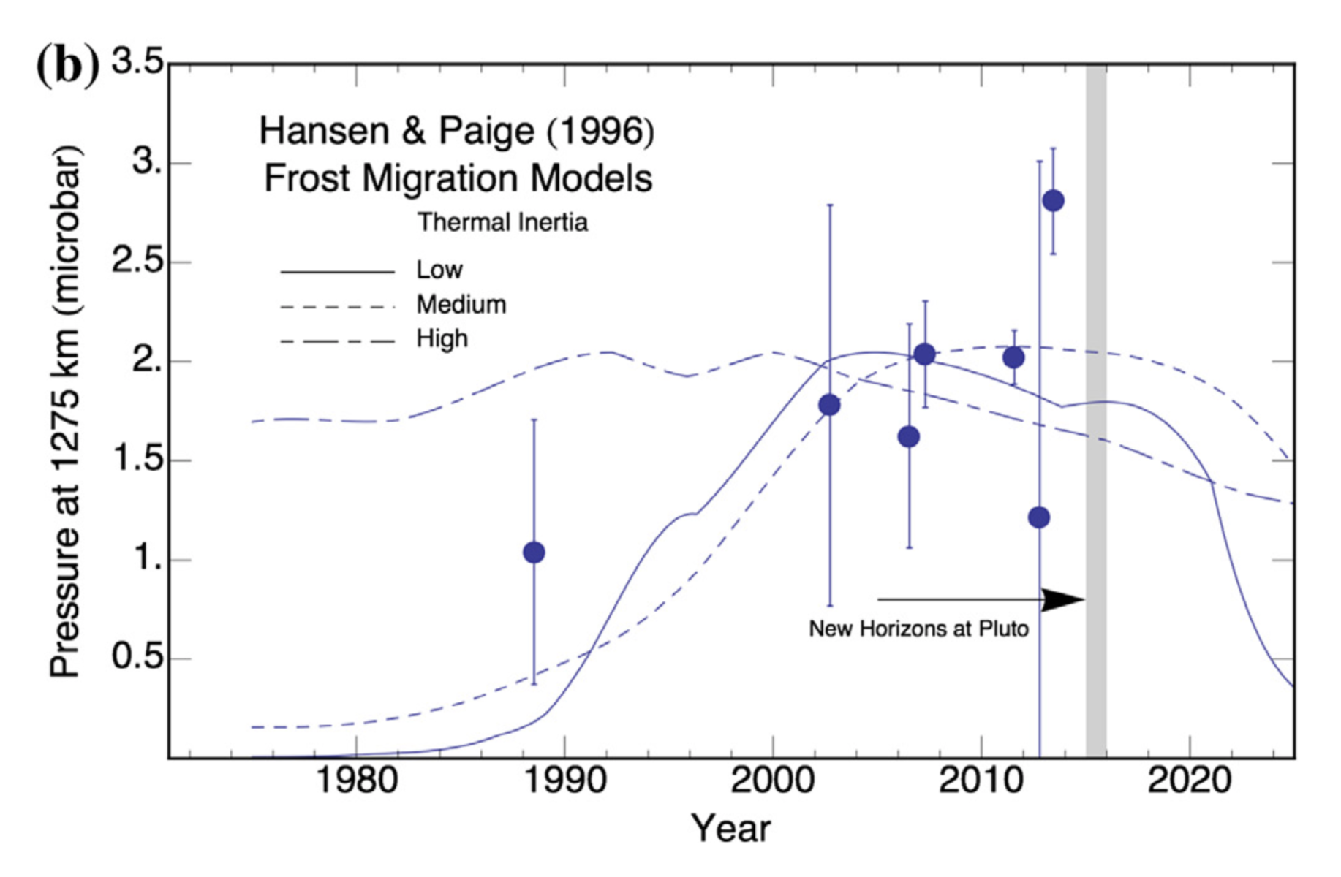
Fig 9-XX. Measurements of the extent of Pluto’s atmosphere, as determined via several stellar occultations between 1988 and 2013 from Bosh et al (2015). The frost migration model predictions of Hansen and Paige (1996) are also included, adjusting the pressure to a radius of 1275 km, to provide context for the differing measurements. The arrival time of the New Horizons spacecraft at Pluto is indicated by the grey vertical bar. (Adapted from Bosh et al. 2015).
Young (2013) developed a new model whose physics was very similar to that of HP96 (mobile N₂ ices; subsurface conduction; globally isobaric and isothermal N₂ ice), but with much faster implementation (VT3D; Young 2017). This allowed Young (2013) to cover a grid of thermal inertia from 1 to 3162 tui, N₂-ice albedo of 0.2 to 0.8, frost emissivity of 0.55 to 0.8, and an average global N₂ inventory of 20 to 640 kg m⁻². Of the 672 cases run, 52 were consistent with the 1988, 2002, and 2006 occultations, and from these, only 19 were also consistent with thermal, visible, and near-IR data. The 52 cases fell into three broad classes. One of these (Exchange with Early Collapse, EEC) had a very small N₂ inventory, in which the spatially confined northern polar cap was modeled to sublime shortly after equinox. In EEC, the peak occurred before the 2002 occultations, and the predicted pressure plummeted by 2015. The second class (Exchange with Pressure Plateau, EPP) shared many characteristics with Fig 7 from HP96 (one of the favored runs of Elliot et al. 2007 and Bosh et al. 2015): small thermal inertia (10 tui) and small N₂ inventory (8-16 kg m⁻³), an exchange of N₂ between northern and southern polar caps, two strong pressure maxima per Pluto orbit, minimum surface pressures below 1 mPa, and a peak pressure near 2002 followed by a very slow decrease. The final class (Permanent Northern Volatiles, PNV) had no equivalent in HP96, and was characterized by: high thermal inertia (typically ≥ 1000 tiu), large N₂ inventory (typically > 100 kg m⁻²); the presence of N₂ in the northern hemisphere at every point in Pluto’s orbit; one pressure peak per Pluto orbit; minimum surface pressures near 1 Pa, well above the pressure for which the atmosphere becomes local; and pressures that increase 1988 through 2015. On the basis of a 2013 occultation that showed that the pressure was still increasing (Olkin et al. 2015), the occultation record eliminated the EEC class, and favored the PNV class, which predicted pressures still rising at flyby, with surface pressures near 1.5 to 10 Pa.
Hansen et al. (2015) used the identical model as Hansen & Paige (1996), updated with new observational constraints. As discussed by Hansen et al. (2015), the physics is similar to Young (2013) and Olkin et al. (2015), but the engine was completely independent, and the set and weighting of observational constraints differed. While Young (2013) emphasized the occultation record, and the increase of occultation pressures 1988-2013, Hansen et al. (2015) emphasized the albedo record (Section 2.1.1), especially (1) that HST did not detect bright zonal bands, disallowing models where N₂ ice persisted at a given latitude over a Pluto orbit; (2) that a southern polar cap was detected before and during equinox; (3) that the northern cap was larger than the southern cap at equinox; and (4) that the infrared spectral evidence pointed toward a shrinking northern polar cap, 2001-2012. They found it very difficult to find combinations of parameters that had pressures rising past 2013 and a south polar cap in 1988. Their favored model (run 22) had a thermal inertia of 42 tiu and an N₂ inventory of 50 kg m⁻², both higher than Fig 7 of HP96, but much lower than the PNV runs of Young (2013). Similar in character to the HP96 models and the Young (2013) EPP models, Hansen et al. (2015) runs 22 and 48 had two pressure peaks, a complete exchange between summer and winter poles, and pressure minima near the local/global cutoff. Hansen et al. (2015) predicted, for the time of the flyby, a large summer polar cap extending to low-to-mid northern latitudes that would be in the process of subliming, and pressures between 0.14 and 3.2 Pa that were falling slowly.
Both Hansen (2015) and Young (2013) had trouble reconciling the occultation record with the evidence for a bright southern cap prior to and at equinox. Young (2013) did not try to reproduce that cap, and found high-thermal-inertia solutions with pressures rising past 2015, and northern N₂ ice deposits that persisted through a Pluto year. Hansen et al. (2015) required the southern cap, leading to lower thermal inertia solutions with pressures dropping slowly in 2015, pressures at flyby near 2.4 Pa, and a large but mobile northern cap. Neither model anticipated the large reservoir of N₂ in Sputnik Planitia. Both models highlight one of the persistent questions: the amount and role of volatiles in Pluto’s southern latitudes.
Several factors between the 2002 occultations and flyby inspired new studies of Pluto’s atmospheric dynamics. The anticipated arrival of spacecraft sparked interest. Several occultations showed the signature of wave-like temperature fluctuations. The seasonal models of Young (2013) and Hansen et al. (2015) could provide initial conditions, especially for the subsurface temperatures. And some simplified dynamical models could shed light on seasonal effects. Much of this is treated in the Chapter by Forget et al., and we focus here on where dynamics touch on volatile cycles. In brief, Toigo et al. (2010) and French et al. (2015) calculate the thermal tides on Pluto, quantitatively predicting vertical winds at the surface due to the diurnal cycle of sublimation and condensation. Two GCMs were developed pre-encounter (PlutoWRF; Toigo et al. 2015; LMD, Vangvichith 2013), which also ran their own predictions for seasonal volatile cycles. Vangvichith showed the interaction between the N₂ and CH₄ cycles. Toigo et al. (2015) showed double-peaked pressures over a Pluto year for lower thermal inertia, and single-peaked for higher, and suggested that the mobile ices in the PNV class of Young (2013) would become static if the model were run for more Pluto years. As with Young (2013) and Hansen et al. (2015), the PlutoWRF and LMD models pre-encounter could not anticipate the N₂ reservoir of Sputnik Planitia (although some of their simulations used the joint spectra/HST maps that include an equatorial N₂ source near 180° longitude). The themes of southern N₂, perennial vs. seasonally mobile ices, diurnal tides, minimum pressure, and entwined N₂-CH₄ cycles all proved to be as important after the New Horizons flyby as they were before.

4.4 Pluto Volatiles after New Horizons
In Table 3-XX, we list those post-encounter models which calculated sublimation/condensation rates or changes volatile distributions or surface pressures. These are organized roughly by research group, to more clearly show the hierarchy of models. We present these in this section in roughly chronological order, emphasizing their assumptions, and their broad conclusions, particularly how they alter our understanding of the processes most affecting Pluto’s interacting surface and atmosphere. A consolidated summary of the model results sorted by the different timescales is given in Section 5.

Table 3-XX. Post-encounter models for volatile cycles and trends
Model | Diurnal | Seasonal | Milankovitch | Topography | Subsurface Conduction | Mobile N₂ | CH₄ | Resolution (km) | Tuned to occultations
Moores et al. (2016) | Yes | Yes | Yes | No | Yes | Yes | No | XX | Yes
Earle et al. (2017) | No | Yes | Yes | No | No | No | Yes^{d} | 20 | No
Stern et al. (2017) | No | Yes | Yes | No | No | No | Yes^{d} | 150 | No
Earle et al. (2018) | No | Yes | Yes | No | No | Yes | Yes^{d} | 10 | No
Young et al. (2015) | No | Yes | No | No | Yes | Yes | No | 208 | Yes
Lewis et al. (2019) | No | Noª | No | Yes | No | No | No | 1 | Yes
Johnson et al. (2019) | No | Yes | Yes | No | Yes | No | No | 1 | Yes
Bertrand & Forget (2016) | Yes | Yes | No | Yes | Yes | Yes^{c} | Yes | 190 | Yes
Forget et al. (2017) | Yes | No^{b} | No | Yes | Yes | Yes^{c} | Yes | 190 | Yes
Bertrand et al. (2018) | Yes | Yes | Yes | Yes | Yes | Yes | No | 63&190 | No
Bertrand et al. (2019) | Yes | Yes | Yes | Yes | Yes | Yes | Yes | 190 | No
Meza et al. (2019) | Yes | Yes | No | Yes | Yes | Yes^{c} | Yes^{e} | 95 | Yes
Bertrand et al. (2020) | Yes | Yes | No | Yes | Yes | Yes | Yes | 63&190 | XX
ª Snapshot of mass fluxes at flyby. ^{b} Calculated on timescale of several earth decades. ^{c} N₂ allowed to be mobile, but evolves to a static configuration. ^{d} N₂ and CH₄ modeled independently. ^{e} CH₄ is implemented, but does not interact with the N₂ cycle in practice.

4.4.1 First models of Sputnik Planitia
Sputnik Planitia changed everything. The presence of a reservoir of N₂-rich ice in the diurnal zone affects the volatile and climate cycles on all timescales, from non-cyclic, to Milankovitch cycles, Pluto’s seasonal cycle, or Pluto’s day.
In pre-encounter models (Young, 2013; Hansen et al. 2015), surface pressures plummeted when the last of the N₂ ice left the summer hemisphere, because the globally averaged insolation onto the N₂ ice dropped to nearly zero. But on the real Pluto, the N₂-rich Sputnik Planitia straddles the equator, and so there is some insolation onto N₂-rich ices every Pluto day. Early post-flyby models that imposed an N₂-ice reservoir at Sputnik Planitia (Young et al. 2015) showed that adding this reservoir delayed the sublimation from the summer hemisphere and raised the minimum pressure for a sample case with low thermal inertia (Young 2013/EPP14, with 3 tui), but had little effect on the volatile distribution and pressures for a case with high thermal inertia (Young 2013/PNV23, with 1000 tui).
Researchers soon recognized that Sputnik Planitia was a natural place for N₂ to accumulate, both because of its low elevation (Stern et al. 2015; Moore et al. 2016; cf. Section 3.2.3) and its lower insolation, averaged over a Pluto year (Hamilton et al. 2016; cf. Section 3.1.2).
Two important early models (Forget et al. 2017; Bertrand & Forget 2016, hereafter BF16) included an idealized Sputnik Planitia as a circular depression, 3.8-km deep and 1000 km wide. These papers arose from Laboratoire de Météorologie Dynamique (LMD), which developed two related volatile transport models: a full Global Climate Model (GCM; Forget et al. 17; Chapter by Forget et al.); and a reduced version that used a simple global mixing function for N₂, CH₄ and CO in place of 3D atmospheric transport and dynamics (BF16). These two models were complementary. The reduced model ran much more quickly, and was therefore suitable for simulations on the timescale of Pluto’s 248-year orbit to 10’s of thousands of years. The reduced model was used to initialize the surface ice distribution and sub-surface temperatures for the GCM. The GCM calculated the transport between surface and atmosphere, and within the atmosphere from one location to another, on the timescale of Pluto’s day to several Earth decades. Tests done with the GCM determined the timescales for atmospheric transport of CH₄ (10⁷ s, about 4 Earth months) and N₂ (1 s, instantaneous mixing) used in the reduced model.
The main result from Forget et al. (2017) for the purpose of this chapter was that the cold atmospheric layer seen the lowest kms above Sputnik Planitia was due, in part, to the daytime sublimation of N₂ over Sputnik. The winds and atmospheric temperature results from the GCM in F17 are covered in the Chapter by Forget et al.
The seasonal model of BF16 captured many of the important points of Pluto’s surface volatiles: a migration of N₂ into the Sputnik Planitia basin after several thousands of years; the role of Sputnik Planitia as the dominant N₂ reservoir, the presence of CH₄-rich ice at higher latitudes, and volatile-free areas near the equator. The model predicted seasonal variation in the CH₄ distribution, with the northern CH₄ cap disappearing by 2030.
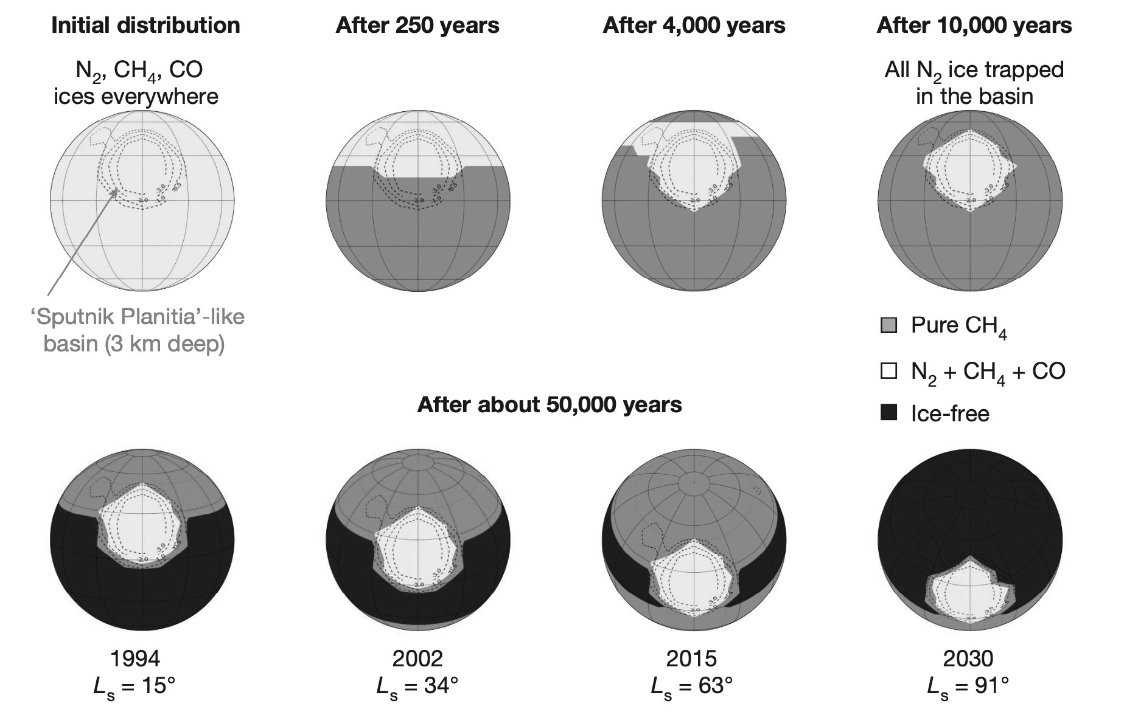
Fig. 10-XX. Surface maps from the reference simulation of BF16 with thermal inertia = 800 tiu. Top: The evolution beginning with all ices uniformly distributed. Bottom: Four views of the seasonal evolution of the CH₄ ice (the N₂ ice remains sequestered in Sputnik Planitia). See Bertrand and Forget (2016) for the original figure (in color).
BF16 were also able to find combinations of thermal inertia and N₂-ice albedo that reproduced the surface pressures seen by New Horizons and the occultation record (Fig 11-XX). These models favored high thermal inertias for roughly the upper 40 m of the subsurface; the reference model was 800 tiu, and the BF16 model ruled out thermal inertias lower than 500 tui.
Surface pressures were modeled by BF16 to peak near 2015. It is intriguing to think that we can test this observationally to measure the time of the peak pressure from occultations, looking for a zero or negative slope. Care must be taken in this search. Measuring a slope is more difficult than measuring a value. This is exacerbated because different methods for measuring the pressure have yielded different results (Section 2.1.3). The temperature template method of Dias-Oliveira et al. (2015) is robust and uses the entire lightcurve, and is a good method for as long as the temperature profile stays steady.
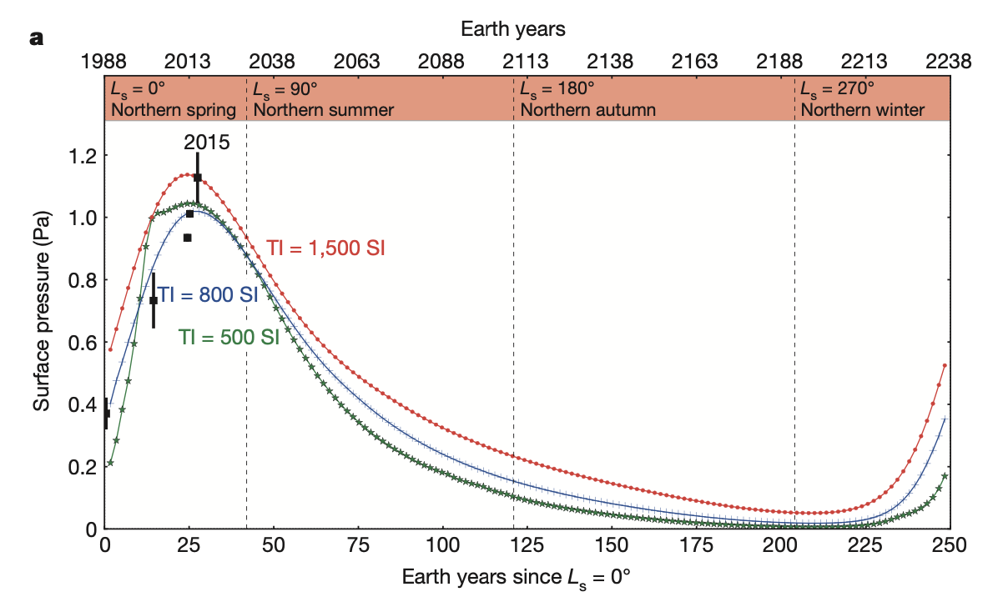
Fig. 11-XX. Surface pressure Ps for three scenarios, for which the N₂ ice albedo and emissivity were chosen to yield a surface pressure near 1–1.1 Pa in July 2015. Black squares show Ps measured by stellar occultations, extrapolated to Pluto’s surface pressure.

4.4.2 Geological considerations
Pluto’s geology revealed evidence of ongoing, recent, or past volatile cycles (See Chapter by Moore & Howard). These include: cryovolcanism (Wright and Picard Mons); the pits within Sputnik Planitia; the albedo variations within Sputnik Planitia; possible wind streaks and dunes in western Sputnik Planitia; high-altitude methane deposits; N₂ glaciers flowing into eastern Sputnik Planitia from the neighboring highlands; km-wide ridged of CH₄-rich ice in the Bladed Terrain Deposits; the smooth Alcyonia Lacus; albedo contrast in the equatorial regions (maculae vs. Tombaugh Regio); evidence for thick, eroded CH₄-rich mantles in Pioneer and Hayabusa Terrae northeast of Sputnik Planitia; and erosional valleys north and northeast of Sputnik Planitia. The rich geology at Pluto proved that, once again, our imaginations were less varied than reality. Pre-encounter, modelers considered volatile transport involving sublimation/condensation and atmospheric winds. Pluto’s volatile transport additionally include: large-scale convection within Sputnik Planitia; ancient and present-day glacial flow; liquification of N₂ at the base of ancient or current deep N₂ ice, and possible ancient cryovolcanism.
Some of the geologic features motivated the possibility that Pluto’s pressure may have been much higher in the past. The importance of the Milankovitch cycles was re-enforced by Pluto’s latitudinal variation in albedo (Binzel et al. 2017), which raised the possibility that obliquity and L_{S,peri} could be important for Pluto’s volatile cycles. This was investigated by Earle et al. (2017) and Stern et al (2017), who defined polar caps extending to ±45°, ±60°, or ±75°, and, in Stern et al. (2017), a rectangular Sputnik Planitia 45° wide from 45° N to 30° S. Given emissivity of 0.6 or 0.9, and albedo from 0.1 to 0.6, these models calculated pressures vs. time for three epochs: the current epoch; extreme northern summer 0.9 My ago when perihelion coincided with northern summer solstice; and extreme southern summer 2.35 My ago when perihelion coincided with southern summer solstice. They found that the Milankovitch cycles can have a significant effect, which has been borne out by future modelers. Their specific conclusions, that pressures could be much higher than the current pressure (10s or 100s of mbar) depends on a mechanism (unidentified for Pluto’s current Milankovitch cycle) for maintaining N₂ at Pluto’s poles.
The relationship between geology and the Milankovitch cycles (Binzel et al. 2017) was explored quantitatively by Earle et al. (2018) who explored the stability of N₂ and CH₄ ices. N₂ and CH₄ were modeled independently, treating each in turn as the dominant volatile. For the N₂-cycle, they found two very different styles of variation, depending on albedo. For dark N₂ ice (A < 0.3), the equator lost its N₂, and the seasonal cycle was an exchange of N₂ between northern and southern polar caps. For bright N₂ ice (A > 0.6), there was still some exchange of the polar caps, since the deposition rate onto a latitude in artic night is independent of albedo. However, the main result for bright N₂-rich ice was that the N₂ was trapped near the latitudes where the annual insolation was least. Thus, for high obliquity (103°, 0.9 Myr ago), when the insolation minimum was at the equator, the N₂-ice distribution was sharply peaked around the equator, mainly confined to ±30°. For low obliquity (126°, 2.35 Myr ago), when the insolation minimum was at ±30°, the N₂-ice distribution was very broad, with maxima near ±45°. Comparing the low and high albedo cases, Earle et al. (2018) concluded that, qualitatively, N₂ ice was subject to runaway albedo at low- to mid-latitudes. Both dark area free of N₂-free (such as Cthulhu), and bright, N₂-rich areas (such as Tombaugh Regio) were found to the stable near the equator on million-year timescales. While Pluto’s volatiles are not dominated by CH₄, the CH₄-dominated cases are interesting because they treated the darkening of ices with time due to haze deposition, and the subsequent brightening when new ice is laid down. The results showed that runaway albedo may get triggered over a single Pluto season.
The Bladed Terrain may be a sublimation effect, in analogy with terrestrial penitentes (Moores et al. 2016; Moore et al. 2018; see Chapter by Moore and Howard). This motivated the climate calculations in Moores et al. (2016), using the PlutoWRF GCM engine described in Toigo et al. (2015). Moores et al. incorporated some new model simulations based on early Pluto results, including some latitudinal information but no topography. Their models predicted not just pressure vs. time at different epochs of Pluto’s Milankovitch cycles, but also parameters related to the growth of penitentes. Their result that the pressure is a maximum near equinox may be related to early Pluto results, later-revised. However, they also show the importance of the Milankovitch cycles for Pluto climate studies, and its geologic expression.

4.4.3 N₂ cycles on seasonal and Milankovitch timescales
Higher resolution New Horizons products followed, in 2017 and 2018, including the near-surface pressures vs. altitude, and high-resolution geologic, topographic, color, and composition surface maps (See Section 2.2).
Using these products, Bertrand et al. (2018; B18) modeled the N₂ cycle on Pluto with a model based on BF16, including thermal conduction into the substrate. Additions were the Milankovitch cycles, topographic information, glacial flow, a larger N₂ inventory, and higher spatial resolution for some runs focused on Sputnik Planitia. Simplifications include averaging insolation over diurnal cycle (which should have minimal impact; Young 2012), and consideration of a small set of thermal inertia (generally 800 tui, with a few cases at 400 or 1200 tui) and albedo (generally 0.7, with a few cases at 0.4). B18 also included much larger amounts of N₂ inventory than in BF16, which takes much longer to equilibrate. Thus, B18 considered two related problems: a study of the sublimation patterns within Sputnik Planitia, run at higher spatial resolution, with an initial distribution of N₂ confined to the Sputnik Planitia basin; and a study of the stability of N₂ outside Sputnik Planitia, with a variety of initial N₂ distributions.
The results of the Sputnik Planitia study are summarized in Fig 11-XX, on seasonal, and Milankovitz timescales. The observed north-south pattern of albedo, grain size, and CH₄ abundance (Protopapa et al. 2017) may be related to the movement of N₂ from the north to the south within Sputnik Planitia for the last 30 years. The modelled seasonally averaged transport was in the opposite sense, predicting a net sublimation at 20°S to 10° N, and have been for 0.1 Myr—a timescale and location commiserate with the pits within Sputnik Planitia. The modeled ice sheet varied on Milankovitch timescales. From 1.3 to 0.1 Myr ago, B18 predicted that the center of Sputnik Planitia accumulated N₂, so that that the ice sheet currently covers a minimum area. The modeled rise and fall of the edges of Sputnik Planitia, especially the northern boundary, may have contributed to erosion of the water-ice border, particularly near Al-Idrisi. Averaged over a 2.9-Myr obliquity cycle, B18 found that Sputnik Planitia lost 1 km from its northern edge, and 0.15 km from its southern edge, with net transport to the center, accompanied by glacial flow to and from the central latitudes.
The experiments of B18 on N₂ stability included N₂ inventories of with global averages of 200 m, 500 m, or 1000 m (2 x 10⁵, 5 x 10⁵, or 10⁶ kg m⁻²), consistent with the expected volume of Sputnik Planitia (Glein and Waite 2018), with initial distributions of N₂ that were global, confined to low latitudes, or confined to high latitudes. All simulations quickly filled the Sputnik Planitia basin within 6 to 30 Myr. In many simulations, N₂ was stable at the equator for 10s of Myr, especially for large N₂ inventories. The N₂ was never found to be stable at high latitudes.
B18 also found the pressure over Milankovitch cycles varied between 10 mPa and 10 Pa for the nominal A = 0.7. For darker N₂ ice, A = 0.4, the pressure range was higher, ranging between 1 and 100 Pa.
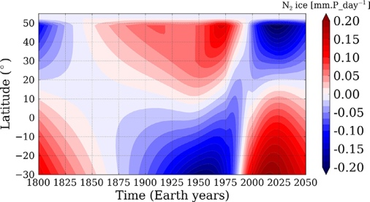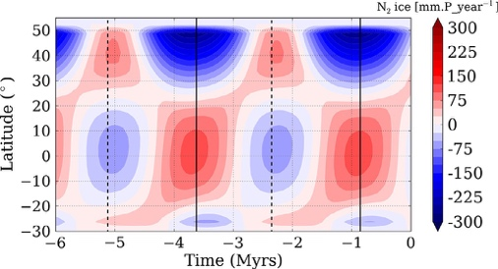
Fig 11-XX Left: Evolution of the diurnal mean condensation-sublimation rate within Sputnik Planitia (mm per Pluto day; red is condensation), in current orbital conditions, from 1800 to 2050 assuming that the glacier remains flat. Right: Evolution of the annual mean condensation-sublimation rate of N2 ice with time (mm per Pluto year; red is condensation), assuming that the glacier remains flat (same as Fig. 8. The vertical solid and dashed lines correspond to the periods of high (104°) and low (127°) obliquity, respectively
Lewis et al. (2020) calculated energy balance and mass fluxes using high-resolution maps of bolometric albedo (Buratti et al. 2017) and N₂ presence (Schmitt, personal communication), based in part on the CH₄ spectral shifts, and extrapolating ice coverage to unmapped areas. By matching the observed 2015 surface pressure, they derived N₂ emissivity of 0.47-0.78, with the exact value dependent on assumptions of the unmapped hemisphere (the non-encounter longitudes, and the southern latitudes). From this, they produced a map of the current sublimation and condensation rates. Like B18, they found a trend of north-to-south transport within Sputnik Planitia, similar to B18. However, the maps of Lewis et al. (2020) also included N₂ observed to be outside Sputnik Planitia. They found high sublimation rates of 3 g cm⁻² yr⁻¹ (0.52 mm (Pluto day)⁻¹) for N₂ at mid latitudes.
Johnson et al. (2020) used similar maps as Lewis et al. (2020), and calculated pressure vs. time over a Pluto year given four assumptions of a static N₂ ice distribution (Fig 12-XX). This work made a systematic search over albedo (A), emissivity (ε), and thermal inertia (Γ). This work identified those triplets of A, ε, and Γ that satisfied the New Horizons pressure constraints (surface pressure 1.15 Pa) and 1988 pressure constraints (3.14 > P₂₀₁₅/P₁₉₈₈ > 1.82). The motivation for this work was to study the minimum pressures reached over Milankovitch timescales, to see if haze production would be disrupted. They found that most models had minimum pressures greater than 6 mPa, although a few cases with smaller minimum pressures were possible.
While the LMD models in Meza et al. (2019) formally include CH₄ ice, we treat them in this section. The three simulations with rising pressures 1988-2015 in Meza et al. (2019) had perennial N₂ in Sputnik Planitia and in the depressions in the northern hemisphere, with low-albedo CH₄ ice (A_{CH4} = 0.5). Because of the low-albedo (and therefore warm) of CH₄ ice, there was very little seasonal deposit of N₂ ice. In the southern hemisphere, the CH₄ deposits were very thin and the albedo remained low. Thus, the N₂ ice distribution in Meza et al. (2019) was essentially static, and directly comparable to the runs of Johnson et al. (2020). In these runs (Meza et a. 2019), the surface pressure peaked between 2020 and 2025 (Fig 12-XX), because of the many perennial N₂ deposits in the northern hemisphere and almost no condensation in the southern hemisphere. Differences between the Meza et al. (2019) and Johnson et al (2020) predictions likely arose from the differences in the observational constraints. To some extent, the spatial resolution may play a role, since many of the N₂-rich mid-latitude depressions were observed to be 10s of km across.
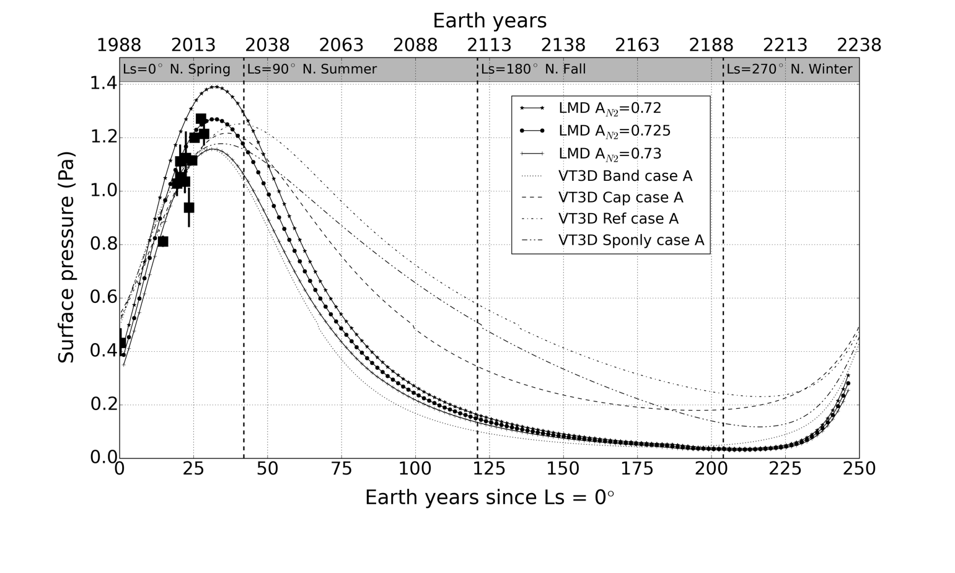
Fig 12-XX. Dashed: four models of pressure over a Pluto season for four assumptions of a static N₂-ice distribution from Johnson et al. (2020): Sputnik only (Sponly); the N₂-presence map of Lewis et al. (2020) (Ref); the N₂-presence map plus a southern N₂ polar cap (Cap); or the presence map plus a southern N₂ mid-latitude band (Band). Solid: Three models of pressure over a Pluto season from Meza et al. (2019).

4.4.4 N₂ - CH₄ cycles on seasonal and Milankovitch timescales
Bertrand et al. (2019) addressed Pluto’s climate with both the N₂ and CH₄ volatile cycles. Surface units are treated as either volatile-free, N₂-rich with 0.5% CH₄, or pure CH₄. In reality, the CH₄ mixing ratio within N₂-rich ice was observed to vary with location on Pluto (Protopapa et al. 2017), which is not tracked by this model. As described in Section 3.4.1, this simplification should have little effect on the calculated N₂ or CH₄ mass fluxes over N₂-rich areas or the CH₄ mass fluxes over CH₄-rich areas. The last combination, N₂ fluxes onto CH₄-rich areas, is more problematic. For condensation, the model simply assumes that a cold CH₄-rich area can become a N₂ condensation site when the temperature is low enough, at which point the area is modeled as N₂-rich. N₂ sublimation from CH₄-rich areas is not modeled. This model explored the complex ways in which modeled changes in surface albedos, emissivities and thermal inertias affected volatile transport, surface distributions, and atmospheric pressure and composition. Bertrand et al. (2019) presented a variety of runs to show the range of modeled outcomes; in Meza et al. (2019), runs were fine-tuned (e.g., in N₂ albedo) to match the occultation record.
This work demonstrates the challenge of how to explain the observed wide-spread presence of CH₄ outside of Sputnik Planitia, as models such as this predict that CH₄ would accumulate in Sputnik Planitia on the timescale of several My if CH₄ were allowed to condense into Sputnik Planitia. The mechanism for preventing all the CH₄ from accumulating into Sputnik Planitia in unknown, but Bertrand et al. (2019) speculate that the mixing state of the upper layers of the volatiles may be responsible (Section 3.4). It may also be related to the cycle of net N₂ into or out of Sputnik Planitia on mega-seasonal timescales (Bertrand et al. 2018, 2019).
Initializing Pluto with N₂ in Sputnik Planitia and a globally uniform distribution of 4 m of CH₄ and a uniform CH₄ albedo (Bertrand et al. 2019; their Section 3), the CH₄ is modeled to slowly migrate to the equator at a rate of roughly 3 m My⁻¹, mainly by loss of CH₄ from the poles. If the CH₄ ice is more mobile (darker CH₄ albedo, or lower substrate thermal inertia), then the modeled equatorial deposits are wider. Their extension into mid-latitudes depends on the season at perihelion: the short intense northern summers of L_{s,peri} = 90° (northern solstice at perihelion) drives CH₄ to accumulate south of the equator, and vise-versa (Fig 13-XX).

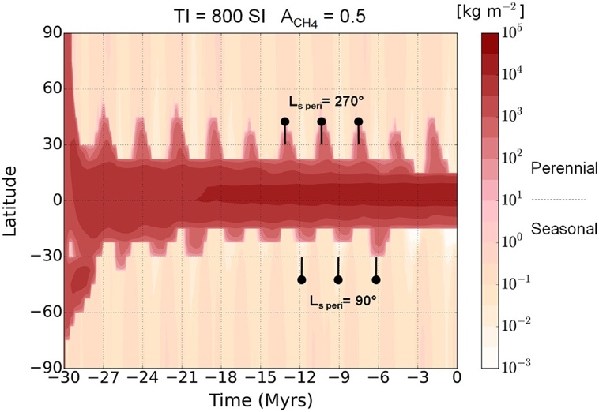
Fig 13-XX. Example run for an initially global CH₄ with A_{CH4} = 0.5, showing the zonal annual mean of CH₄ outside of Sputnik Planitia.
An alternate initial state (Fig 14-XX, panel 1) also began with N₂ in Sputnik Planitia, but included an infinite reservoir of CH₄ roughly at the latitudes of the bladed terrains (excluding Cthulhu). This initial state represented the bladed terrains as a perennial CH4 source. These runs allowed different CH₄ albedos for equatorial CH₄ vs. CH₄ at mid-latitudes or the poles. Fig 14-XX attempts to bring some order to the large variety of outcomes. For the class of runs with dark equatorial CH₄, (A_{CH4,eq} << 0.6, Fig 14-XX, panel 2), the CH₄ remained too warm for N₂ condensation. At mid-to-hight latitudes, dark CH₄ was not stable against sublimation, and formed only thin seasonal deposits. This class appeared to match the occultation record. Whether or not this class is viable depends critically on whether the observational evidence is for perennial or seasonal N₂ or CH₄ deposits at mid-to-high latitudes.
For the class of runs with bright equatorial CH₄ (A_{CH4,eq} >> 0.6, Fig 14-XX, panel 3), N₂ was able to condense on the bladed terrains and remain very stable in these equatorial regions. N₂ thus covered CH₄ and shut down the CH4 cycle. N₂ is stable at the equator. No volatiles were seen outside of the equator in these models, either seasonal or perennial. This did not match the volatile distribution seen at Pluto.
For the class of runs with moderately bright equatorial CH₄ (A_{CH4,eq} ≈ 0.6, Fig 14-XX, panels 4 and 5), N₂ was able to condense onto equatorial CH₄, but only in depressions, leaving high-altitude areas CH₄-rich, as observed. If the run also had dark mid-latitude/polar CH₄ (A_{CH4,polar} << 0.6, Fig 14-XX, panel 4), then the CH₄ can form seasonal deposits at mid-to-high latitudes. If the run has bright mid-latitude/polar CH₄ (Fig 14-XX, panel 4), the N₂ was able to condense onto it, trap more CH₄ and result in more perennial CH₄ ice deposits at mid latitudes (the CH₄ deposits remained seasonal at the poles in all cases). The moderately bright equatorial, bright polar CH₄ class reproduced some of the observed trends in surface volatiles: N₂ in depressions; seasonal N₂ and CH₄ at midlatitudes; and seasonal N₂ at the poles.
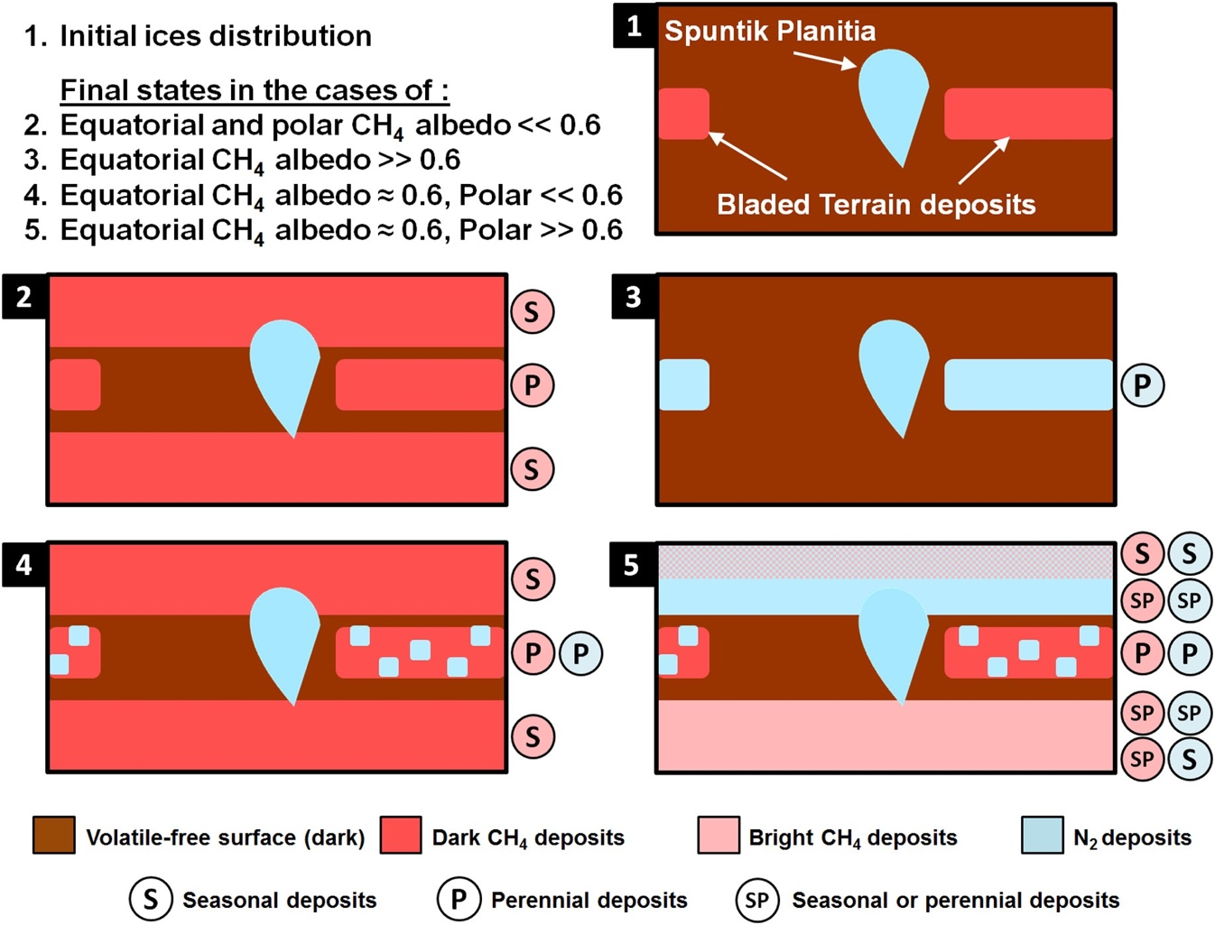
Fig 14-XX. Summary of the simulation results for runs with that were initialized with N₂ in Sputnik Planitia, and an infinite reservoir of CH₄ at the latitudes of the bladed terrain (Bertrand et al. 2019; their Section 4).

5. Volatile Transport at Short and Long Timescales
In this section, we summarize the results of the preceding models on several timescales (Table 1-XX). We avoid the term “secular,” which can be applied both to evolutionary changes over 4 billion years, and observed changes on decadal timescales. Sputnik Planitia dominates much of the movement of volatiles at all timescales. Outside Sputnik Planitia, describing the volatile cycles becomes messy, since the surface pressure is heavily influenced by the distribution of N₂, but the N₂ cycle is difficult to separate from the CH₄ cycle.
The various times scales (Table 4-XX) are intertwined as well. The astronomical cycle fills in Sputnik Planitia, and the presence of Sputnik Planitia affects all of the cycles. This includes the migration of CH₄ to form deep mantles. The location and albedo of the large methane reservoirs affect the growth and ebbing of perennial deposits. The locations of perennial deposits together with seasonal deposits affects the annual motion of the pressure.
Where possible, we emphasize observational constraints. Complementary perspectives on volatile processes can be found in other chapters: the Chapter by Forget et al. covers many issues relating to the diurnal cycles, and the Chapters by White et al. and Moore et al. covers aspects of the volatile activity on astronomical timescales.

Table 2-XX. Timescales for volatile transport
Timescale | Cycle Duration | Examples
Non-cyclical (aka evolutionary) | 10 Myr to 4.5 Gyr duration, not cyclic. | Infilling of Sputnik Planitia; atmospheric escape; formation of Bladed Terrain Deposits
Milankovitch cycles,(aka orbit/pole, obliquity, longitude cycles, mega-seasons) | 2.8 Myr obliquity cycle; 3.7 Myr eccentricity and libration of argument of perihelion | Variation of pressure extreme; Sputnik Planitia shorelines & erosion; Northern boundary of Bladed Terrain; glacial flow.
Seasonal (aka orbital, annual) | 248 Earth years | N-S flow within Spunik Planitia, Pressure changes; transport of seasonal volatile ice
Diurnal (aka rotational, daily) | 6.4 Earth days | Cold troposphere above Sputnik Planitia

5.1 Non-cyclical timescales
A singular event in Pluto’s volatile history is the infilling of Sputnik Planitia. If Sputnik formed as an impact basin (Moore et al. 2016) in its current location, then the combined effects of enhanced condensation in a topographic low and insolation minima near the equator would cause Sputnik Planitia to fill in about 10 Myr (Bertrand et al. 2018), or a rate of ~1 km Myr⁻¹ (10⁶ kg m⁻² Myr⁻¹). Some modelers find that the insolation effect might be enough, without an impact basin (Hamilton et al. 2016). Some model runs found that N₂ could be temporarily in low latitudes outside of Sputnik Planitia for 10s of Myr, before finally condensing into Sputnik Planitia.
CH₄ is much less mobile than N₂. CH₄ also preferentially condenses near the long-term average minimum insolation, but it does it slowly (Bertrand et al. 2019), at a rate near 1 m Myr⁻¹ (10³ kg m⁻² Myr⁻¹). The latitudes at which CH₄ was modeled to condense coincides with the latitudes of the Bladed Terrain Deposits on the encounter hemisphere (Bertrand et al. 2019). The modeled CH₄ deposits tend slightly north of the equator, as do the latitudes of the Bladed Terrain Deposits on the encounter hemisphere. . At these slow rates, the it would have had to take millions of years to build up the Bladed Terrains to the observed depths of 100s of meters. Even though CH₄ is less mobile than N₂, it still remains a puzzle why CH₄ is not also mainly sequestered within Sputnik Planitia. In simulations over 10’s of Myr (Bertrand et al. 2019), there can be two reservoirs of CH₄: either at low latitudes similar to the Bladed Terrain; or at mid-latitudes, similar to the CH₄-rich mantled terrains. However, only one reservoir is stable at a time. In the current epoch, models suggest (Bertand et al. 2019) that the low-latitude CH₄ is subliming, feeding the mid-latitude CH₄ and carving out the blades of the Bladed Terrain. At rates of 1 m Myr⁻¹, ff there is a cyclic exchange between low and mid-latitude CH₄, it must occur over 100s of Myr. The mechanism for such a cycle is unclear.
Prior to the New Horizons encounter, the escape of volatiles over the age of the solar system was expected to be a major component in shaping the landscape of Pluto. This picture was changed by two discoveries. First, the escape rate of N₂ (~5 x 10²² N₂ s⁻¹; Young et al. 2018) was ~3000 times lower than expected pre-encounter (Gladstone et al. 2017). The major escaping species was found to be CH₄ (~6 x 10²⁵ CH₄ s⁻¹; Young et al. 2018), which was also escaping too slowly to sculpt the landscape. Precipitation of hydrocarbons and nitriles have been shown to be a more significant sink of volatiles than escape (Krasnopolsky 2020).

5.2 Milankovitch cycles
Since the flyby, there has been a new appreciation for the impact of the Milankovitch cycles, particularly the 2.8-Myr obliquity cycle, and the variation of the solar longitude at perihelion (varying by 360° over 2.8 Myr, with a secondary 24° oscillation over 3.95-Myr). Even without any variation in the distribution of volatiles, the changing insolation would affect the seasonal variation of atmospheric pressure (Earle et al. 2017; Meza et al. 2019; Johnson et al. 2020). In Pluto’s current epoch, and for the previous 30 Myr, the minima and maxima vary with obliquity. The details depend on the parameters in the model runs, but the pressure generally remains between 1 mPa and 100 Pa (Bertrand et al. 2018, Johnson et al. 2020). This implies that, for the great majority of parameter space, Pluto’s atmosphere remains global its entire season over multiple obliquity cycles, and sublimation winds are able to keep N₂ ice temperatures nearly isothermal. It also suggests that the geologic evidence for periods of high surface pressure (Stern et al. 2017) were not made recently (Bertrand et al. 2018). Alternatives include higher pressure very early in Pluto’s evolution, or ancient flows at the bottom of deep glaciers (Bertrand et al. 2018).
However Sputnik Planitia was established, it is now a deep reservoir of N₂ straddling Pluto’s equator, experiencing insolation changes. The difference in insolation at the northetn and southern extremes of Sputnik Planitia vs. its center causes variation of up to 300 m of the elevations of the edges of the ice sheet (Bertrand et al. 2019). In the current epoch, the ice sheet is close to its minimal extension, with depressions at the northern and southern boundaries. The center also rises and falls each obliquity cycle (Bertrand et al. 2018), which is balanced by glacial flow from the center to the extremes. The deep pits within Sputnik Planitia probably formed on timescales of 100,000 yr (Buhler and Ingersoll 2018)—longer than Pluto’s orbit, but short on Milankovich timescales. A snapshot of the annually averaged insolation suggests a correlation between pit formation (a sublimation process, see Chapter by Moore) and so the latitudes of pit formation may well vary on Milankovich timescales.Outside of Sputnik Planitia, N₂ can be stable over a season at the equator or at mid-latitudes, but the stability varies with obliquity.
The location of the CH₄ deposits vary with the Milankovitch cycle too. Some models (Bertrand et al. 2019) show a steady accumulation of Bladed Terrains, with the boundary of the terrains varying such that it favors the perihelion winter hemisphere (e.g., equator and low southern latitudes when L_{S,peri} = 90°; Fig 13-XX).

5.3 Seasonal cycles
Pluto’s present obliquity (119.6˚) and eccentricity results in pronounced seasonal variations in illumination. These seasonal variations of insolation are expected to drive significant changes in sublimation and condensation rates of the volatile ices over the course of a Pluto year, and thus to affect the atmospheric pressure and composition, and the volatile surface distribution. Volatile transport models highlight the sensitivity of the volatile cycles to several unconstrained parameters, such as the initial ice distribution, bolometric Bond albedo, emissivity, and the seasonal thermal inertia of the subsurface (Hansen and Paige 1996; Young 2013; Stansberry and Yelle 1999). An important observational constraint for these free parameters came from the large number of stellar occultations points acquired between 1988 and 2016, showing a threefold increase in surface pressure during this period. In July 2015, New Horizons observations directly measured the surface pressure and volatile distribution, which brought stronger constraints for the free parameters in volatile transport models. The deep permanent reservoirs of volatile ice in Sputnik Planitia fundamentally changed our understanding about the motion of volatiles on Pluto.
New Horizons flew by Pluto during northern spring. Models predicted transport within Sputnik Planitia from the north (15°N to 50°N) to the south (30°S to 15°N) since shortly after Pluto’s equinox in 1988 through the present and on to the next equinox in 2109 (Bertrand et al. 2018, their Fig 7 & 8), with south-to-north transport the preceding 124 years. Protopapa et al. (2017) found that the abundance and grain size of the N₂-rich ice increased from the northwest to southeast within Sputnik Planitia, and Schmitt et al. (2017) found a similar trend with the N₂ band depth at 2.15 µm. Over the last 30 years, a few cm of N₂-rich ice is predicted to have moved north-to-south, which is comparable to the derived grain size of CH₄ in northwest Sputnik Planitia (Protopapa et al. 2017), and may indicate the formation of CH₄-rich ice during sublimation (Stansberry et al. 1996; Tan & Kargel 2018). It is less clear that the deposition of a few cm will affect the IR spectra of the N₂-rich ice in central and southern Sputnik Planitia, since ice there has derived decimeter-to-meter-scale “grain sizes.” The deposited ice may affect the albedo, emissivity, or the thermal inertia of the diurnal thermal wave.
Pluto’s surface pressure is controlled by the N₂-rich ices, so observations of the surface pressure constrain the surface properties. Pluto’s atmosphere is expected to vary by an order of magnitude or more over Pluto’s 248-year orbit around the sun, and has already been observed to approximately triple between 1988 and 2015 (Olkin et al. 2015; Bosh et al. 2015; Meza et al. 2019). The very simple calculation of how a uniform surface covered with N₂-ice reacts to the heliocentric distance varying from 29.7 to 49.9 AU, and ignoring thermal inertia, gives that the N₂ equilibrium temperature would change by over 8 K, and the equilibrium pressure would change by three orders of magnitude. Some pre-encounter models predicted pressures that could drop precipitously and dramatically if the ices in the summer hemisphere were allowed to sublime completely, leaving only ices on the winter hemisphere, (Trafton et al. 1998, Hansen & Paige 1996; Young 2013; Hansen et al. 2015). Post-encounter, we see that the N₂ never leaves either summer hemisphere completely, as Sputnik Planitia ensures that there is always N₂ absorbing sunlight every day (Young et al 2015; Bertrand & Forget 2016; Meza et al. 2019; Johnson et al. 2020). This decreases the magnitude of the allowable pressure variation.
Models with N₂ confined to Sputnik Planitia (Bertand & Forget 2016; Johnson et al. 2019) have typical solutions with Γ ~ 700-800 tiu, A ~ 0.7, and ε~0.65 to 0.9 (or, more generally, (1-A)/ε ~ 0.4). In Pluto’s current orbit, these models find that: (1) there is only one minimum and maximum every Pluto year, while pre-encounter models with completely mobile ices often had one maximum at each of the southern or northern summers; (2) the pressure maximum occurs near the time of maximum insolation on Sputnik Planitia, sometime between perihelion and northern solstice (that is, near in time of the New Horizons flyby and the writing of this Chapter), with a maximum pressure near 1.1 Pa (with a good match achieved by tuning the albedo and emissivity); (3) the pressure minimum occurs near northern winter solstice, with a pressure minimum is usually large enough to maintain a global atmosphere all year in the current orbit.
Outside of Sputnik Planitia, copious N₂-rich ice is observed at mid latitudes, and in isolated spots at equatorial or high northern latitudes. Including these more-northerly deposits in models (Meza et al. 2019; Johnson et al. 2020) delays the timing of the maximum pressure by 5 to 15 years vs. a Sputnik-only N₂ reservoir and raises the highest pressure by ~30% (a consequence of the delayed date of the pressure peak, and the constraint that the 2015 pressure is near 1.1 Pa). Typical thermal inertias are similar to the Sputnik-only case, with very slightly larger albedos, and still with (1-A)/ε ~ 0.4. Johnson et al. (2019) assumed the N₂-rich ices controlling the pressure did not change in their locations, equivalent to stating that the pressure is controlled by the perennial N₂ deposits that remain over the course of a Pluto year. This is the case favored also by Meza et al. (2019). If the CH₄ ice is relatively dark (A ~ 0.5 for both polar and equatorial), then N₂ is confined in the north to Sputnik Planitia and permanent N₂ deposits in depressions, with almost no condensation in the southern hemisphere. In this case, Johnson et al. (2019) reference case and Meza et al (2019) describe similar physical situations. The differences in the predicted pressure variation between these two models may be due to differences in the details of the distribution of the perennial N₂ deposits, as Johnson et al. (2019) constructed a map based on infrared spectra, and Meza et al. (2019) predicted where perennial N₂ would form based on simulations and topographic models.
We have no compositional information south of 40°S. There are three approaches to the question of southern N₂. One is observational, from the historical albedo record. As described in Section 2.1, there is evidence for a bright southern pole. But since CH₄-rich ice and N₂-rich ice have similar albedos in Pluto’s mid-latitudes east of Sputnik, deriving composition from only albedo is difficult. For this reason, the historical albedo record has not yet been used to constrain any post-flyby volatile transport models. A second approach is to impose N₂ below 40°S, calculate its effects on pressures or haze production, and compare results to observations (Forget et al. 2017; Bertrand & Forget 2017; Meza et al. 2019; Johnson et al. 2019, Lewis et al. 2019). If too much N₂ is in the southern hemisphere, then pressures would not be increasing since 1988 as observed (Meza et al. 2019; Johnson et al. 2019), but solutions can be found with a southern cap (N₂ from 90°S to 60°S) or southern band (N₂ from 35°S to 55°S) that contain 20% N₂-rich ice (Johnson et al. 2019). The southern-band solutions have substantially lower thermal inertias than other solutions (Johnson et al. 2019), consistent with the conclusions of Lewis et al. (2019) that solutions without thermal inertia require southern N₂-rich ice. The third method is to derive the conditions under which the southern latitudes should be frost-covered or clear—that is, to see if models predict the formation of southern N₂-rich ice. Most pre-flyby models predicted seasonal southern N₂ (Hansen & Paige 1996; Young 2013; Hansen et al. 2017), but included no topography. Post-flyby models with only the N₂ cycle has N₂-rich ice only in the depression that is Sputnik Planitia (Bertrand et al. 2018), but the addition of CH₄ to models allows CH₄ condensation sites to then become N₂ condensation sites (Bertrand et al. 2019), unless the CH₄ is dark. Bertrand et al. (2019) found that southern N₂ tended to lead to an earlier peak in pressure, near 2010, but Johnson et al. (2020) were able to find solutions that matched the 1988-2015 occultation record, with either a southern N₂ cap, or a southern mid-latitude band with N₂ areal fraction of 20%.
Even with some southern N₂-rich ice, most post-flyby models predict that Pluto’s atmosphere will not entirely freeze out to become a local atmosphere over Pluto’s year with current obliquity and orbital conditions (Johnson et al 2019; Bertrand & Forget 2016; Meza et al. 2019). This was also suggested by some of the pre-New Horizons models (Stansberry & Yelle 1999; Olkin et al. 2015, Trafton 1990). This is partly due to the effect of the high seasonal thermal inertia of the substrate, which enables the poles to store the heat accumulated during summer and to release it during winter, and thus remain too warm for N₂ condensation, and to the near-equatorial location of Sputnik Planitia, ensuring insolation on N₂-ices even during northern winter. The pressure maximum and minimum can be more extreme during times when northern solstice coincides with perihelion (Johnson et al 2019; Bertrand et al. 2018). In the LMD and VT3D models, the minimum surface pressure generally stays above 6 mPa, and so is likely always global, although it is possible to have lower pressures in some Pluto orbital configurations for some model inputs (Johnson et al 2019; Bertrand et al. 2018).
In post-flyby models that include CO and CH₄ (Bertrand & Forget 2016; Bertrand et al. 2019), the CO tends to follow N₂ and condense where N₂-rich deposits are already present, in agreement with observations. Bertrand and Forget (2016), showed that 0.3% CO (Merlin et al., 2015) in N₂-rich ice filling Sputnik Planitia leads to an atmospheric mean gas volume mixing ratio close to 0.04% in 2015, in good agreement with telescopic measurements (Lellouch et al., 2011). They also showed that without the presence of permanent N2-rich deposits, the CO gas mixing ratio would reach 20%–30% in 2010, which is unrealistic and reinforces the picture of a permanent cold trap in Sputnik Planitia.
CH₄ is seen, outside of Sputnik Planitia, to have latitudinal trends, with CH₄-rich ice above 55°N, N₂-rich ice 35°N to 55˚N, and CH₄-rich ice again 20°N to 35° N (Schmitt et al., 2017, Protopapa et al., 2017, Earle et al., 2018b). The N₂-rich band may be the remnant of two opposing sublimation fronts (Protopapa et al. 2017): a slowly moving north-bound front driven by low-latitude heating from 1975 to 1995; and a more rapid south-bound front driven by high-latitude heating from 1995 to 2015, particularly 2005 to 2015. The effect of solar insolation on the CH₄ distribution is supported by simulations (Bertrand & Forget 2016; Bertrand et al. 2019) that reproduce, to first order, the spatial distribution of N₂ and CH₄ ices observed in 2015 outside Sputnik Planitia. In these simulations, when the CH₄-rich ice is bright (A > 0.65), it gets cold enough in autumn and winter that N₂ condenses on it and forms seasonal or perennial N₂-rich deposits at mid-latitudes, as observed. Seasonal or perennial CH₄ deposits may even form on the dark, low-latitude terrains during winter, consistent with the low-latitude band of CH₄-rich ice (Protopapa et al. 2017; Earle et al., 2018b).
Whether the two fronts will meet (Protopapa et al. 2017) comes to the core of whether the mid-latitude N₂ ice is seasonal (varying greatly—perhaps completely subliming—every Pluto orbit) or perennial (slowly growing or shrinking over the timescale of many Pluto orbits).
Bertrand and Forget (2016) predicted a range in the atmospheric CH4 mixing ratio could vary from 0.1% to 5% over current Pluto’s year. A larger ratio could be expected in northern winter, when most post-flyby models predict that the atmosphere will be thinner by orders of magnitudes and would thus provide less dilution of methane

5.4 Diurnal
Much of the diurnal volatile cycle involves the winds transporting heat and mass across the surface, and the vertical winds (also sometimes called “atmospheric breathing”) from local sublimation and condensation, as described in the Chapter on atmospheric dynamics by Forget et al. There are few direct observational constraints on the diurnal cycle.
Sputnik Planitia is mainly within the diurnal zone, and so experiences sunrise and sunset every single Pluto day for the last 10’s of My or longer. The higher noon-time insolation is balanced by sublimation, with only ~mK changes to the N₂-rich ice temperature, or ~mPa changes to the equilibrium surface pressure (Young 2012; Forget et al. 2017). At the time of flyby, superimposed on the net north-south transport within Sputnik Planitia, tens of g m⁻² of fresh N₂ condensed and sublimed each day (Forget et al. 2017, their Fig 8), equivalent to a depth of several tens of microns of N₂-rich ice. It is likely that this thin ice layer is too thin to be detectable. The N₂-rich ice outside of Sputnik Planitia, like the ice within Sputnik Planitia, is also likely to stay nearly isothermal.
The daily sublimation of tens of g m⁻² of N₂ corresponds to about 1 km of cold N₂ gas being injected into Pluto’s lower atmosphere over Sputnik Planitia each day (Hinson et al. 2017; Forget et al. 2017). The cold boundary layer was directly detected in the REX ingress profile (Hinson et al. 2017; Forget et al. 2017). The daily sublimation and condensation cycles induce vertical winds that vary in magnitude on a daily cycle. These may force waves that are detectable as layers seen in haze images (Forget et al. 2017) or the density and temperature variations seen in ground-based occultations (Toigo et al. 2010; French et al. 2015).
Areas free of N₂ over a day will be warmer than the N₂-rich ice. Forget et al. (2017) model CH₄ temperatures that range from just slightly warmer than the N₂-rich ice to 52 K in isolated polar areas. Thermal models based on the pre-encounter composition maps and constrained by ISO, Spitzer, and Herschel thermal observations favor low thermal inertia for the diurnal skin depth, and predict CH₄ temperatures that also reach a localized maximum of 54 K (Lellouch et al. 2000, 2011, 2016). The temperatures of non-volatile terrains are not buffered by the latent heat of sublimation, and tend to be darker and therefore warmer. The temperatures of CH₄-rich ices are buffered by latent heat only somewhat. If a CH₄-rich or non-volatile area becomes cold enough, it would become an N₂ condensation site. Would volatiles condense overnight and be visible at the dawn limb? Such a search will probably wait for an orbiter, since the equatorial dawn limb was only imaged by New Horizons after the solar occultation, at high phase angle and low spatial resolution.
CH₄-rich areas that do not become N₂ condensation sites will be warmer than the N₂-rich ice, and will be CH₄ condensation or sublimation sites depending on whether they are cooler or warmer than the critical temperature (Eq 4-XX), which is 42.1 K for pure CH₄-rich ice (slightly warmer for CH₄-irich ice saturated with N₂). The CH₄ mass flux will vary with location and time of day. The diurnal variation at a given location is only 3 to 6 K (Forget et al. 2017). Considering a 3 K temperature range around 42.1 K, and using $U_{*}C_{m}$~0.22 cm s⁻¹ (Forget et al. 2017), the mass rates are about 0.1 micron of condensation per Pluto day at 40.6 K, and 0.3 microns of sublimation per Pluto day at 43.6 K. Thus, the daily cycle of CH₄ sublimation and condensation is small. It is also asymmetric, which will contribute to the net mass flux averaged over many Pluto days.

6. Conclusions and Future Work
Pluto complements Triton, Io, and Mars as examples of vapor-pressure-equilibrium atmospheres. In the outer solar system, Pluto is unique, both for its intrinsic properties (the surface complexity; the presence of Sputnik Planitia; the prevalence of both CH₄ and N₂), and for the rich collection of observations (the New Horizons surface maps of geology, topography, and critically, composition; the UV and radio occultations and a nearly simultaneous ground-based stellar occultation; the long time-base of occultations and other Earth-based observations). Pluto has already allowed us to study the effects of albedo, emissivity, thermal inertia, topography, and Milankovitch-like orbital variation on the volatile and climate cycles. It is poised to be a laboratory in which to study the physics of ice mixtures, the N₂ α-β phase transition, albedo feedbacks, and the role of ice contamination by haze particles.
While great strides have been already made, important open questions remain.
• How do the CH₄-N₂ thermodynamics impact the volatile transport on Pluto, and the vertical structure of Pluto’s ices? New Horizons found that while both N₂-rich and CH₄-rich phases of ice are present, the N₂-rich ice is not saturated with CH₄. This is surprising because the N₂-rich ice is expected to saturate before any CH₄-rich ice forms. The lack of saturation is even more surprising given the excess of CH₄ in Pluto’s atmosphere. Part of the solution may lie in the formation of CH₄-rich ices during sublimation, as calculated by Tan & Kargel (2018). Part of the solution may also be the complex interplay between the creation of a CH₄-rich layer at the surface-atmosphere interface (Schmitt et al. 2017; Trafton et al. 2019), the annealing rate of newly deposited N₂-rich ice (Eluszkiewicz 1991; Young et al. 2019), and the sublimation of N₂ some cm below the surface and redeposition near the surface from solar gadening (Grundy and Stansberry 2000).
• Where are the seasonal and perennial ices? Which ices have built up over millions of years? Prior to New Horizons, many models imagined a small inventory of N₂ ice moving across Pluto, alternately covering up and revealing substrate. One of the many ways in which Sputnik Planitia has shaken our concepts of “how Pluto works” is the new picture of a large reservoir of N₂, and the transport of atmospheric N₂ between perennial deposits of N₂ ice that last over many Pluto orbits. The CH₄ ice, also, appears to have some deposits that come and go over a Pluto orbit, but also large deposits, such as the Bladed Terrain Deposits (BTD) that must have taken millions of years to build. When did the BTD form, and are they current disappearing? Why are the BTD located east of Sputnik Planitia, whereas the regions west of Sputnik Planitia are depleted in volatile ices? These questions are also tied to estimates of the current total volatile inventory derived from composition maps, since seasonal deposits will be shallower than perennial ones. The depth of current or past deposits is also connected to the question of glacial flows, since N₂ is more ductile (or, perhaps, even liquid) under the pressure of deep ice deposits.
• What is the composition and evolution of the southern hemisphere? Historical photometry argues for a bright southern polar cap, pre-equinox. If the bright southern cap was N₂-rich, then it should have remained an N₂-rich condensation site during the ensuing darkness. However, many models made after New Horizons suggest that the unseen southern hemisphere should be free of N₂ in order to match the occultation record. It is not clear how to reconcile these. The south pole will not be seen again from Earth until 2109.
• What are the processes that change albedo, composition, or other thermophysical properties of the volatile ices? What drives the strong contrasts in color on Pluto’s surface? Albedo sets up a positive feedback, particularly in the diurnal climate zone, but, except for Sputnik Planitia, it is unclear how this is triggered. Albedo could be a function of age if ices are processed by UV and energetic particles, or if ices are contaminated by sedimenting haze particles—all of which are also affected by the atmospheric conditions, so there could be complex feedbacks. Thin (seasonal) deposits may allow the albedo of the underlying material to control the energy balance. The N₂ grain size depends on the deposition rate, and the effect of “solar gardening” can increase porosity (and thermal inertia) at depth and decrease it at the upper-most layer.
One approach to address these questions is to improve future models to account for additional processes: the alteration of albedo and other surface properties; the interaction of CH₄ and N₂; the CH₄ cycle over astronomical timescales. With higher fidelity comes increased complexity, as many elements of these processes remain unknown or not well constrained. In order to further understand the processes at play on Pluto (and on many other KBOs), observations, modeling and experiments will need to be combined. Experiments on ice mixtures are needed, to test the predictions of Tan & Kargel (2018), and to study the behavior of N₂, CO, and CH₄ in disequilibrium. We only have atmospheric data over a tenth of Pluto’s year, during which time we observed a tripling of the surface pressure. Ground based observations of surface pressure (stellar occultations), atmospheric and surface composition (spectroscopy), and surface albedo (visible imagery) are needed at least every few Earth years in order to further constrain the models. Our current puzzlement would serve well in the design of any future mission to Pluto. As the breakthrough observations of the 1980’s and 1990’s allowed us to take the first steps toward understanding Pluto’s volatiles, and New Horizons gave Pluto science one giant leap, the combination of new modeling, lab work, observations, and perhaps a return to Pluto will lift us to new heights.

References

Andersson, L. E. and J. D. Fix 1973. Pluto: New Photometry and a Determination of the Axis of Rotation. Icarus 20, 279-283.
Aumann, H. H. and R. G. Walker 1987. IRAS Observations of the Pluto-Charon System. The Astronomical Journal 94, 1088.
Bertrand, T., and 16 colleagues 2019. The CH₄ cycles on Pluto over seasonal and astronomical timescales. Icarus 329, 148-165.
Bertrand, T., and 14 colleagues 2018. The nitrogen cycles on Pluto over seasonal and astronomical timescales. Icarus 309, 277-296.
Bertrand, T. and F. Forget 2017. 3D modeling of organic haze in Pluto's atmosphere. Icarus 287, 72-86.
Bertrand, T. and F. Forget 2016. Observed glacier and volatile distribution on Pluto from atmosphere-topography processes. Nature 540, 86-89. [BF19]
Binzel, R. P. and W. B. Hubbard 1997. Mutual Events and Stellar Occultations. Pluto and Charon In Pluto and Charon, eds. S. A. Stern and D. Tholen (U. Arizona Press, Tucson), pp. 85-102.
Bockelée-Morvan, D., E. Lellouch, N. Biver, G. Paubert, J. Bauer, P. Colom, and D. C. Lis 2001. Search for CO gas in Pluto, Centaurs and Kuiper Belt objects at radio wavelengths. Astronomy and Astrophysics 377, 343-353.
Brosch, N. 1995. The 1985 stellar occultation by Pluto. Mon. Not. R. Astron. Soc. Vol 276, 571-578.
Buhler, P. B. and A. P. Ingersoll 2018. Sublimation pit distribution indicates convection cell surface velocities of ∼10 cm per year in Sputnik Planitia, Pluto. Icarus 300, 327-340.
Buie, M. W. and W. M. Folkner 2015. Astrometry of Pluto from 1930-1951 Observations: the Lampland Plate Collection. The Astronomical Journal 149, 22.
Buie, M. W., W. M. Grundy, E. F. Young, L. A. Young, and S. A. Stern 2010a. Pluto and Charon with the Hubble Space Telescope. I. Monitoring Global Change and Improved Surface Properties from Light Curves. The Astronomical Journal 139, 1117-1127.
Buie, M. W., W. M. Grundy, E. F. Young, L. A. Young, and S. A. Stern 2010b. Pluto and Charon with the Hubble Space Telescope. II. Resolving Changes on Pluto's Surface and a Map for Charon. The Astronomical Journal 139, 1128-1143.
Buratti, B. J., J. K. Hillier, A. Heinze, M. D. Hicks, K. A. Tryka, J. A. Mosher, J. Ward, M. Garske, J. Young, and J. Atienza-Rosel 2003. Photometry of Pluto in the last decade and before: evidence for volatile transport?. Icarus 162, 171-182.
Buratti, B. J., M. D. Hicks, P. A. Dalba, D. Chu, A. O'Neill, J. K. Hillier, J. Masiero, S. Banholzer, and H. Rhoades 2015. Photometry of Pluto 2008-2014: Evidence of Ongoing Seasonal Volatile Transport and Activity. The Astrophysical Journal 804, L6.
Buratti, B. J., and 16 colleagues 2017. Global albedos of Pluto and Charon from LORRI New Horizons observations. Icarus 287, 207-217.
Butler, H. J, M. A. Gurwell, E. Lellouch, T. Fouchet, D. Lis, R. Moreno, A. Moullet, S. A. Stern, and L. A. Young 2019. Emission from Pluto and Charon at Long Wavelengths: Observations using ALMA, SMA, and VLA. Submitted to AJ.
Carson, J. K., S. J. Lovatt, D. J. Tanner, A. C. Cleland and 2005. Thermal conductivity bounds for isotropic, porous materials. International Journal of Heat and Mass Transfer 48, 2150-2158,
Cruikshank, D. P., Pilcher, C. B., and Morrison, D. 1976. Pluto: Evidence for methane frost. Science 194, 835-837.
Cruikshank, D. P., and Silvaggio, P. M., 1980. The surface and atmosphere of Pluto. Icarus 41, 96-102.
Cruikshank, D. P., and 12 colleagues 2015. The surface compositions of Pluto and Charon. Icarus 246, 82-92.
DeMeo, F. E., C. Dumas, C. de Bergh, S. Protopapa, D. P. Cruikshank, T. R. Geballe, A. Alvarez-Candal, F. Merlin, and M. A. Barucci 2010. A search for ethane on Pluto and Triton. Icarus 208, 412-424.
Desmars, J., and 15 colleagues 2019. Pluto’s ephemeris from ground-based stellar occultation (1988–2016). Astronomy and Astrophysics Vol 625, A43
Dias-Oliveira et al. 2015. Pluto’s atmosphere from stellar occultations in 2012 and 2013. Astron. J. Vol 811, 53
Dobrovolskis, A. R., S. J. Peale, and A. W. Harris 1997. Dynamics of the Pluto-Charon Binary. Pluto and Charon 159.
Douté, S., B. Schmitt, E. Quirico, T. C. Owen, D. P. Cruikshank, C. de Bergh, T. R. Geballe, and T. L. Roush 1999. Evidence for Methane Segregation at the Surface of Pluto. Icarus 142, 421-444.
Duxbury & Brown 1993 XX
Earle, A. M. 2013. Spectral Mapping and Long-Term Seasonal Evolution of Pluto. Ph.D. Thesis. Massachusetts Institute of Technology.
Earle, A. M., R. P. Binzel, L. A. Young, S. A. Stern, K. Ennico, W. Grundy, C. B. Olkin, H. A. Weaver, and New Horizons Geology and Geophysics Imaging Team 2017. Long-term surface temperature modeling of Pluto. Icarus 287, 37-46.
Earle, A. M., and 19 colleagues 2018. Methane distribution on Pluto as mapped by the New Horizons Ralph/MVIC instrument. Icarus 314, 195-209.

Eglitis, I., M. Eglite, L. V. Kazantseva, S. V. Shatokhina, Y. I. Protsyuk, O. E. Kovylianskaya, and V. M. Andruk 2018. Astrometric and photometric processing of Pluto digitized photographic observations 1961- 1996. Results of Processing of Digitized Astronomical Photographic Plates 37-40.
Elliot, J. L., E. W. Dunham, A. S. Bosh, S. M. Slivan, L. A. Young, L. H. Wasserman, and R. L. Millis 1989. Pluto's atmosphere. Icarus 77, 148-170.
Elliot, J. L. and L. A. Young 1992. Analysis of Stellar Occultation Data for Planetary Atmospheres. I. Model Fitting Application to Pluto. The Astronomical Journal 103, 991.
Elliot, J.L. and Olkin, C.B. 1996. Probing planetary atmospheres with stellar occul­tations. Annual Review of Earth and Planetary Sciences,Vol 24, 89-124
Elliot, J. L., and 28 colleagues 2003. The recent expansion of Pluto’s atmosphere. Nature Vol 424, 165-168
Elliot, J. L., Person, M. J. and Qu, S. 2003. Analysis of stellar occultation data. II. Inversion, with application to Pluto and Triton. Astronomical Journal Vol 126, 1041-1079
Elliot, J. L. and 19 colleagues 2007. Changes in Pluto’s atmosphere: 1988-2006. Astronomical Journal Vol 134, 1-13
Eluszkiewicz, J. 1991. On the microphysical state of the surface of Triton. Journal of Geophysical Research 96, 19217-19229.
Fink, U., Smith, B. A., Johnson, J. R.. Reitsema, H. H., Benner, D. C., Westphal, J. A. 1980. Detection of a CH₄ atmosphere on Pluto. Icarus 44, 62-71.
Forget, F., T. Bertrand, M. Vangvichith, J. Leconte, E. Millour, and E. Lellouch 2017. A post-new horizons global climate model of Pluto including the N₂, CH₄ and CO cycles. Icarus 287, 54-71.
FraySchmitt2009_PSS_57_14
French, R. G., A. D. Toigo, P. J. Gierasch, C. J. Hansen, L. A. Young, B. Sicardy, A. Dias-Oliveira, and S. D. Guzewich 2015. Seasonal variations in Pluto's atmospheric tides. Icarus 246, 247-267.
Gabasova, L. et al. 2019. Global compositional cartography of Pluto from intensity-based registration of LEISA data. Submitted to Icarus, Nov 11. 2019.
Gladstone et al. 2016. The atmosphere of Pluto as observed by New Horizons. Science Vol. 351, aad8866
Grundy et al. 2016. Surface compositions across Pluto and Charon. Science Vol. 351, aad9189
Glein, C. R. and J. H. Waite 2018. Primordial N2 provides a cosmochemical explanation for the existence of Sputnik Planitia, Pluto. Icarus 313, 79-92.
Greaves, J. S., C. Helling, and P. Friberg 2011. Discovery of carbon monoxide in the upper atmosphere of Pluto. Monthly Notices of the Royal Astronomical Society 414, L36-L40.
Grundy, W. M. 1995. Methane and Nitrogen Ices on Pluto and Triton: a Combined Laboratory and Telescope Investigation., Ph.D. Thesis, University of Arizona.
Grundy, W.M., Buie, M.W., 2002. Spatial and compositional constraints on non-ice components and H2O on Pluto’s surface. Icarus 157, 128–138.
Grundy, W.M., Fink, U., 1996. Synoptic CCD spectrophotometry of Pluto over the past 15 years. Icarus 124, 329–343.
Grundy, W. M., C. B. Olkin, L. A. Young, M. W. Buie, and E. F. Young 2013. Near-infrared spectral monitoring of Pluto's ices: Spatial distribution and secular evolution. Icarus 223, 710-721.
Grundy, W. M., C. B. Olkin, L. A. Young, and B. J. Holler 2014. Near-infrared spectral monitoring of Pluto's ices II: Recent decline of CO and N₂ ice absorptions. Icarus 235, 220-224.
Gulbis, A. A. S., J. P. Emery, M. J. Person, A. S. Bosh, C. A. Zuluaga, J. M. Pasachoff, and B. A. Babcock 2015. Observations of a successive stellar occultation by Charon and graze by Pluto in 2011: Multiwavelength SpeX and MORIS data from the IRTF. Icarus 246, 226-236.
Hamilton, D. P., and 19 colleagues 2016. The rapid formation of Sputnik Planitia early in Pluto's history. Nature 540, 97-99.
Hansen, C. J. and D. A. Paige 1996. Seasonal Nitrogen Cycles on Pluto. Icarus 120, 247-265.
Hansen, C. J., D. A. Paige, and L. A. Young 2015. Pluto's climate modeled with new observational constraints. Icarus 246, 183-191.
Hinson, D. P., and 15 colleagues 2017. Radio occultation measurements of Pluto's neutral atmosphere with New Horizons. Icarus 290, 96-111.
Hofgartner, J. D, B. J. Buratti, P. O. Hayne, L. A. Young 2019. Ongoing resurfacing of KBO Eris by volatile transport in local, collisional, sublimation atmosphere regime. Icarus, in press. https://doi.org/10.1016/j.icarus.2018.10.028.
Howard, A. D., and 14 colleagues 2017a. Present and past glaciation on Pluto. Icarus 287, 287-300.
Howard, A. D., and 16 colleagues 2017b. Pluto: Pits and mantles on uplands north and east of Sputnik Planitia. Icarus 293, 218-230.
Howell, S. B., E. P. Horch, M. E. Everett, and D. R. Ciardi 2012. Speckle Camera Imaging of the Planet Pluto. Publications of the Astronomical Society of the Pacific 124, 1124.
Hubbard, W. B., D. M. Hunten, S. W. Dieters, K. M. Hill, and R. D. Watson 1988. Occultation evidence for an atmosphere on Pluto. Nature 336, 452-454.
Hubbard, W. B., R. V. Yelle, and J. I. Lunine 1990. Nonisothermal Pluto atmosphere models. Icarus 84, 1-11.
Hubbard, W. 2003. Planetary science: Pluto's atmospheric surprise. Nature 424, 137-138.
Hunten, D. M., and Watson, A. J. 1982. Stability of Pluto’s atmosphere. Icarus 51, 665-667.
Ingersoll, A.P., Summers, M.E., Schlipf, S.G., 1985. Supersonic meteorology of Io: Sublimation-driven flow of SO₂. Icarus 64, 375–390.
Jewitt, D. C. 1994. Heat From Pluto. The Astronomical Journal 107, 372.
Johnson, P. and L. Young 2018. Pluto's Minimum Pressure in the Current Season from a Thermophysical Model. AAS/Division for Planetary Sciences Meeting Abstracts 502.04. XX replace this with the paper when she submits.
Krasnopolsky, V. A. 2020. A photochemical model of Pluto's atmosphere and ionosphere. Icarus 335, 113374.
Leighton, R. B. and Murray, B. C. 1966. Behavior of carbon dioxide and other volatiles on Mars. Science, 153, 136-144.
Lellouch, E., R. Laureijs, B. Schmitt, E. Quirico, C. de Bergh, J. Crovisier, and A. Coustenis 2000. Pluto's Non-isothermal Surface. Icarus 147, 220-250.
Lellouch, E., de Bergh, C., Sicardy, B., Ferron, S., and Käufl, H.-U.: Detection of CO in Triton's atmosphere and the nature of surface-atmosphere interactions, Astronomy and Astrophysics, Vol 512, pp L8, 2010.
Lellouch, E., C. de Bergh, B. Sicardy, H. U. Käufl, and A. Smette 2011a. High resolution spectroscopy of Pluto's atmosphere: detection of the 2.3 μm CH₄ bands and evidence for carbon monoxide. Astronomy and Astrophysics 530, L4.
Lellouch, E., J. Stansberry, J. Emery, W. Grundy, and D. P. Cruikshank 2011b. Thermal properties of Pluto's and Charon's surfaces from Spitzer observations. Icarus 214, 701-716.
Lellouch, E., and 11 colleagues 2016. The long-wavelength thermal emission of the Pluto-Charon system from Herschel observations. Evidence for emissivity effects. Astronomy and Astrophysics 588, A2.
Lellouch, E., and 18 colleagues 2017. Detection of CO and HCN in Pluto's atmosphere with ALMA. Icarus 286, 289-307.
Marcialis, R. L. and L. A. Lebofsky 1991. CVF spectrophotometry of Pluto: Correlation of composition with Albedo. Icarus 89, 255-263.
McKinnon, W. B., and 61 colleagues 2016. Convection in a volatile nitrogen-ice-rich layer drives Pluto's geological vigour. Nature 534, 82-85.
Merlin, F., M. A. Barucci, C. de Bergh, F. E. DeMeo, A. Alvarez-Candal, C. Dumas, and D. P. Cruikshank 2010. Chemical and physical properties of the variegated Pluto and Charon surfaces. Icarus 210, 930-943.
Merlin, F. 2015. New constraints on the surface of Pluto. Astronomy and Astrophysics 582, A39.
Meza, E., and 169 colleagues 2019. Lower atmosphere and pressure evolution on Pluto from ground-based stellar occultations, 1988-2016. Astronomy and Astrophysics 625, A42.
Moore et al. 2016. The geology of Pluto and Charon through the eyes of New Horizons. Science Vol. 351, 1284-1993
Moore, J. M., and 25 colleagues 2018. Bladed Terrain on Pluto: Possible origins and evolution. Icarus 300, 129-144.
Moores, J. E., C. L. Smith, A. D. Toigo, and S. D. Guzewich 2017. Penitentes as the origin of the bladed terrain of Tartarus Dorsa on Pluto. Nature 541, 188-190. [Note to typesetter: Yes, this is “Moores,” not “Moore.”]
Nadeau, A. and R. McGehee 2017. A simple formula for a planet's mean annual insolation by latitude. Icarus 291, 46-50.
Nadeau, A. and E. Jaschke 2019. Stable asymmetric ice belts in an energy balance model of Pluto. Icarus 331, 15-25.
Nimmo, F., and 16 colleagues 2017. Mean radius and shape of Pluto and Charon from New Horizons images. Icarus 287, 12-29.
Olkin, C. B., E. F. Young, L. A. Young, W. Grundy, B. Schmitt, A. Tokunaga, T. Owen, T. Roush, and H. Terada 2007. Pluto's Spectrum from 1.0 to 4.2 μm: Implications for Surface Properties. The Astronomical Journal 133, 420-431.
Olkin, C. B., and 23 colleagues 2015. Evidence that Pluto's atmosphere does not collapse from occultations including the 2013 May 04 event. Icarus 246, 220-225.
Olkin, C. B., and 25 colleagues 2017. The Global Color of Pluto from New Horizons. The Astronomical Journal 154, 258.
Owen, T. C., T. L. Roush, D. P. Cruikshank, J. L. Elliot, L. A. Young, C. de Bergh, B. Schmitt, T. R. Geballe, R. H. Brown, and M. J. Bartholomew 1993. Science 261,745-748.
Prokhvatilov, A. L. & Yantsevich, L. D. 1983. Soviet J. Low Temp Phys. 9, 94.
Protopapa, S., H. Boehnhardt, T. M. Herbst, D. P. Cruikshank, W. M. Grundy, F. Merlin, and C. B. Olkin 2008. Surface characterization of Pluto and Charon by L and M band spectra. Astronomy and Astrophysics 490, 365-375.
Protopapa, S., W. M. Grundy, S. C. Tegler, and J. M. Bergonio 2015. Absorption coefficients of the methane-nitrogen binary ice system: Implications for Pluto. Icarus 253, 179-188.
Protopapa, and 22 colleagues 2017. Pluto's global surface composition through pixel-by-pixel Hapke modeling of New Horizons Ralph/LEISA data. Icarus 287, 218-228.
Putzig, N. E., Thermal inertia and surface heterogeneity on Mars, Ph. D. dissertation, University of Colorado, Boulder, 2006.
Schaefer, B. E., M. W. Buie, and L. T. Smith 2008. Pluto's light curve in 1933-1934. Icarus 197, 590-598.
Schenk, P. M., and 19 colleagues 2018. Basins, fractures and volcanoes: Global cartography and topography of Pluto from New Horizons. Icarus 314, 400-433.
Schmitt, B., and 28 colleagues 2017. Physical state and distribution of materials at the surface of Pluto from New Horizons LEISA imaging spectrometer. Icarus 287, 229-260.
Sicardy, B., and 40 colleagues 2003. Large changes in Pluto’s atmosphere as revealed by recent stellar occultations, Nature Vol 424, 168-170
Sicardy et al. 2016. Pluto‘s atmosphere from the 2015 June 29 ground-based stellar occultation at the time of the New Horizons flyby. Astrophys. J. Lett. Vol 819, L38
Spencer, J. R., L. A. Lebofsky, and M. V. Sykes 1989. Systematic biases in radiometric diameter determinations. Icarus 78, 337-354.
Spencer, J. R., M. W. Buie, and G. L. Bjoraker 1990. Solid methane on Triton and Pluto: 3- to 4-μm spectrophotometry. Icarus 88, 491-496.
Spencer, J. R., Stansberry, J. A., Trafton, L. M., Young, E., Binzel, R. P., Croft, S. K. 1997. Volatile transport, seasonal cycles, and atmospheric dynamics on Pluto. In Pluto and Charon, eds. S. A. Stern and D. Tholen (U. Arizona Press, Tucson), pp. 435-473.
Stansberry, J. A., D. J. Pisano, and R. V. Yelle 1996a. The emissivity of volatile ices on Triton and Pluto. Planet. Space Sci. 44, 945–955.
Stansberry, J. A., Spencer, J. R., Schmitt, B., Benchkora, A., Yelle, R. V., and Lunine, J. I. 1996b. A model for the overabundance of methane in the atmospheres of Pluto and Triton. Planet. Spa. Sci. 44, 1051-1063.
Stansberry, J. A. and R. V. Yelle 1999. Emissivity and the Fate of Pluto's Atmosphere. Icarus 141, 299-306.
Stern, S. A. and L. Trafton 1984. Constraints on bulk composition, seasonal variation, and global dynamics of Pluto's atmosphere. Icarus 57, 231-240.
Stern, S. A. and L. M. Trafton 2008. On the Atmospheres of Objects in the Kuiper Belt. The Solar System Beyond Neptune, eds Barucci et al. (U. Arizona Press, Tucson) 365-380.
Stern, S. A., L. M. Trafton, and G. R. Gladstone 1988. Why is Pluto bright? Implications of the albedo and lightcurve behavior of Pluto. Icarus 75, 485-498.
Stern, S. A., D. A. Weintraub, and M. C. Festou 1993. Evidence for a Low Surface Temperature on Pluto from Millimeter-Wave Thermal Emission Measurements. Science 261, 1713-1716.
Stern et al. 2015. The Pluto system: initial results from its exploration by New Horizons. Science Vol. 350, aad1815.
Stern, S. A., and 13 colleagues 2017. Past epochs of significantly higher pressure atmospheres on Pluto. Icarus 287, 47-53.
Sykes, M. V., R. M. Cutri, L. A. Lebofsky, and R. P. Binzel 1987. IRAS Serendipitous Survey Observations of Pluto and Charon. Science 237, 1336-1340.
Tan, S. P. and Kargel, J. S. 2018. Solid-phase equilibria on Pluto’s surface, MNRAS, 474, 4254–4263.
Telfer, M. W., and 19 colleagues 2018. Dunes on Pluto. Science 360, 992-997.
Tegler et al. 2019. A new two-molecule combination band as a diagnostic of carbon monoxide diluted in nitrogen ice on Triton. Astron. J. 158, 17.1-8.
Toigo, A. D., R. G. French, P. J. Gierasch, S. D. Guzewich, X. Zhu, and M. I. Richardson 2015. General circulation models of the dynamics of Pluto's volatile transport on the eve of the New Horizons encounter. Icarus 254, 306-323.
Trafton, L. 1980. Does Pluto have a substantial atmosphere? Icarus 44, 53-61.
Trafton, L. 1981. Pluto's atmospheric bulk near perihelion. Advances in Space Research 1, 93-97.
Trafton, L. M. 1984. Large seasonal variations in Triton's atmosphere. Astrophys. J. 359, 512-523. Icarus, 312-324.
Trafton, L. M. 1989. Pluto's atmosphere near perihelion. Geophysical Research Letters 16, 1213-1216.
Trafton, L. M. 1990. A two-component volatile atmosphere for Pluto I. The bulk hydrodynamic escape regime. Astrophys. J. 359, 512-523.
Trafton, L. M. 2015. On the state of methane and nitrogen ice on Pluto and Triton: Implications of the binary phase diagram. Icarus 246, 197-205.
Trafton, L. and S. A. Stern 1983. On the global distribution of Pluto's atmosphere. The Astrophysical Journal 267, 872-881.
Trafton, L. M., Stern, S. A., and Gladstone, G. R. 1988. The Pluto-Charon System: The escape of Charon’s primordial atmosphere. Icarus 74, 108-120.
Trafton, L. M., Matson, D. L., and Stansberry, J. A. 1998. Surface/atmosphere interaction and volatile transport (Triton, Pluto, and Io). In Solar System Ices, eds. B. Schmitt, C. de Bergh and M. Festou (Dordrecht: Kluwer), pp. 773-812.
Trafton, L. M., and Stansberry, J. A. 2015. 47th meeting of the AAS/DPS Society.
Trafton, L. M., Tan, S., and Stansberry, J. H. 2019. On the equilibrium state of Pluto’s surface ice, LPI Contributions 2133, 7070, Pluto after New Horizons Conference held at APL Laurel, MD July 14-19, 2019.
Tryka, K. A., Brown, R. H., Anicich, V., Cruikshank, D. P., Owen, T. C. 1993. Spectroscopic determination of the phase composition and temperature of nitrogen ice on Triton, Science, 261, 751-754.
Tryka, K. A., Brown, R. H., Cruikshank, D. P., Owen, T. C., Geballe, T. R., and de Bergh, C.: Temperature of Nitrogen Ice on Pluto and Its Implications for Flux Measurements, Icarus, Vol 112, pp 513-527, 1994.
Tryka, K. A. Nitrogen on Triton and Pluto, Ph.D. thesis, California Institute of Technology. 1995.
Tucker, O. J., Erwin, J. T., Johnson, R. E., Volkov, A. N., & Cassidy, T. A. 2011. Fluid/Kinetic Hybrid Simulation of Atmospheric Escape: Pluto. AIP Conference Proceedings 1333, 1145.
Vangvichith, M. 2013. Modélisation des Atmosphères et des Glaces de Pluton et Triton. Ph.D. Thesis. Université Pierre et Marie Curie.
Vapillon, L., M. Combes, and J. Lecacheux 1973. The beta Scorpii occultation by Jupiter. II. The temperature and density profiles of the Jupiter upper atmosphere. Astronomy and Astrophysics 29, 135.
Vetter, M., H.-J. Jodl, and A. Brodyanski 2007. From optical spectra to phase diagrams—the binary mixture N₂-CO. Low Temperature Physics 33, 1052-1060.
Volkov, A. N., Johnson, R. E., Tucker, O. J., Erwin, J. T. 2011. Thermally driven atmospheric escape: Transition to hydrodynamic to Jeans escape. Astrophys. J. Lett. 729, L24.
White, O. L., and 24 colleagues 2017. Geological mapping of Sputnik Planitia on Pluto. Icarus 287, 261-286.
Young, E. F. 1993. An Albedo Map and Frost Model of Pluto. Ph.D. Thesis. Massachusetts Institute of Technology.
Young, L. A. 2012. Volatile transport on inhomogeneous surfaces: I - Analytic expressions, with application to Pluto’s day. Icarus 221, 80-88.
Young, L. A. 2013. Pluto's Seasons: New Predictions for New Horizons. The Astrophysical Journal 766, L22.
Young, L. A., J. L. Elliot, A. Tokunaga, C. de Bergh, and T. Owen 1997. Detection of Gaseous Methane on Pluto. Icarus 127, 258-262.
Young, E. F., K. Galdamez, M. W. Buie, R. P. Binzel, and D. J. Tholen 1999. Mapping the Variegated Surface of Pluto. The Astronomical Journal 117, 1063-1076.
Young, L. A., J. C. Cook, R. V. Yelle, and E. F. Young 2001a. Upper Limits on Gaseous CO at Pluto and Triton from High-Resolution Near-IR Spectroscopy. Icarus 153, 148-156.
Young, L. A., and 25 colleagues 2018. Structure and composition of Pluto's atmosphere from the New Horizons solar ultraviolet occultation. Icarus 300, 174-199.
Young, E. F., R. P. Binzel, and K. Crane 2001b. A Two-Color Map of Pluto's Sub-Charon Hemisphere. The Astronomical Journal 121, 552-561.
Young, L. A., S. P. Tan, L. M. Trafton, J. A. Stansberry, W. B. Grundy, S. Protopapa, B. Schmitt, O. M. Umurhan, and T. Bertrand 2019. On the Disequilibrium of Pluto's Volatiles. Presented at Pluto System After New Horizons. LPI Contributions 2133, 7039.
Zalucha+2011_Icarus_211_804
Zalucha, A. M., X. Zhu, A. A. S. Gulbis, D. F. Strobel, and J. L. Elliot 2011b. An investigation of Pluto's troposphere using stellar occultation light curves and an atmospheric radiative-conductive-convective model. Icarus 214, 685-700.
Zangari, A. 2015. A meta-analysis of coordinate systems and bibliography of their use on Pluto from Charon's discovery to the present day. Icarus 246, 93-145.

